SECTION 1 – MAJOR APPLICATIONS

None.
SECTION 2 - OTHER APPLICATIONS RECOMMENDED FOR GRANT

Item No. |  | 2/01
Address: |  | LAND REAR OF 47-51 GAYTON ROAD, HARROW
Reference: |  | P/2804/13
Description: |  | REDEVELOPMENT TO CONSTRUCT A TWO AND THREE STOREY BUILDING TO PROVIDE 8 FLATS WITH ASSOCIATED LANDSCAPE AND PARKING, REFUSE AND CYCLE STORAGE
Ward: |  | GREENHILL
Applicant: |  | MR SEAN O`BRIEN
Agent: |  | W J MACLEOD LTD
Case Officer: |  | FERGAL O’DONNELL
Expiry Date: |  | 11 NOVEMBER 2013
RECOMMENDATION
GRANT planning permission for the development described in the application and the submitted plans, subject to conditions.
INFORMATION:
This application is being reported to Planning Committee as the application constitutes the development of eight new dwellings. The application is therefore referred to the Planning Committee as it is excluded by Category 1(b) of Part 1 of the Scheme of Delegation dated 29 May 2013.
Statutory Return Type: Minor Development, all Other
Council Interest: None
Gross Floorspace: 678sqm
Net Additional Floorspace (Provisional): 617sqm
GLA Community Infrastructure (CIL) Contribution (Provisional): £21,595 (based on £35 per sqm)
Harrow CIL contribution (Provisional): £67,870 (based on £110 per sqm)
Site Description
- The site is located in the former rear gardens of The Gayton Hotel , 47-49 Gayton Road and Cornerways Hotel, No.51 Gayton Road.
- Access is from Northwick Park Road to the rear of 51 Gayton Road.
- The site is almost completely hard surfaced and is currently used for the storage of builders’ materials and machinery. The site also has a chalet building in the centre of the site which the applicant describes as a residential use but is not currently occupied.
- The site also has a detached garage in the north-west corner, near the protected tree.
- In the north west corner of the site is a large Monterey Cypress tree which is protected by TPO No. 903
- The site is bounded by The Gayton Hotel (No.47-49) and Cornerways Hotel (No.51) to the south, the rear garden of 45 Gayton Road to the west, Hanbury Court (a block of flats) to the north.
- Opposite the site on the corner of Gayton Road and Northwick Park Road is the Comfort Hotel.
- The area is characterised by two-storey dwellinghouses, many of which have accommodation in the roofspace, and some of which are in hotel and guest house use.
- Gayton Road and Northwick Park Road have residential parking controls.

Proposal Details
- It is proposed to demolish the existing single storey sheds, chalet and garage on the site and construct a two and three-storey building to provide eight two-bed flats.
- The proposed building would be set between 7.5 and 9m from the front boundary of the site, 1.35m from the northern boundary, 6.4m from the southern boundary and between 15m and 16m from the rear boundary.
- The building would be between 19.7m wide and between 13 and 15m in depth.
- The building would have a central apex with gable ends, dividing the scale of the building, with a two-storey element to the south of the apex and a three-storey element to the north.
- The building would have pitched and crowned roofs either side of the central gable apex which would have a pitched roof running perpendicular to the highway.
- The eaves of the two-storey element would be 5.4m high and the overall height of this part of the building would be 8.7m. The eaves of the gable feature and the three-storey element would be 8m high and the overall height of this element would be 11.5m.
- The architectural detailing of the building would have references to Edwardian proportions and styling, with stone banding and cills and rectangular front bays. The building would also have modern design elements, such as Juliette balconies and render finishes to the bays.
- The site would be laid out to provide 8 car parking spaces to the rear. The existing access to the site off Northwick Park Road adjacent to the Hanbury Court would be utilised. The access way would be constructed along the front boundary of the site, wrap around the south-eastern corner of the site to the car park at the south-western corner of the site.
- The remaining area in the rear garden would be provided as a communal amenity space. The other areas in the rear, front and side would have soft landscaping.
- Eight cycle spaces and 3 large bins spaces would be provided within an enclosure on the southern flank wall of the building.
- The development would provide eight no. two-bed flats. Three units would be provided on the ground and first floors and two units would be provided on the second floor.
- The units would have Gross Internal Areas (GIAs) of:
- 73.75sqm (three person)
- 67.42sqm (three person)
- 67.42sqm (three person)
- 76.53sqm (three person)
- 72.61sqm (three person)
- 67.42sqm (three person)
- 67.42sqm (three person)
- 72.51sqm (three person)

Relevant History
Land rear of 47 & 49 Gayton Road:

P/2809/04/CFU
TWO-STOREY DETACHED BUILDING AT REAR TO PROVIDE THREE FLATS WITH TWO ATTACHED GARAGES, ACCESS AND FORECOURT PARKING
Refused: 07 February 2005
Reasons for Refusal:
1 The proposed development, by reason of excessive site coverage by building and a lack of space around the building, would result in an over-intensive use and amount to overdevelopment of the site to the detriment of neighbouring residents and the character of the area.
2 The proposed development, by reason of the height and bulk of the building, combined with a change in levels would be overbearing and obtrusive in relation to the garden and amenity space of adjoining residents, to the detriment of the visual and residential amenities of the occupiers thereof.
3 The proposed development, by reason of siting and orientation would give rise to overlooking and loss of privacy, to the detriment of residential amenity.
4 The proposed parking arrangement does not provide adequate forecourt and manoeuvring area, and the development would be likely to give rise to conditions prejudicial to safety and the free flow of traffic on the adjoining highway
P/666/05/CFU
TWO STOREY TERRACE OF THREE HOUSES, ACCESS AND CAR PARKING
Refused: 11 May 2005
Reasons for Refusal:
1 The proposed development, by reason of excessive site coverage by building and a lack of space around the building, would result in an over-intensive use and amount to overdevelopment of the site to the detriment of neighbouring residents and the character of the area.
2 The proposed development, by reason of the height and bulk of the building, combined with a change in levels would be overbearing and obtrusive in relation to the garden and amenity space of adjoining residents, to the detriment of the visual and residential amenities of the occupiers thereof.
3 The proposed development, by reason of siting and orientation would give rise to overlooking and loss of privacy, to the detriment of residential amenity.
4 The proposed parking arrangement does not provide adequate forecourt and manoeuvring area, and the development would be likely to give rise to conditions prejudicial to safety and the free flow of traffic on the adjoining highway.
5 Insufficient information has been provided regarding the proposed levels of the submitted scheme to enable a full assessment of the impact of the proposals on existing trees, which represent an important amenity feature.
P/1591/05/DFU
TWO SEMI-DETACHED BUNGALOWS WITH HABITABLE ROOFSPACE, FORECOURT, PARKING AND ACCESS FROM NORTHWICK PARK ROAD (RESIDENT PERMIT RESTRICTED)
Granted: 12 October 2005

Land at rear of 47 – 51 Gayton Road

P/2813/06/CFU
CONSTRUCTION OF PART THREE, PART FOUR-STOREY BLOCK OF 14 FLATS WITH GARDENS AND CAR PARKING
Refused: 08 December 2006
Appeal Withdrawn
Reasons for Refusal:
1 The proposed development, by reason of excessive density and site coverage by building, would result in an over-intensive use of the site, which by reason of associated disturbance and activity would amount to an overdevelopment to the detriment of neighbouring residential amenity contrary to policies EP25 and D4 of the Harrow Unitary Development Plan (2004).
2 The proposed development, by reason of its height and siting would lead to overlooking of the rear garden space of the adjoining property at 45 Gayton Road resulting in an unreasonable loss of privacy and amenity to its occupiers contrary to policies D4 and D5 of the Harrow Unitary Development Plan (2004).
P/1294/07/CFU
CONSTRUCTION OF BLOCK OF NINE FLATS WITH BASEMENT CAR PARKING AND GARDEN FOR HOTEL (RESIDENT PERMIT RESTRICTED)
Granted: 19 July 2007

P/1754/10
EXTENSION OF TIME TO PLANNING PERMISSION P/1294/07/CFU DATED 19/07/2007 FOR CONSTRUCTION OF BLOCK OF NINE FLATS WITH BASEMENT CAR PARKING AND GARDEN FOR HOTEL (RESIDENT PERMIT RESTRICTED)
Granted: 22 September 2010

P/1250/10
TWO SEMI-DETACHED BUNGALOWS WITH HABITABLE ROOFSPACE, FORECOURT PARKING AND ACCESS FROM NORTHWICK PARK ROAD (RESIDENT PERMIT RESTRICTED)
Refused: 15 July 2010
Reasons for Refusal:
1 The applicant has failed to supply a tree constraints plan, in the absence of which the impact of the proposed development on the protected tree on the site cannot be assessed, contrary to saved policy D10 of the Harrow Unitary Development Plan (2004).
P/2178/10
TWO SEMI-DETACHED BUNGALOWS WITH HABITABLE ROOFSPACE FORECOURT PARKING AND ACCESS FROM NORTHWICK PARK ROAD (RESIDENT PERMIT RESTRICTED).
Granted: 27 October 2010

Pre-application discussion
- None

Applicant Submission Documents
- Design and Access Statement
- Arboricultural Survey
- Planning Statement

Consultations

Notifications
Sent: 49
Replies: 1
Expiry: 26 October 2013

Neighbours Notified:
Northwick Park Road: 2-12
Hanbury Court, Northwick Park Road: 1-38
Gayton Road: Flats 45-45d; 45, 45A, 45B, 45C, 45D, 47, 49, 51

Summary of Responses:
- Application listed as being in Gayton Road when it is not. Neighbours in Northwick Park Road should be notified.

APPRAISAL
The Development Plan
Section 38(6) of the Planning and Compulsory Purchase Act 2004 requires that:

‘If regard is to be had to the Development Plan for the purpose of any determination to be made under the Planning Acts, the determination must be made in accordance with the Plan unless material considerations indicate otherwise.’

The Government has issued the National Planning Policy Framework [NPPF] which consolidates national planning policy and is a material consideration in the determination of this application.

In this instance, the Development Plan comprises The London Plan 2011 [LP] and the Local Development Framework [LDF]. The LDF comprises The Harrow Core Strategy 2012 [CS], Harrow and Wealdstone Area Action Plan 2013 [AAP], the Development Management Policies Local Plan 2013 [DMP], the Site Allocations Local Plan 2013 [SALP] and Harrow Local Area Map 2013 [LAP].

On 11 October 2013, the Revised Early Minor Alterations [REMA] to The London Plan 2011 were adopted. The REMA now form part of development plan.
MAIN CONSIDERATIONS
Principle of Development and Land Use
Character and Appearance of the Area
Design, Layout and Amenity
Sustainability
Transport Implications
Development and Flood Risk
Equalities Implications
S17 Crime & Disorder Act
Consultation Responses
Principle of Development and Land Use
The application site has been the subject of an extensive planning history and applications as outlined in the ‘Planning History’ section of the report above. The most recent applications on the site, P/1754/10 & P/2178/10 established that the residential use of the site was an appropriate use. Nevertheless and as detailed at the beginning of the appraisal section above, the development plan has been replaced in its entirety since the consideration of these applications and the NPPF has also been adopted.

Policy CS1 of the CS sets out the strategic growth strategy for the borough which seeks to direct growth towards the ‘Heart of Harrow’ and strategic previously developed sites in the rest of the borough. The site lies to the east of the boundary of the ‘Heart of Harrow’ and is not one of the strategically identified previously developed sites. However, the CS also recognises that appropriate ‘windfall’ sites will also come forward over the course of the development plan.

The site appears to have been historically severed from the rear of the commercial units at 47-51 Gayton though it is unclear when this occurred. The applicant indicates the chalet bungalow on the site is a residential unit. However, there appears to be no planning history for such a use and certainly it appears as though the site is no longer used for this purpose. The site appears to be used primarily for the storage of building materials but neither is this conclusively established. However, it seems likely that the lawful use of the land is either land severed from the commercial properties of 47-51 Gayton Road or a building’s yard used for the storage of materials. In either case, the land is previously developed. The policies of the development plan do not offer any protection of either of these uses but rather seeks to direct development towards previously developed sites.

The use of the land for residential purposes would accord with one of the objectives of the CS which seeks to deliver a minimum of 6,050 net additional homes between 2009 and 2026. The development would therefore provide an effective and efficient use of land resources within the borough whilst the use of the land for residential uses would fit in with the surrounding pattern of development and land uses.

For these reasons, it is considered that the principle of the proposed development would accord with policy CS1 of the CS and the principle of use of the land for residential use can therefore be supported.
Character and Appearance of the Area
Policy and Site Context
Policy DM1 of the DMP requires all new development to provide a high standard of design and layout, respecting the context, siting and scale of the surrounding environment. This policy broadly reflect policies 7.4.B and 7.6.B of The London Plan 2011 and gives effect to policy CS1.B of the Harrow Core Strategy 2012, policies which seek to ensure that development respects local character and provide architecture of proportion, composition and scale that enhances the public realm.

The site is located within a primarily residential context and though some of the properties have been converted to commercial uses, the residential character of the area is still predominant. In terms of the composition of the residential buildings in the locality, there is no predominant design or regular rhythm of development along Northwick Park Road, with interwar semi-detached dwellings interspersed with more modern detached dwellings and the 1980/90s Hanbury Court building directly to the north of the site. Gayton Road, to the south of the application site does display a more regular pattern of development and is characterised by large detached interwar properties in the main. The site itself is entirely hardsurfaced and has been boarded up for a lengthy period of time.

Scale and Siting
The scale of the proposed building is considered to be proportionate to the site and the surrounding scale of development. The building would clearly form part of the streetscene of Northwick Park Road and appropriately relates its siting to the building line along Northwick Park Road. The front building line of the proposed development would be set marginally behind Hanbury Court to the north which marginally reduces its prominence in the street. The reduced prominence of the building, in urban design terms, is considered to be an appropriate mechanism to address the relatively shallow amount of space between the southern elevation of the building and the rear elevations of those buildings along Gayton Road. The building would sit comfortably within the central areas of the site, leaving adequate spaces around the building to provide an appropriate setting.

The scale of the building takes its cues from the surrounding development at the southern end of Northwick Park Road. Hanbury Court to the north is three-storey in scale and the northernmost parts of the building would be three-storey in scale. Though the building would be marginally higher (300mm) than Hanbury Court, this difference in height would not be discernible from the streetscene. In any event, a marginal change in levels would be expected given the slightly higher land levels at this end of Northwick Park Road in comparison to Hanbury court.

The southernmost parts of the building would reduce to two-storey in scale in response to the two-storey scale of the buildings along Gayton Road and the two/three-storey scale of the Comfort Inn opposite. The reduction in the height of the building is considered to be an appropriate design strategy, respecting the building heights of adjacent properties whilst also adding some visual interest to the front façade. The use of crowned roofs would highlight the scale, depth and bulk of the building. However, the depth or the bulk of the building is not considered to be so great as to be considered excessive. The siting of the building behind the eastern flank elevation of No.51 Gayton Road and Hanbury Court would also help reduce the views of the crowned roof in the streetscene.

Architectural Form and Appearance
The design approach for the building is to provide a traditional form coupled with more modern features such as Juliette balconies. In the main, a robust palette of materials such as stone banding, stone cills and bricks are proposed.

The design approach is considered to satisfactorily relate to the surrounding development. The architectural design would provide a building of appropriate proportions which would sit comfortably within its surroundings. Subject to the use of robust materials, which would be secured by conditions, it is considered that the building proposed would accord with policies 7.4.B and 7.6.B of the LP, policy CS1.B of the CS and policy DM1 of the DMP.

To ensure that the architectural form of the building would not be compromised by a proliferation of ancillary equipment which might otherwise be erected on the building without planning permission, a condition of development is recommended to ensure a strategy for the provision telecommunication equipment on the building is provided prior to the occupation of the building.

Trees, Landscaping and Refuse
The Monteray Cypress at the rear of the site is protected by a Tree Preservation Order and the applicant shares the view that this tree is of amenity value to the locality. To this end, the applicant has provided a Method Statement within the Arboricultural Survey to ensure that this tree is not adversely affected by construction works or post development pressures.

The applicant acknowledges that the proposed building on the site and part of the car park would encroach on a small part of the root protection area. However, the encroachment of development into the RPA is not significant and given the existing levels of hardstanding across the site, it is considered that appropriate conditions of development would ensure the development would not have an adverse impact on the health of the trees. The Council’s Arboricultural Officer has commented on the application and has not raised any objections subject to a condition of development.

It is proposed to introduce an improved level of greenery and soft landscaping across the site which would have positive impacts on the character of the area. Condition of developments are recommended to ensure the landscaping details would provide appropriate species to fit in with the character of the locality and are maintained to appropriate standards.

For these reasons, it is considered that the proposed development would accord with policies 7.4.B, 7.6.B and 7.8.C/D/E of the LP and policies DM1, DM7 and DM18 of the DMP, in providing high quality architecture that would enhance the visual and cultural qualities of the locality whilst respecting the scale and siting of the surrounding context.
Design, Layout, Amenity and Accessibility
Policy 7.6.B of the LP requires that development proposals do not adversely the affect the privacy of neighbouring occupiers and seeks a high standard of design and architecture. Policies DM1 and DM2 of the DMP requires all new development to provide a high standard of design and layout, providing sustainable neighbourhoods and ensuring the privacy of neighbouring occupiers is not compromised by development.

Neighbouring Amenity
The building would be sited 1.35m from the northern boundary of the site. The neighbouring building to the north, Hanbury Court, has a lateral form with a depth approximately equal to the proposed building and a secondary perpendicular wing which extends much further to the rear. The lateral form of Hanbury Court is between 1.3 and 3m from the common boundary and the front and rear building lines of the proposed building form would approximately align with the front and rear of this part of Hanbury Court. The perpendicular form of Hanbury Court is sited much further from the boundary and would not be affected by the proposed development given the distances involved.

The proposed building would accord with the horizontal 45 degree code, as set out at paragraph 4.68 of the adopted SPD: Residential Design Guide, in respect of the front and rear building lines (of the lateral form of development) at Hanbury Court. The southern flank elevation of Hanbury Court does have window openings. However, these appear to serve non-habitable rooms and common hallway areas within the building. As such, it is considered that the occupiers of this property would not experience unreasonable levels of overbearing or loss of light, given the relatively proportionate three-storey scale of the proposed building and its siting off the boundary.

Six small windows are proposed in the northern flank elevation of the proposed building, two at each storey. These windows would serve as secondary windows for each of the rooms they would serve and as such, overlooking from these windows would be limited. Nonetheless, given the presence of openings on the southern flank of Hanbury Court and the secondary nature of the proposed windows, it is considered reasonable that these windows should be obscured and non-opening below 1.7m to avoid any undue overlooking of the Hanbury Court. Subject to such conditions, the physical form of the proposed development would not have an adverse impact on the amenities of the occupiers of Hanbury Court.

The proposed building would be sited almost 9m from the rear elevation of No.49, the closest building to the south of the site. The development of the site would also significantly reduce the available space within the curtilage of No.’s 47, 49 and 51. Each of these properties is in use as hotel. There are a number of bedrooms on the ground floor on the rear of these properties. However, given (i) the distance from the rear of these properties to the proposed development, (ii) the absence of windows on the southern flank wall, (iii) the two-storey scale of the proposed development and (iv) the orientation of the building to the north of these properties, it is considered that the development would not give rise to unreasonable impacts in terms of the physical form of development on these properties.

Though the development proposal would result in the rear gardens of these properties being reduced in depth, given the use of these properties as hotels, it is considered that the loss of this external space would not have unreasonable impacts on the users of these properties.

The provision of an access way and car park along the southern boundary of the site would introduce greater levels of noise and disturbance in this location than that currently experienced. However, given the number of spaces proposed, it is considered that unreasonably levels of noise and disturbance to the surrounding occupiers would not occur.

The building would be sited approximately 15m from the rear boundary of the site which is considered to be adequate to overcome any issues with regard to overbearing of the neighbouring gardens at No.45 Gayton Road which abuts the rear boundary of the site. This distance would also ensure that unreasonable overlooking of the neighbouring rear garden would not occur.

The proposal would result in an increase in the intensity of the use of the property but the use of the property would still be consistent with relatively low density residential living and would be compatible with the neighbouring properties. It is considered that no adverse impact on the amenities of the neighbouring occupiers as a result of noise, activity or disturbance would therefore arise.

Accordingly, it is considered that the amenity and privacy of the neighbouring properties would not be unreasonably affected by the proposed development, thereby according with policy 7.6.B of the LP and policy DM1 of the DMP.

Future Occupiers of the Development
Each of the units would meet and exceed the minimum GIAs as outlined at policy 3.5 of the London Plan and the Council’s adopted Residential Design Guide SPD for the overall size of the units and room sizes. The layout and outlook of the units is considered to be appropriate and would provide adequately lit units, two of which would be dual-aspect.

The units would be vertically stacked with ‘like-for-like’ rooms above and below. Noise transference would therefore be limited which is considered to be appropriate.

The provision of the access road and car parking to the rear would require vehicles to drive close to the bedroom windows of two of the units on the ground floor. However, as vehicles would not stop in this location, disturbance would be transient and the number of vehicles that would use the space is limited to eight. The car parking area to the rear would be sited an adequate distance from the rear of the property to avoid nuisance by reason of disturbance or activity.

Amenity Space
Communal amenity would be provided to the rear and though the adopted SPD sets a preference to provide private amenity space for each unit, given the scale of development and the overlooking issues that may arise with balconies, it is considered reasonable to provide communal space in this instance. The level of space provided significantly exceeds the 5sqm per unit required by the London Plan and subject to appropriate landscaping treatment, the development would provide adequate amenity space for future occupiers.

The proposed development would therefore accord with policy 7.6.B of the LP and policy DM1 of the DMP in providing high standards of deign and layout.

Accessibility
Policies 3.5 and 3.8 of the LP, policy CS1.K of the CS and policies DM1 and DM2 of the DMP require developments to provide appropriate layouts and configurations and be accessible to all.

The applicant has demonstrated that each of the units would accord with each of the 16 Lifetime Homes standards set out in the adopted SPD: Accessible Homes 2010 and would be capable of easy adaptation to accommodate all potential residential users.

The proposed development would therefore accord with policies 3.5 and 3.8 of the LP, policy CS1.K of the CS and policies DM1 and DM2 of the DMP.
Sustainability
Policy 5.1 of The London Plan 2011 seeks to achieve an overall reduction in London’s carbon dioxide emissions of 60 per cent by 2025. Harrow Council has adopted a Supplementary Planning Document on Sustainable Building Design (adopted May 2009).

For minor development proposals, the development plan at this point does not set out energy and sustainability targets greater than those required by Building Regulations. However, policy DM12 requires all development proposals to take reasonable steps to secure a sustainable design and layout of development.

The applicant has indicated that the development would accord with Lifetime Homes standards and has also reference is made to the provision of solar panels. The submitted Planning Statement also makes reference to the improved sustainability credentials of development in comparison with the proposals previously granted on the site. However, no other specific details of sustainability measures have been provided, nor has the applicant indicated the steps proposed to incorporate sustainable design. Nonetheless, it is considered that appropriate measures could be provided for within the build and accordingly, a condition of development is recommended in order to address policy DM12 of the DMP. Subject to such a condition, it is considered that the development would accord with policy 5.1 of the LP and policy DM12 of the DMP.
Transport and Servicing Implications
The site is located within a short walking distance of Harrow town centre and has a good public transport accessibility [PTAL] level of 5.

Parking and Cycle Provision
The development proposes to provide 8 car parking spaces which is at the upper end of parking standards set out in the London Plan 2011. Nonetheless, the development would be within the LP standards and coupled with the good PTAL of the site, the parking constraints locally and the convenient access to goods and services in the locality, it is considered that such levels would be appropriate.

Eight cycles spaces are also proposed would accords with LP standards. Such levels of cycle provisions are therefore considered to be appropriate.

Access Arrangements and Trip Generation
Currently there is a single access that emerges directly onto the neighbouring Northwick Park Road and it is proposed for this access point to remain and be utilised for the proposal. For the quantum of development this provision is considered adequate as it is designed to the appropriate Council and national standards.

Traffic generation will increase as compared to the existing relatively dormant usage. However, the eight units are statistically unlikely to generate more than 5 movements at morning or evening peak traffic periods i.e. on average one vehicle movement into/out of the site every 10 minutes. The impact of development is therefore unlikely to be significant in highway impact terms as compared to overall traffic flows in the area. Therefore, the proposal would be acceptable in highway safety and convenience terms.

Refuse Arrangements
The proposed bin store arrangements accords with Department for Transport guidance but falls marginally short of the Council’s Refuse Code of Practice which encourages bin placement to be within 10m of the point of pick-up (the bin store would be approximately 18-20m from the pick-up point). However, given the marginal difference, the absence of any adopted planning policies relating to such standards and the fact that the bin stores would accord with national guidance, it is considered that a refusal on the basis of such a marginal breach of local refuse standards would be unreasonable. A condition of development would ensure that the bins are kept in the designated stores which would ensure that there would be no adverse impacts on the amenities of neighbouring occupiers of the character of the area.

Collection of refuse would be concentrated off-peak avoiding peak hours of traffic and such arrangements are therefore unlikely to affect residential amenity to any measurable degree.

Accordingly, it is considered that the development would accord with policies 6.3, 6.9 and 6.13 of the LP and policies DM42, DM43 and DM45 of the DMP.
Development and Flood Risk
The site is not located within a flood zone. However, given the potential for the site to result in higher levels of water discharge into the surrounding drains which could have an impact on the capacity of the surrounding water network to cope with higher than normal levels of rainfall, conditions are recommended to ensure that development does not increase flood risk on or near the site and would not result in unacceptable levels of surface water run-off.

To ensure that all areas of hard surfacing accord with the principles of sustainable urban drainage systems and reduce water run-off from the site, a condition of development requires hard surfacing materials to be either permeable or direct surface water run-off to permeable areas of the site.

Subject to such conditions the development would accord with National Planning Policy, The London Plan policy 5.12.B/C/D and policy DM10 of the DMP.
Equalities Implications
Section 149 of the Equalities Act 2010 created the public sector equality duty. Section 149 states:-
(1) A public authority must, in the exercise of its functions, have due regard to the need to:
(a) eliminate discrimination, harassment, victimisation and any other conduct that is prohibited by or under this Act;
(b) advance equality of opportunity between persons who share a relevant protected characteristic and persons who do not share it;
(c) foster good relations between persons who share a relevant protected characteristic and persons who do not share it.

When making policy decisions, the Council must take account of the equality duty and in particular any potential impact on protected groups. It is considered that this application would not have any impact on equalities.
S17 Crime & Disorder Act 1998
Policies 7.3.B and 7.13.B of The London Plan and policy DM1 of the Development Management Policies Local Plan 2013 require all new developments to have regard to safety and the measures to reduce crime in the design of development proposal.

The applicant has not addressed ‘Secured by Design’ principles. However, it is considered that the principles of ‘Secured by Design’ could be achieved on the site and these would be secured by condition. Subject to a condition then, the development would not result in any adverse crime risk.
Consultation responses
Application listed as being in Gayton Road when it is not. Neighbours in Northwick Park Road should be notified
This comment is noted. Though the site would front onto Northwick Park Road, the applicant has described the address of the land as the rear of 47-51 Gayton Road. It is considered that this address actually describes the address of the site. The submitted plans clearly indicate the land to be developed and all statutory consultees were notified of the application including those along Northwick Park Road. It is therefore considered that nobody has been prejudiced by the address of the development site.

CONCLUSION
Though the site is not adopted for development in the development plan, the principle of the use of this previously developed land for residential use would accord with the objectives and provisions of the development plan, helping to deliver new housing on this ‘windfall’ site. The residential nature of development would accord with the surrounding land uses and the context and scale of development would respect the context of development in the surrounding area without adversely affecting the amenities of neighbouring occupiers.

The development would deliver good quality housing that would be accessible for all persons. Subject to appropriate conditions, the development would provided a sustainably constructed building that would enhance the character of the streetscene by infilling the existing unsightly site and providing enhanced levels of streetside greenery. The development would provide for appropriate levels of car parking and a secure and safe environment for future residents.

For these reasons, weighing up the development plan policies and proposals, and other material considerations including comments received in response to notification and consultation as set out above, it is considered that a departure from the development is justified in this instance and the application is recommended for grant.

CONDITIONS:
1 The development hereby permitted shall be begun before the expiration of three years from the date of this permission.

REASON: To comply with the provisions of Section 91 of the Town and Country Planning Act 1990.
2 Notwithstanding the details of materials shown on the approved drawings, the development hereby permitted shall not commence beyond damp proof course level until samples of the materials to be used in the construction of the all external surfaces noted below have been submitted to, and approved in writing by, the local planning authority:
a: the proposed building (including doors, windows and rainwater goods)
b: the ground surfacing (hard surfacing materials)
The development shall be carried out in accordance with the approved details and shall thereafter be retained.
REASON: To ensure a satisfactory form of development and safeguard the appearance of the locality, thereby according with policies 7.4.B and 7.6.B of The London Plan 2011, policy CS1.B of the Harrow Core Strategy 2012 and policy DM1 of the Development Management Policies Local Plan 2013.
3 Prior to the occupation of the units hereby permitted, additional details of a strategy for the provision of communal facilities for television reception (eg. aerials, dishes and other such equipment) shall be submitted to and approved in writing by the Local Planning Authority. Such details shall include the specific size and location of all equipment. The approved details shall be implemented prior to the first occupation of the building and shall be retained thereafter. No other television reception equipment shall be introduced onto the walls or the roof of the building without the prior written approval of the Local Planning Authority.
REASON: In order to prevent the proliferation of individual television reception items on the building that would be harmful to the character and appearance of the building and the visual amenity of the area, thereby according with policy 7.4.B of The London Plan 2011 and polices DM1 of the Development Management Policies Local Plan 2013.
4 The development hereby permitted shall not be occupied until there has been submitted to, and approved by, the local planning authority,
  - A scheme of hard and soft landscape works for the site;
  - Landscaping Management Plan and Maintenance Schedule
  - Details and specifications of boundary treatments
  - Details of the proposed site levels
Soft landscape works shall include: planting plans, and schedules of plants, noting species, plant sizes and proposed numbers / densities.
REASON: To safeguard the appearance and character of the area, and to enhance the appearance of the development, thereby according with policy 7.4.B of The London Plan 2011 and policies DM1 and DM22 of the Development Management Policies Local Plan 2013.
5 All planting, seeding or turfing comprised in the approved details of landscaping shall be carried out in the first planting and seeding seasons following the occupation of the building(s), or the completion of the development, whichever is the sooner. Any existing or new trees or shrubs which, within a period of 5 years from the completion of the development, die, are removed, or become seriously damaged or diseased, shall be replaced in the next planting season, with others of a similar size and species, unless the local authority agrees any variation in writing.
REASON: To safeguard the appearance and character of the area, and to enhance the appearance of the development, thereby according with policy 7.4.B of The London Plan 2011 and policies DM1 and DM22 of the Development Management Policies Local Plan 2013.
6 Construction works and the erection of fencing for the protection of the retained Monteray Cypress shall be undertaken in accordance with the recommendations outlined in the Method Statement (Appendix 4) in the approved Arboricultural Survey by Merewood Arboricultural Consultancy Services dated 12th September 2013 and particulars before any equipment, machinery or materials are brought on to the site for the purposes of the development, and shall be maintained until all equipment, machinery and surplus materials have been removed from the site. Nothing shall be stored or placed in any area fenced in accordance with this condition, and the ground levels within those areas shall not be altered, nor shall any excavation be made, without the written consent of the local planning authority. No works to trees, including their removal of lopping shall occur between the months of March to August (inclusive).
REASON: To safeguard any trees near the site of amenity value and mitigate the impact of development on local ecology and in the interests of site ecology, in accordance with policy 7.21 of The London Plan and policies DM20 and DM22 of the Development Management Policies Local Plan 2013
7 The windows in the northern flank wall of the approved development shall:
a) be of purpose-made obscure glass,
b) be permanently fixed closed below a height of 1.7 metres above finished floor level,
and shall thereafter be retained in that form.
REASON: To ensure the development would not have any undue overlooking of the neighbouring property to the north, Hanbury Court, in accordance with policy DM1 of the Development Management Policies Local Plan 2013.
8 Prior to the occupation of the development hereby approved, details of a scheme for external lighting to the building shall be submitted to an approved in writing by the Local Planning Authority. Unless otherwise approved in writing by the Local Planning Authority under this condition, no external lighting shall be fixed to the building or placed within the external areas of the site.
REASON: To ensure that lighting within the site does not cause unacceptable nuisance to residents in the adjacent properties or adversely affect highway safety for users of the adjoining highway, thereby according with policy DM1 of the Development Management Policies Local Plan 2013.
9 No development shall take place, including any works of demolition, until a Construction Method Statement has been submitted to, and approved in writing by, the local planning authority. The approved Statement shall be adhered to throughout the construction period. The Statement shall provide for:
- the parking of vehicles of site operatives and visitors
- loading and unloading of plant and materials
- storage of plant and materials used in constructing the development
- measures to control the emission of dust and dirt during construction
- a scheme for recycling/disposing of waste resulting from demolition and construction works
REASON: To ensure that the construction of the development does not unduly impact on the amenities of the existing occupiers of the properties on the site, thereby according with saved policies DM1 and DM44 of the Development Management Policies Local Plan 2013.
10 Before the development hereby permitted is commenced a Sustainability Strategy, detailing the steps taken to secure a sustainable design and layout of development shall be submitted to and approved in writing by the Local Planning Authority. The development shall be constructed in accordance with the approved Sustainability Strategy.
REASON: To ensure the delivery of a sustainable development in accordance with policy 5.1 of The London Plan 2011 and policy DM12 of the Development Management Policies Local Plan 2013.
11 The refuse bins shall be stored at all times, other than on collection days, in the designated refuse storage area, as shown on the approved drawing.
REASON: To safeguard the appearance of the locality, the amenities of neighbouring occupiers and provide adequate access for collectors, thereby according with policies DM1 and DM45 of the Development Management Policies Local Plan 2013.
12 The development of any buildings hereby permitted shall not be commenced until works for the disposal of surface water and surface water storage and attenuation and storage works have been submitted to, and approved in writing by, the local planning authority.
REASON: To ensure that adequate drainage facilities are provided, reduce and mitigate the effects of flood risk accordance with the National Planning Policy Framework 2012, policy 5.12.B/C/D of The London Plan 2011 and policy DM10 of the Development Management Policies Local Plan 2013
13 Before the hard surfacing hereby permitted is brought into use the surfacing shall EITHER be constructed from porous materials, for example, gravel, permeable block paving or porous asphalt, OR provision shall be made to direct run-off water from the hard surfacing to a permeable or porous area or surface within the curtilage of the site.
REASON: To ensure that adequate and sustainable drainage facilities are provided, and to prevent any increased risk of flooding and policy 5.12.B/C/D of The London Plan 2011 and policy DM10 of the Development Management Policies Local Plan 2013
14 Prior to occupation of the development hereby permitted, measures to minimise the risk of crime in a visually acceptable manner and meet the specific security needs of the application site / development shall be installed in accordance with details to be submitted to and approved in writing by the local planning authority. Any such measures should follow the design principles set out in the relevant Design Guides on the Secured by Design website: http://www.securedbydesign.com and shall include the following requirements:
1. all main entrance door sets to individual dwellings and communal entrance door sets shall be made secure to standards, independently certified, set out in BS PAS 24-1:1999 'Security standard for domestic door sets';
2. all window sets on the ground floor of the development and those adjacent to flat roofs or large rainwater pipes (downpipes) shall be made secure to standards, independently certified, set out in BS.7950 'Security standard for domestic window sets'.
Following implementation the works shall thereafter be retained.
REASON: In the interests of creating safer and more sustainable communities and to safeguard amenity by reducing the risk of crime and the fear of crime, in accordance with policy 7.3.B of The London Plan 2011, policy DM1 of the Development Management Policies Local Plan 2013, and Section 17 of the Crime & Disorder Act 1998.
15 The development hereby permitted shall be carried out in accordance with the following approved plans and documents (and any other documents required to discharge conditions): 13/3298/1; 13/3298/2; 13/3298/3; 13/3298/4; 13/3298/5; Site Plan; Planning Statement; Design and Access Statement; Arboricultural Survey (dated 12 Sep 2013); Tree Protection Plan
REASON: For the avoidance of doubt and in the interests of proper planning.
INFORMATIVES:
1 INFORMATIVE:
The following National Planning Policy, the policies and proposals in The London Plan 2011, the Harrow Core Strategy 2012 and Development Management Policies Local Plan 2013 are relevant to this decision:
National Planning Policy Framework 2012
The London Plan 2011: 5.1, 5.3.B, 6.3.A/B/C, 6.9, 6.13.C/D/E, 7.2.C, 7.3.B, 7.4.B, 7.6.B, 7.21.B
Revised Early Minor Alterations to The London Plan 2011 (October 2013): 6.9
The Harrow Core Strategy: CS1.A/B
Development Management Policies Local Plan 2013: DM1, DM2, DM10, DM12, DM20, DM22, DM42, DM43, DM45
2 Please be advised that this application attracts a liability payment of £21,595 of Community Infrastructure Levy. This charge has been levied under Greater London Authority CIL charging schedule and s211 of the Planning Act 2008.

Harrow Council as CIL collecting authority upon the grant of planning permission will be collecting the Mayoral Community Infrastructure Levy (CIL). Your proposal is subject to a CIL Liability Notice indicating a levy of £21,595 for the application, based on the levy rate for Harrow of £35/sqm and the additional net floor area of 617sq.m.
3 Harrow has a Community Infrastructure Levy which will apply Borough wide for certain uses of over 100sqm gross internal floor space. The CIL has been examined by the Planning Inspectorate and found to be legally compliant. It will be charged from the 1st October 2013. Any planning application determined after this date will be charged accordingly.
Harrow's Charges are:

Residential (Use Class C3) - £110 per sqm;
Hotels (Use Class C1), Residential Institutions except Hospitals, (Use Class C2), Student Accommodation, Hostels and HMOs (Sui generis)- £55 per sqm;
Retail (Use Class A1), Financial & Professional Services (Use Class A2), Restaurants and Cafes (Use Class A3) Drinking Establishments (Use Class A4) Hot Food Takeaways (Use Class A5) - £100 per sqm
All other uses - Nil.

The Harrow CIL Liability for this development is: £67,870
4 GRANT WITHOUT PRE-APPLICATION ADVICE
Statement under Article 31 (1)(cc) of The Town and Country Planning (Development Management Procedure) (England) Order 2010 (as amended)
This decision has been taken in accordance with paragraphs 187-189 of The National Planning Policy Framework. Harrow Council has a pre-application advice service and actively encourages applicants to use this service. Please note this for future reference prior to submitting any future planning applications.
5 COMPLIANCE WITH PLANNING CONDITIONS
IMPORTANT: Compliance With Planning Conditions Requiring Submission and Approval of Details Before Development Commences
- You will be in breach of planning permission if you start development without complying with a condition requiring you to do something before you start. For example, that a scheme or details of the development must first be approved by the Local Planning Authority.
- Carrying out works in breach of such a condition will not satisfy the requirement to commence the development within the time permitted.
- Beginning development in breach of a planning condition will invalidate your planning permission.
- If you require confirmation as to whether the works you have carried out are acceptable, then you should apply to the Local Planning Authority for a certificate of lawfulness.
6 CONSIDERATE CONTRACTOR CODE OF PRACTICE
The applicant's attention is drawn to the requirements in the attached Considerate Contractor Code of Practice, in the interests of minimising any adverse effects arising from building operations, and in particular the limitations on hours of working.
7 PARTY WALL ACT:
The Party Wall etc. Act 1996 requires a building owner to notify and obtain formal agreement from adjoining owner(s) where the building owner intends to carry out building work which involves:
1. work on an existing wall shared with another property;
2. building on the boundary with a neighbouring property;
3. excavating near a neighbouring building,
and that work falls within the scope of the Act.
Procedures under this Act are quite separate from the need for planning permission or building regulations approval.
“The Party Wall etc. Act 1996: Explanatory booklet” is available free of charge from:
Communities and Local Government Publications, PO Box 236, Wetherby, LS23 7NB
Please quote Product code: 02 BR 00862 when ordering
Also available for download from the CLG website:
http://www.communities.gov.uk/documents/planningandbuilding/pdf/133214.pdf
Tel: 0870 1226 236 Fax: 0870 1226 237
Textphone: 0870 1207 405
E-mail: communities@twoten.com
8 CONSTRUCTION METHODS
The development hereby approved may be subject to the Construction (Design and Management) Regulations 1994 which govern health and safety through all stages of a construction project. The Regulations require clients (i.e. those, including developers, who commission projects) to appoint a planning supervisor and principal contractor who are competent and adequately resourced to carry out their health and safety responsibilities. Clients have further obligations. Your designer will tell you about these and your planning supervisor can assist you in fulfilling them. Further information is available from the Health and Safety Executive Infoline on 0541 545500.
(Please note that any reference in this informative to "planning supervisor" has no connection with any Planning Officers within Harrow's Planning Services or with the Town and Country Planning Act 1990.)
9 The applicant is advised that as no detail is provided of the solar panels referred to drawing no. 13/3298/2 and these solar panels are not referenced in the description of development, these elements are not assessed here. Solar panels may constitute permitted development by virtue of Part 40 of The Town and Country (General Permitted Development) Order 1995 (as amended). A Certificate of Lawful Proposed Development could be applied for to establish whether any such panels would require planning permission.
Plan Nos: 13/3298/1; 13/3298/2; 13/3298/3; 13/3298/4; 13/3298/5; Site Plan; Planning Statement; Design and Access Statement; Arboricultural Survey (dated 12 Sep 2013); Tree Protection Plan

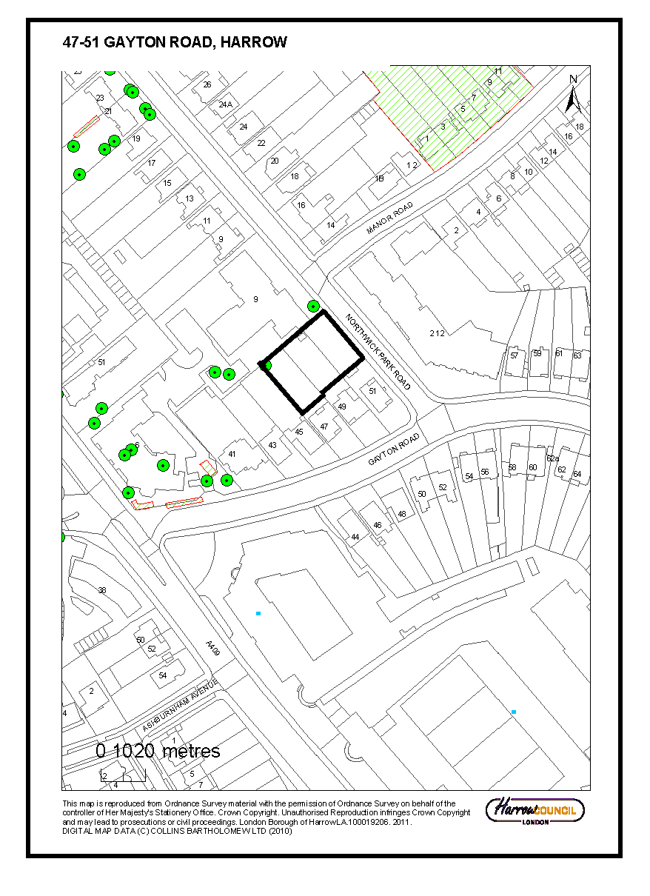

Item No. | 2/02
Address: | KODAK, HEADSTONE DRIVE, WEALDSTONE
Reference: | P/3277/13
Description: | APPLICATION FOR MODIFICATION OF SECTION 37 AGREEMENT DATED 17/07/1969 RELATING TO LAND AT HARROW VIEW HARROW TO RELEASE THE OWNER OF THE OBLIGATIONS CONTAINED WITHIN THAT AGREEMENT
Ward: | MARLBOROUGH
Applicant: | LS HARROW PROPERTIES LTD
Agent: | N/A
Case Officer: | ORLA MURPHY
Expiry Date: | 21/01/2014
RECOMMENDATION
APPROVE the discharge of all the obligations of the Section 37 Agreement dated 17 July 1969 as set out in this report, subject to the applicant entering into a Deed of Release with the Council and the payment of Harrow Council’s reasonable costs in the preparation of the Deed of Release
REASON
The requirements of the Section 37 Agreement are no longer relevant following the granting of outline planning permission ref P/3405/11 for the redevelopment of this site, which will include a new green link and financial contributions intended to deliver qualitative enhancements and increased carrying capacity at strategic sports pitches located within a convenient travel distance from the site. The decision to APPROVE the discharge of the obligations of the legal agreement attached to planning application has been taken having regard to the National Planning Policy Framework 2012, the policies of The London Plan Revised Early Minor Alterations 2013, the Harrow Core Strategy 2012, the Development Management Policies Local Plan 2013, and the Harrow and Wealdstone Area Action Plan 2013.
INFORMATION:
This application is being reported to committee as in the opinion of the Divisional Director of Planning Services, the application to discharge the obligation of the Section 106 Agreement relating to the use of the land falls outside of Category 22(b) of the Scheme of Delegation dated 29 May 2013.
Statutory Return Type: Other
Council Interest: None
Harrow / GLA Community Infrastructure (CIL) Contribution: Not applicable as applications made under S106 of the Town and Country Planning Act (as amended) do not attract a CIL.
Site Description
- The application site comprises the former Kodak sports ground (Harrow View West), now closed and formerly known as Zoom Leisure.
- Harrow View West comprises the former Zoom Leisure Centre, which closed in September 2011, as well as car parking associated with this use and Kodak operations.
- Harrow View West is 7.9 hectares in area and comprises privately owned playing fields, tennis courts, bowls greens and indoor sports and leisure facilities, with associated hard surfaced parking areas.
- The site slopes up from south to north, with maximum levels difference of approximately 8.9 metres.
- The site benefits from two existing vehicle accesses from Harrow View. A further pedestrian access (via a locked gate) exists between the site and Headstone Recreation Ground.

Proposal Details
- It is proposed to discharge the obligations of the S37 Agreement attached to planning application LBH/757/3 for the formation of car park and construction of foot bridge over Harrow View.
- The obligations of the S37 Agreement solely relate to the provision of an area within the site to be retained for use for private sports and recreational purposes only, and restricting the development of any buildings or other structures on the land except those ancillary to the authorised use.

Relevant History
LBH/757/3 Formation Of Car Park And Construction Of Foot Bridge Over Harrow View
Granted 28/07/1969 subject to S37 agreement to the effect that

P/3405/11 Outline Planning Application For A Comprehensive, Phased, Mixed Use Development Of Land At Harrow View And Headstone Drive, As Set Out In The Development Specification (March 2012). The Development Comprises The Demolition Of Existing Buildings And Structures (With The Exception Of The Chimney And Part Of Powerhouse) And Redevelopment Of The Site For A Mix Of Uses Comprising Business And Employment Uses (Within Use Classes B1(A), B1(B), B1(C), B2 And B8 – Up To 35,975sqm); Residential Dwellings (Within Use Class C3 – Up To 985 Units); Student Accommodation (Sui Generis Use – Up To 220 Units); Senior Living Accommodation (Within Use Class C2); Assisted Living Care Home (Within Use Class C2) (Total C2 Uses Up To 9,300sqm); Retail And Restaurant Uses (Within Use Classes A1, A2, A3, A4 And A5 – Up To 5,000sqm); Commercial Leisure Uses (Use Class D2); Community Uses (Use Class D1); Health Centre (Use Class D1); A Primary School (Use Class D1) (Total D1/D2 Uses Up To 8,830sqm); Energy Centre (Sui Generis Use – Up To 4,500sqm); Together With New Streets And Other Means Of Access And Circulation; Highway Improvements; Associated Parking; Re-Profiling Of Site Levels; Utilities Diversions And Connections; Open Space; Landscaping And Ancillary Development Including Infrastructure, Works And Facilities.
Granted 21/12/2012

APPRAISAL
Section 38(6) of the Planning and Compulsory Purchase Act 2004 requires that:
‘If regard is to be had to the Development Plan for the purpose of any determination to be made under the Planning Acts, the determination must be made in accordance with the Plan unless material considerations indicate otherwise.’

On 11 October 2013, the Greater London Authority [GLA] published Revised Early Minor Alterations [REMA] to The London Plan 2011. From this date, the REMA are operative as formal alterations to The London Plan 2011 and therefore form part of the Development Plan for Harrow.

In this instance, the Development Plan comprises The London Plan (2011), Harrow’s Core Strategy (2012) and the Development Management Policies Local Plan 2013 [DMP], the Harrow and Wealdstone Area Action Plan 2013 [AAP], the Site Allocations Local Plan 2013 [SALP] and Harrow Local Area Map 2013 [LAM].

The National Planning Policy Framework [NPPF] which consolidates national planning policy has been adopted, and has now been in place for over 12 months and is considered in relation to this application. Whilst Harrow's Core Strategy was adopted one month before the NPPF came into force, it was subject to a consultation on its conformity with the draft NPPF, and the Inspector's report concludes that the Core Strategy is in conformity with the NPPF.
MAIN CONSIDERATIONS
Use of Space
Use of Space
Planning permission was granted in 1969 for the formation of an extended car park associated with the land on the west of Harrow View, which was at that time used by Kodak for sports and recreation (and until recently in use as the Zoom Leisure site). At that time, the Council granted the planning permission subject to a provision within a Section 37 Agreement that required the owner of the land to restrict the use of the remainder of the relevant part of the site (delineated on a plan annexed to the S37 Agreement) for sports and recreational use purposes only. The site includes approximately 4.3 hectares of playing fields, which comprised part of the former Zoom Leisure private sports facility (total area approximately 7.9 hectares, including car parking). An indoor leisure facility also occupies the site, alongside associated car parking.

Planning permission P/3405/11 for outline consent for the mixed use redevelopment of the Kodak site, encompassing the areas to the east and west of Harrow View, was granted on the 21/12/2012, subject to planning conditions and a Section 106 Agreement. Phase 1B of the development will comprise the whole of the Harrow View West site, and gives consent for new residential development. This development will encroach upon the land that is subject to the Section 37 Agreement restrictions as set out above, and therefore would be in breach of this Agreement.

A detailed assessment of the loss of the sports and recreation space associated with the outline application was set out section 5 of the Committee Report. In relation to this matter, the report concluded that:

“The changes to the open space, to enable its reformatting and re-provision to create a green link through the site (with appropriate reservoirs to ensure that at no time is there a net loss of open space) is considered to meet the requirements of the development plan to maintain the boroughs stock of open space. The loss of sports pitches is compensated for by financial contributions intended to deliver qualitative enhancements and increased carrying capacity at strategic sports pitches located within a convenient travel distance from the site and notwithstanding Sport England’s objection to the proposals, is considered to be appropriate to ensure that the needs of sport in the borough are not undermined.”

An application for planning permission involving the comprehensive re-development of the Kodak site has recently been granted by the Council. Measures to safeguard sports and recreation interests within that permission were the subject of comprehensive package of mitigation through that application. It is therefore considered that, having regard to the development plan, the objectives of the earlier S37 Agreement will be satisfied by other means. As such, it is considered appropriate to enter into a Deed of Release with Kodak so that the obligations of the S37 are no longer applicable.

CONCLUSION
The original S37 agreement served a planning purpose associated with the safeguarding of recreational space as part of an earlier proposal for development on the site. With the grant of permission for a comprehensive re-development of the Kodak estate, including the re-packaging and re-provision of sport and recreational facilities on and off site, it is considered that the original S37 agreement is no longer appropriate. The recent planning permission was granted subject to a S106 agreement and with appropriate mitigation. A deed of release of the obligation in the 1969 agreement is therefore considered appropriate.

INFORMATIVES:
1 INFORMATIVE: This decision is based on the following policies:

National Planning Policy
National Planning Policy Framework 2012

The London Plan Revised Early Minor Alterations (2013):
8.2 Planning obligations

The Harrow Core Strategy 2012
CS1 G Open Space, Sport and Recreation
CS 1 Z/AA/AB Infrastructure

Harrow and Wealdstone Area Action Plan 2013

AAP11 Provision of Open Space
Plan Nos: N/A

Item No: | 2/03
Address: | SAINT ANSELMS RC PRIMARY SCHOOL, ROXBOROUGH PARK, HARROW
Reference: | P/2654/13
Description: | RE-CONFIGURATION AND REFURBISHMENT OF EXISTING PLAYGROUND TO INCLUDE NETBALL COURT, RAMP AND SOFT PLAY AREA; RE-BUILDING OF EXISTING RETAINING BOUNDARY WALL AND REPLACEMENT ENTRANCE GATES
Ward: | GREENHILL
Applicant: | THE GOVERNING BODY
Agent: | DHP (UH) LLP
Case Officer: | CALLUM SAYERS
Expiry Date: | 12/11/2013
RECOMMENDATION
GRANT planning permission for the development described in the application and submitted plans subject to condition(s):
INFORMATION:
REASON
The development within the St Anselms RC Primary School would secure the enhanced re-provision of play space on the site. The proposed development would preserve the character of the Roxborough Park and the Grove Conservation Area and would not unacceptably harm the amenities of neighbouring residential occupiers. The decision to grant planning permission has been taken having regard to national planning policy, the policies of The London Plan 2011, the Harrow Core Strategy 2012, the Development Management Policies Local Plan 2013, The Harrow on the Hill Conservation Area SPD (2008), Roxborough Park and the Grove Conservation Area Appraisal and Management Strategy and policies DM1, DM7, DM46, DM47 of the harrow Development Management Local Policies Plan (2013).
Statutory Return Type: Minor Development; All Other
Council Interest: None
Net additional floor space: N/A
GLA Community Infrastructure Levy (CIL) Contribution: N/A
Harrow Community Infrastructure Levy (CIL) Contribution: N/A

Information
The case is reported to committee because the application site area exceeds 0.1ha, and as such falls outside the tolerances of Part 1(d) of the Scheme of Delegation.

Site Description
- The application site is Saint Anselms RC Primary School, which is located on the southern side of Roxborough Park.
- The site is located within the Roxborough Park and the Grove Conservation Area, and is within the setting of a Grade II Listed Building, which is located at the northern end of the site.
- There are a number of group Tree Preservation Orders within the property, located to the north and east of the site.
- The site adjoins both Metropolitan Open Land and a site of nature conservation area.

Proposal Details
- It is proposed to re-contour the existing children’s play ground to provide a safer play area for the students.
- It is proposed to rebuild the existing retaining wall that runs along the western and part of the southern boundary of the property. The rebuilt retaining wall would retain the land that the proposed netball court would be located on.
- The existing tarmac area that is located between the western flank of the existing school building and the western site boundary would be resurfaced. This area is to be used as a netball court.
- There will be an enclosed play area between the proposed netball court and the existing western flank elevation of the school building. A level access ramp would provide access from the school building up to the proposed netball court.
- It is proposed to replace the existing access gates on the north western corner of the site. The proposed replacement gates will be of a similar colour and appearance, albeit 300mm higher than the existing.

Relevant History
EAST/1221/00/FUL – Single-storey building for parish centre with landscaping and parking
Granted – 14-Jun-2001

P/1761/06 – Metal railings along Roxborough Park
Granted – 13-Oct-2006

P/1993/06 – Demolition of front brick boundary wall (Conservation Area Consent)
Granted – 09-Nov-2006

Other history omitted

Pre-Application Discussion
- N/A

Applicant Submission Documents
- Design and Access Statement

Consultations
Conservation Area Appraisal Committee: No Objection.
The 1930s scout hut is not part of the proposal so need not be considered.

- English Heritage – No Objection
- Highways Authority – No Objection
- Conservation Officer – No Objection

Newspaper Advertisement: 17th October 2013
Expires: 7th November 2013

Site Notice: 18th October 2013
Expires: 8th November 2013

Neighbourhood Notifications:
Our Lady and St Thomas Church, Roxborough Park, Harrow, HA1 3BE
Presbytery, 22 Roxborough Park, Harrow, HA1 3BE
Copperfields, 14 Roxborough Park, Harrow, HA1 3BE
Scout Hut Rear of Church, Roxborough Park, Harrow.
Flats 1- 17, Copperfields, 14 Roxborough Park, Harrow, HA1 3BE
Church Fields, West Street, Harrow.
Flats 1 – 14 Sheppards Court, Roxborough Avenue, Harrow, HA1 3BY
Sheppards Court, Roxborough Avenue, Harrow, HA1 3BY

Sent: 38
Replies: 0
Expiry: 02/11/2013

Summary of Comments;
- N/A

APPRAISAL
Section 38(6) of the Planning and Compulsory Purchase Act 2004 requires that:

‘If regard is to be had to the Development Plan for the purpose of any determination to be made under the Planning Acts, the determination must be made in accordance with the Plan unless material considerations indicate otherwise.’

The Government has issued the National Planning Policy Framework (NPPF), which consolidates national planning policy and is a material consideration in the determination of this application.

In this instance, the Development Plan comprises The London Plan 2011, published Revised Early Minor Alterations [REMA] to The London Plan 2011 and the Local Development Framework (LDF). The LDF comprises The Harrow Core Strategy 2012, Harrow and Wealdstone Area Action Plan (AAP) 2013, the Development Management Policies Local Plan (DMP) 2013, the Site Allocations Local Plan (SALP) 2013 and Harrow Local Area Map (LAP) 2013.

MAIN CONSIDERATIONS
Principle of Development
Character and Appearance of the Roxborough Park and The Grove Conservation Area
Residential Amenity
Traffic and Parking
Tree and Development
Equalities
S17 Crime & Disorder Act 1998
Consultation Responses

Principle of Development
The application proposes to undertake works to the school to refurbish areas of the playground that have fallen into disrepair and as result of their poor state are unable to be used by school children. An existing retaining wall that runs along the western and southern boundaries is showing clear signs of deterioration and instability. Furthermore, the tar-sealed area above this retaining wall has become broken with many trip hazards. In addition, there are areas of significant subsidence, leading to health and safety issues. Lastly, it is proposed to replace the existing chain link fence that currently runs along existing retaining wall.

The proposed works are to be undertaken to improve the existing play space for the school, which given its current state of disrepair is unable to be utilised by the school. The proposed works would bring this play space back into use. It is therefore considered that the proposed refurbishment works would accord with Policies DM46 and DM47 of the DMP (2013).

The property is located within the Roxborough Park and The Grove Conservation Area, and within the curtilage of a Grade II Listed Building. Therefore any development within the site would need to comply with the relevant policies for development that is located within such areas.
Character and Appearance of the Roxborough Park and the Grove Conservation Area
Policy 7.16A of The London Plan (2011) states that The Mayor strongly supports the current extent of Metropolitan Open Land (MOL), its extension in appropriate circumstances and its protection from development having an adverse impact on the openness. Saved policy DM16 of the Harrow Development Management Local Policies Plan (2013) states that the Council will support development proposal which would not have a detrimental visual impact on the open character of the Green Belt and Metropolitan Open Space.

Policy DM1 of the Harrow Development Management Policies Local Plan 2013 (2013) requires all new development to provide a high standard of design and layout, respecting the context, siting and scale of the surrounding environment. Policies 7.4.B and 7.6.B of The London Plan 2011 and core policy CS1 B of the Harrow Core Strategy which seek to ensure that development should respect local character and provide architecture of proportion, composition and scale that enhances the public realm. Policy DM7 of the Harrow Development Management Local Policies Plan (2013) provides further guidance on managing heritage assets and requires new development not to adversely affect the character or amenity of Conservation Areas, Listed Buildings or other heritage assets.

Roxborough Park and the Grove Conservation Area is characterised by its undulating topography, and unusually permeable pedestrian plan form. There is historic interest and a high quality of architecture throughout, but particularly along Grove Hill and Peterborough Road. As a mark of this nine properties are listed whilst 36 are locally listed. The area contains mainly Victorian and Edwardian buildings providing a good variety of architectural styles including Arts and Crafts designs, late Victorian and Edwardian semi-detached houses and Medieval/Gothic style properties. Public and private greenery also contributes greatly to the area's appearance, which helps soften the streetscene and provide an attractive setting for the architecture of the area. The area has a varied character as the density of development ranges from relatively high with semi-detached residential properties, to green, open grassland or meadowland. It also creates an area of some biodiversity value.

The proposed works would be the refurbishment of an existing area of land between the western side of the main school building and the public walkway. Along this boundary the existing brick built retaining wall has began to appear structurally compromised with large cracks appearing within its face fronting onto the public walkway. As a result there is visible evidence on the ground above the retaining wall which is showing signs of subsidence. The proposed works would not enlarge these areas, rather would rebuild them to provide a safer and more user friendly facility. Along the boundary of the retaining wall a replacement fence and access gate would be located. The applicant has provided detail within the supporting information that the retaining wall would be built using where possible the using salvaged brick from the existing retaining wall. It is considered reasonable to attach a condition requiring that where salvaged bricks are not able to be re-used, then bricks of a similar appearance and texture shall be used in the rebuilding of the retaining wall. Subject to such a condition, it is considered that the rebuilt retaining wall would be acceptable and ensures that the feature would maintain the character and appearance of the conservation area and the listed building within the application site.

The existing hardstanding located between the retaining wall on the western boundary and the existing school buildings has fallen into disrepair with many areas of broken tarmac and subsidence. The existing area results in an unsafe area for children to play due to multiple trip hazards. The proposal scheme would result in this area being re-laid to provide for a netball court. The re-laying of this tarmac would cover the existing area and would not result in any further area of hardstanding than existing.

It is proposed to provide for an early years enclosed play area which directly adjacent to the western flank elevation of the school. No detail has been provided with regards to the means of enclosure. Whilst it is considered acceptable to have such a facility within this location, it is considered reasonable to require detail of the means of enclosure for this facility. A safeguarding condition is attached accordingly.

It is proposed to erect a replacement chain link fence along the rebuilt retaining wall, which would run along side the public access way and the Metropolitan Open Land. The proposed replacement chain link fence would 2.1m high and have a similar appearance to the existing chain link fence and be coloured green. It is proposed to also replace the existing gates to the property at the northern end of the retaining wall, and this would be marginally higher than the existing gates to the property.

Along the northern boundary, adjacent to the scout hut, it is proposed to erect a new brick wall to match the existing wall on this boundary. However, it is noted on the plans submitted that no elevations or detail of this wall has been provided. In principle a brick wall in this location would be acceptable, provided that it would match the existing wall that is existing along this boundary. It would not be considered reasonable to refuse the application on the basis that there is insufficient information provided regarding this element, and as such a safeguarding condition is recommended to require detail of this wall along this boundary to ensure that it would be an appropriate addition.

The church that is located within the northern end of the site is Grade II Listed. The Grade II Listed building is located some 36m away from the proposed works and are sufficiently screened from the development by existing outbuildings located within the site. It is therefore considered that the proposed works would not unacceptably harm the setting of the Grade II Listed building located within the site.

The southern boundary of the retaining wall fronts onto adjoining Metropolitan Open Land and also a Site of Nature Conservation Importance. It is considered that the reuse of bricks along this boundary and the appropriate use of the chain link fence would result in a development that would be similar in appearance to the existing situation. Furthermore, it is proposed to provide soft landscaping along the top of the proposed retaining wall which will assist in enhancing the proposed development. A condition is attached accordingly to require detail of soft landscaping within the site. The proposed works would not have an unacceptable impact on the openness of the Metropolitan Open Land or adversely impact on the adjoining Site of Nature Conservation Importance.

It is therefore considered that the proposed remodelling of the school play ground and associated works would, subject to conditions would accord with policies 7.4, 7.6 and 7.8 of The London Plan (2011), and policies DM1, DM7, DM46, DM47 of the Harrow DMP (2013).
Residential Amenity
Policy DM1 of the DMP seeks to “ensure that the amenity and privacy of neighbouring occupiers are safeguarded.

The proposed works would be located within the same footprint of the existing features they are to replace on site. However, it is noted that the green mesh fence would be marginally higher than the existing chain mesh boundary treatment on site. The proposed chain link fencing would be 0.300m higher than the existing fence. The proposed fence would continue to be chain link in appearance, which would ensure that the fence would have a similar impact on the neighbouring residential properties to the west as the existing arrangement would have. It is therefore considered that the proposed works within the site would not result in any unacceptable harm to adjacent neighbouring occupiers through a loss of light or outlook.

It is considered that subject to conditions, the proposed development would accord with policies 7.4 of The London plan (2011), and policy DM1 of the Harrow DMP (2013).
Traffic and Parking
Policy DM42 of the DMP (2013) give advice that developments should make adequate provision for parking and safe access to and within the site and not lead to any material increase in substandard vehicular access.

The proposed works would not result in any further pupils or staff to the site and as such would be considered to not have an unacceptable impact on the free flow and safety of the highway. However, given the site constraints and the confines/sensitivity of the locality of the site, it is considered reasonable to attach a safeguarding condition to require a Construction Method Statement to be submitted to and approved by the Council.

It is therefore considered that subject to safeguarding conditions, the development would not result in any significant increase in traffic movements from the site or unreasonable impacts on highway safety and convenience, and would therefore accord with policy DM42 of the Harrow DMP (2013).
Trees and Development
Policy 7.21B of The London Plan (2011) states that ‘Existing trees of value should be retained and any loss as the result of development should be replaced following the principle of ‘right place, right tree’. Wherever appropriate, the planting of additional trees should be included in new developments, particularly large-canopied species’. Following on from this, Policy DM22 of the Harrow DMP (2013) states that “The Council will seek to achieve and retain a high quality of streetside greenness and forecourt greenery in the Borough”.

St Anselms RC Primary School has a number of group Tree Preservation Orders Located within the property. However, these are noted as being located on the eastern and northern parts of the site. As such the proposed works would not have any harmful impact on any of the trees within the curtilage of the site that are subject to any of the group tree preservation orders.

It is therefore considered that the proposed development would not unacceptably harm trees within the site, and would accord with policies DM1 and DM22 of the Harrow Development Management Local Policies Plan (2013).
Equalities
Section 149 of the Equalities Act 2010 created the public sector equality duty.
Section149 states:-
(1) A public authority must, in the exercise of its functions, have due regard to the need to:
(a) eliminate discrimination, harassment, victimisation and any other conduct that is prohibited by or under this Act;
(b) advance equality of opportunity between persons who share a relevant protected characteristic and persons who do not share it;
(c) foster good relations between persons who share a relevant protected characteristic and persons who do not share it.

When making policy decisions, the Council must take account of the equality duty and in particular any potential impact on protected groups. It is not considered that there are any equality impacts as part of this application.
S17 Crime & Disorder Act 1998
It is considered that the proposed development would not adversely impact upon community safety issues and so it would comply with policy 7.3 of The London Plan (2011).
Consultation Responses
N/A
CONCLUSION
The proposed development is considered to refurbish the existing educational facility, which enable currently unusable areas of the site to be brought back into use by providing safer play facilities for children. Subject to safeguarding conditions it is considered that the proposed works would ensure that the development would preserve the character of the consideration area, maintain the openness of the Metropolitan Open Space. In addition, the proposed works would not unacceptably harm the amenity of neighbouring residential properties.

For these reasons, weighing up the development plan policies and proposals, and other material considerations including comments received in response to notification and consultation as set out above, this application is recommended for grant.
CONDITIONS:
1 The proposed development hereby permitted shall be begun before the expiration of three years from the date of this permission.
REASON: To comply with the provisions of Section 91 of the Town and Country Planning Act 1990.
2 The bricks to be used within the retaining wall hereby approved shall be, where practicable, reused from the existing retaining wall structure. Where existing bricks are unable to be reused, bricks and mortar of a similar appearance and texture shall be used.
REASON: To ensure a satisfactory form of development and safeguard the appearance of the locality and Roxborough Park and the Grove Conservation Area, thereby according with policies 7.4.B and 7.6.B of The London Plan 2011, policies CS1.B and CS1.D of the Harrow Core Strategy 2012 and policies DM1 & DM7 of the Harrow Development Management Policies Local Plan 2013.
3 Prior to construction of the northern boundary wall and internal walls around the early years enclosed play area, details of the walls shall be submitted to and approved in writing by the Local Planning Authority. The details shall demonstrate the height and the appearance of the wall hereby approved.
REASON: To ensure a satisfactory form of development and safeguard the appearance of the locality and Roxborough Park and the Grove Conservation Area, thereby according with policies 7.4.B and 7.6.B of The London Plan 2011, policies CS1.B and CS1.D of the Harrow Core Strategy 2012 and policies DM1 & DM7 of the Harrow Development Management Policies Local Plan 2013.
4 No development shall take place, including any works of demolition, until a Construction Method, phasing plan and Logistics Statement has been submitted to, and approved in writing by, the local planning authority. The approved Statement shall be adhered to throughout the construction period.
The Statement shall provide for:
i. a detailed timeline for the phases and implementation of the development
ii. the parking of vehicles of site operatives and visitors
iii. loading and unloading of plant and materials
iv. storage of plant and materials used in constructing the development
v. measures to control the emission of dust and dirt during construction
vi. a scheme for recycling/disposing of waste resulting from demolition and construction works.
REASON: To ensure that the construction of the development does not unduly impact on the amenities of the existing occupiers of the adjoining properties, in accordance with policies 7.4 and 7.6 of The London Plan 2011 and policies DM1 and DM42 of the Harrow Development Management Local Policies Plan (2013).
5 Notwithstanding the details on the submitted drawings, the development hereby permitted shall not be occupied until there has been submitted to, and approved by, the local planning authority, a scheme of hard and soft landscape works which shall include a survey of all existing trees and hedgerows on the land, indicating those to be retained and those to be lost. Details of those to be retained, together with measures for their protection in the course of the development, shall also be submitted and approved, and carried out in accordance with such approval, prior to any demolition or any other site works, and retained until the development is completed.
Soft landscape works shall include: planting plans, and schedules of plants, noting species, plant sizes and proposed numbers / densities.
Hard Landscape works shall include details of ground surfacing and car parking.
REASON: To safeguard the appearance and character of the area, and to enhance the appearance of the development, as required by policies DM1 and DM7 of the Harrow Development Management Local Policies Plan (2013).
6 The development hereby permitted shall be carried out in accordance with the following approved plans: 4965-P05, 4965-P10, 4965-P20, 4965-P25, 4965-P30, AE/EN/4965
REASON: For the avoidance of doubt and in the interests of proper planning.

INFORMATIVES:
1 INFORMATIVE:
The following national, regional and local planning policies and guidance are relevant to this decision:
National Planning Policy Framework (2012)

The London Plan (2011): 7.2
Policies 3.6, 3.16, 3.18, 7.3B and 7.4B.

Harrow Core Strategy (2012):
Core Policy CS1.B, CS1.Z

Harrow Development Management Policies Local Plan (2013) DM1, DM7, DM42, DM46, DM47

Roxborough Park and the Grove Conservation Area Management & Appraisal

2 Grant without pre-application advice
Statement under Article 31 (1)(cc) of The Town and Country Planning (Development Management Procedure) (England) Order 2010 (as amended)
This decision has been taken in accordance with paragraphs 187-189 of The National Planning Policy Framework. Harrow Council has a pre-application advice service and actively encourages applicants to use this service. Please note this for future reference prior to submitting any future planning applications.
3 CONSIDERATE CONTRACTOR CODE OF PRACTICE
The applicant's attention is drawn to the requirements in the attached Considerate Contractor Code of Practice, in the interests of minimising any adverse effects arising from building operations, and in particular the limitations on hours of working.

4 PARTY WALL ACT:
The Party Wall etc. Act 1996 requires a building owner to notify and obtain formal agreement from adjoining owner(s) where the building owner intends to carry out building work which involves:
1. work on an existing wall shared with another property;
2. building on the boundary with a neighbouring property;
3. excavating near a neighbouring building,
and that work falls within the scope of the Act.
Procedures under this Act are quite separate from the need for planning permission or building regulations approval.
“The Party Wall etc. Act 1996: Explanatory booklet” is available free of charge from:
Communities and Local Government Publications, PO Box 236, Wetherby, LS23 7NB
Please quote Product code: 02 BR 00862 when ordering
Also available for download from the CLG website:
http://www.communities.gov.uk/documents/planningandbuilding/pdf/133214.pdf
Tel: 0870 1226 236 Fax: 0870 1226 237
Textphone: 0870 1207 405
E-mail: communities@twoten.com
5 COMPLIANCE WITH PLANNING CONDITIONS
IMPORTANT: Compliance With Planning Conditions Requiring Submission and Approval of Details Before Development Commences
- You will be in breach of planning permission if you start development without complying with a condition requiring you to do something before you start. For example, that a scheme or details of the development must first be approved by the Local Planning Authority.
- Carrying out works in breach of such a condition will not satisfy the requirement to commence the development within the time permitted.
- Beginning development in breach of a planning condition will invalidate your planning permission.
- If you require confirmation as to whether the works you have carried out are acceptable, then you should apply to the Local Planning Authority for a certificate of lawfulness.
6 CONSTRUCTION METHODS
The development hereby approved may be subject to the Construction (Design and Management) Regulations 1994 which govern health and safety through all stages of a construction project. The Regulations require clients (i.e. those, including developers, who commission projects) to appoint a planning supervisor and principal contractor who are competent and adequately resourced to carry out their health and safety responsibilities. Clients have further obligations. Your designer will tell you about these and your planning supervisor can assist you in fulfilling them. Further information is available from the Health and Safety Executive Infoline on 0541 545500.
(Please note that any reference in this informative to "planning supervisor" has no connection with any Planning Officers within Harrow's Planning Services or with the Town and Country Planning Act 1990.)
7 The proposed plans indicate that there would be play equipment located at the southern end of the raised area above the retaining wall. However, it is noted that there are no elevations of these features, and they are not referred to within the development description. These features are therefore not considered as part of this application, and would require planning permission to be erected.
Plan Nos: 4965-P05, 4965-P10, 4965-P20, 4965-P25, 4965-P30, AE/EN/4965

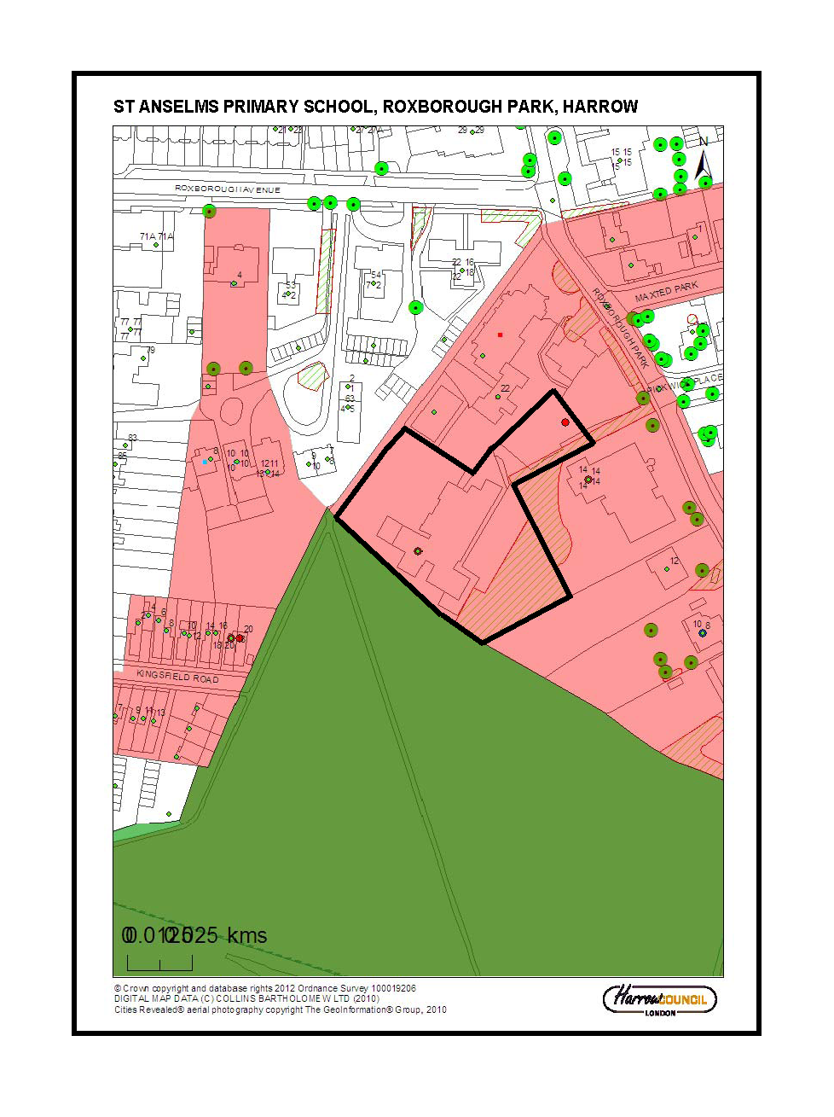

Item No: | 2/04
Address: | 5 THE QUADRANT, HEADSTONE GARDENS, HARROW
Reference: | P/2874/13
Description: | CHANGE OF USE OF GROUND FLOOR FROM RETAIL (CLASS A1) TO OFFICE (CLASS B1); SINGLE STOREY REAR EXTENSION; EXTERNAL ALTERATIONS TO FRONT ELEVATION
Ward: | HEADSTONE SOUTH
Applicant: | MR NEELAM ALI
Agent: | J E CONSULTANTS UK LTD
Case Officer: | CATRIONA COOKE
Expiry Date: | 14/11/2013
RECOMMENDATION
GRANT planning permission subject to conditions

REASON
The proposed change of use of the ground floor of the existing building from a retail use
(Class A1) to office use (Class B1)is considered to be acceptable in planning policy terms for this location. It also introduces an active use at this vacant ground floor premises The proposal would not result in the unacceptable loss of residential amenity for the neighbouring occupiers. The decision to recommend the grant of planning permission has been taken having regard to national planning policy, the policies of The London Plan 2011, the Harrow Core Strategy 2012, and the Development Management Policies Local Plan 2013, as well as to all relevant material considerations including any responses to consultation.

INFORMATION
The application is reported to the Planning Committee because of significant public interest in accordance with provision A of the scheme of delegation dated 29th May 2013.

Statutory Return Type: (E)18 Minor Development, all other
Council Interest: None
Gross Floorspace: 7.6 sqm
GLA Community Infrastructure Levy (CIL) Contribution (provisional): Nil
Harrow Community Infrastructure Levy (CIL) Contribution (provisional): Nil

Site Description
- Two storey mid terraced property with ground floor A1 use with flat above.
- It is within a designated neighbourhood parade of shops
- To the rear of the site are garages and Beverley Court which is a block of flats located on Harrow View
- Access to the rear of the site is gained by a pedestrian alleyway.

Proposal Details
- The application proposes the change of use of the ground floor (66.6m²) from A1 to B1(a).
- Single storey rear extension increasing the existing single storey rear extension to full width of the plot.
- New shopfront

Revisions to Previous Application
Following the previous decision (P/1003/13) the following amendments have been made
- Change of use of ground floor retail use to office only whereas the previous application sought to change the use of the whole of the site, including the flat above the shop to a B1 use.

Relevant History
P/3125/07 - Change Of Use From Shop (Class A1) To Hot Food Take-Away (Class A5): Single Storey Rear Extension and Installation of Extract Duct At Rear Elevation.
Refused – 19/11/2007

Reason for Refusal
“The proposed change of use would lead to additional and injudicious on street parking to the detriment of the free flow and safety of vehicular traffic and pedestrians on the public highway contrary to policies D4, EM20 and T13 of the Harrow Unitary Development Plan (2004).”

P/4142/07UN - Change of use from shop (class a1) to restaurant (class a3); single storey rear extension and installation of extract duct at rear elevation
Granted – 29/02/2008

Permission not implemented.

P/1003/13 - Change of use of ground floor from retail (class a1) and first floor from residential (class c3) to office (class b1) with offices in roofspace; rooflights in front and rear roofslopes; single storey rear extension
Refused – 29/08/2013

Reasons for Refusal:
1. The proposed change of use of the first floor from residential (Class C3) to Office (Class B1) would result in an unacceptable loss of residential accommodation without the provision of a suitable replacement contrary to Policy 3.14(B) of The London Plan (2011).

2. The applicant has failed to demonstrate that the proposed development would achieve an inclusive environment which would be accessible for all and therefore the proposal would be contrary to policy 7.2C of The London Plan (2011) and Policy
DM2 of the Harrow Development Management Local Plan Policies (2013).
Pre-Application Discussion (Ref.)
N/A

Applicant Submission Documents
- Design and Access Statement
- Premises has been vacant for three months. Retail business was not successful
- The existing shop does not provide for any off street parking. As the property is located on a very busy road, it is very convenient to get to by public transport. Free parking is available on the nearby side roads for the public.

Consultations
Headstone Residents Association – No comments received.

Highways Authority - The change of use from A1 to B1(a) is unlikely to measurably affect overall traffic and parking generation to and from the site given the scale of proposal, existing baseline and projected level of activity. The applicant does not propose parking provisions given the physical constraints of the site which is considered acceptable as it is unlikely that parking from this development would measurably impact on surrounding main and residential roads.

There should be 1 secure cycle parking space provided for this address to conform to London Plan 2011 standards for B1(a) uses.

In summary there is no objection.

Advertisement
n/a

Notifications
Sent: 43
Replies: 16
Expiry: 06/11/2013

Addresses Consulted
6, 6A, 4, 4A, 5A The Quadrant
Flat 2, Clarendon Court, 40, Gloucester Road, Flat 60 Bucknall House, Atherton Place
2, 4, 6, 17, 20, 37, 43, 44 Sidney Road, 19, 54, 60, Brook Drive
9, Albert Road, 2, 6, 7, 16, 17 Edward Road, 25 Victor Road, 14 Headstone Gardens
368 Pinner Road, 4A Acacia Avenue

Summary of Responses
- Office totally out of character with area
- Not inclusive environment
- No parking
- No details of type of office provided
- If granted condition should be attached that a sui-generis business must not operate from these premises.

APPRAISAL
The Government has adopted a National Planning Policy Framework [NPPF] on 27 March 2012 that consolidates national planning policy. This document now carries significant weight and has been considered in relation to this application.

Section 38(6) of the Planning and Compulsory Purchase Act 2004 requires that:
‘If regard is to be had to the Development Plan for the purpose of any determination to be under the Planning Acts, the determination must be made in accordance with the Plan unless material considerations indicate otherwise.’

On 11 October 2013, the Greater London Authority [GLA] published Revised Early Minor Alterations [REMA] to The London Plan 2011. From this date, the REMA are operative as formal alterations to The London Plan 2011 and therefore form part of the development plan for Harrow.

In this instance, the Development Plan comprises The London Plan 2011, the Harrow Core strategy 2012 and Development Management Policies Local Plan 2013 [DMP].
MAIN CONSIDERATIONS
Principle of the Development
Character and Appearance of the Area
Residential Amenity
Traffic and Parking
Accessibility
S17 Crime & Disorder Act
Environmental impact Assessment (EIA)
Consultation Responses

Principle of the Development
The application site lies in a designated neighbourhood parade of shops. Policy DM 38 of the Harrow Development Management Policies Local Plan (2013) states:

- Within neighbourhood parades and the non –designated parades of town centres, as defined on the Harrow Policies Map, the use of ground floor premises for purposes that are appropriate town centre, community and economic uses will be permitted provided that:

  - in the case of non A class uses, a window display or other frontage appropriate to the centre would be provided; and
  - the use would not be detrimental to the amenity of neighbouring occupiers”

The existing retail use is vacant. The proposal to introduce a B1 office use on the ground floor would be an appropriate economic use, that is considered to be appropriate in terms of its amenity impacts The proposal would have a total of 8 employees, 5 full time staff and 3 part time. Subject to ensuring that an appropriate shop front is maintained via the imposition of a suitably worded planning condition, the proposal would be in accordance with the objectives set out under Policy DM38 of the Harrow Development Management Policies Local Plan (2013)

Character and Appearance of the Area
The London Plan policy 7.4B states that buildings should provide a high quality design response that has regard to existing spaces and streets in orientation, scale, proportion and mass. The London Plan Policy 7.6B states that architecture should make a positive contribution to the streetscape. Core policy CS1.B of the Harrow Core Strategy states that all development shall respond positively to the local context.

Policy DM1 of the Harrow Development Management Policies Local Plan (2013) states “All development and change of use proposals must achieve a high standard of design and layout. Proposals which fail to achieve a high standard of design and layout, or which are detrimental to local character and appearance, will be resisted.”

The proposed single storey rear extension would be sited at the rear and given its modest scale would be proportionate to the original building, it would be in keeping with the character of the area.

The proposed single storey rear extension would have a satisfactory appearance, in line with the requirements of Policy 7.4B of The London Plan 2011, Policy DM1 of the Development Management Plan Policies (2013).

Residential Amenity
It is considered that given the proposed extension would be at ground floor level with the neighbouring residential properties 6A and 4A The Quadrant being at first floor level there would be no impact on these neighbouring properties in relation to loss of outlook or overshadowing. The proposed extension would be located approximately 10m from the nearest corner of the block of flats to the rear, this is sufficient to mitigate any adverse impact on the occupiers of the building.

In terms of the noise, general activity and disturbance created by the proposed use, it is considered that neighbouring properties will experience a negligible difference in these uses. Furthermore, B1 office uses can generally be sited within close proximity to residential occupiers because the nature of the use is generally low impact in terms of related disturbance. To ensure that the amenities of neighbours are protected, it is considered necessary to recommend that permission is granted subject to a condition that restricts the type of B1 use to an office use only. In the event that a proposal comes forward for another use that would fall within the B1 use class, for example a workshop, planning permission would be required. This would enable the Planning Authority to consider such a proposal on its merits.

The applicant seeks consent to open the property 08:00 to 19:00 Monday to Friday and 08:00 to 13:00 Saturdays. Given the high levels of ambient noise that are experienced in the area due to the busy highway adjacent to the site and the relatively low levels of disturbance that would be created from an office use, it is considered that such hours of opening would be reasonable and appropriate. The opening hours can be secured by condition which is recommended to further protect the amenities of neighbouring residents.

In conclusion, it is considered that the proposed development would not have any detrimental impact upon the residential amenities of the neighbouring occupiers and the proposed development would be in accordance with the objectives set out under policy 7.6 of the London Plan and the Residential Design Guide SPD (2010), and Policy DM1 and DM38 of the Harrow Development Management Policies Local Plan (2013).

Traffic and Parking
The site is well served by good public transport, and it is therefore considered that the proposed change of use from a shop (Use Class A1) to an Office (Use Class B1) would not have a detrimental impact in relation to car parking. With regard to highway safety and the need to ensure that the proposed development would not result in the obstruction to the free flow of traffic, it is considered that the changes to the site would not measurably impact on the surrounding main and residential roads.

Policy 6.9 of the London plans requires developments to provide secure, integrated and accessible cycle parking facilities. A condition is recommended to ensure that one secured parking space is provided. The Highways Engineer has raised no objection to the proposal subject to one secured cycle space.

Given the above, the development would accord with policy 6.13 of The London Plan 2011, Policy DM42 of the Harrow Development Management Policies Local Plan (2013).

Accessibility
Policy 7.2 of the London plan states that “Design and Access statements submitted with development proposals should explain how, following engagement with relevant user groups, the principles of inclusive design, including the specific needs of older and disabled people, have been integrated in the proposed development”. The applicant has not shown on the submitted plans or in their design and access statement that the proposed offices would be accessible and inclusive for all, nor has the applicant justified why such has not been included in their proposal. A condition is recommended which would require that the use hereby permitted shall not commence until details of a scheme to provide an accessible and inclusive environment for all has been submitted and approved in writing by the Local Planning Authority. If, for any reason, it is not possible to provide a level means of access, then the reasons as to why its provision would not be possible would need be justified in a report to the Local Planning Authority.

S17 Crime & Disorder Act
It is considered that the proposed development would not adversely impact upon community safety issues.

Equalities Statement
Section 149 of the Equalities Act 2010 created the public sector equality duty.
Section149 states:-
(1) A public authority must, in the exercise of its functions, have due regard to
the need to:
(a) eliminate discrimination, harassment, victimisation and any other conduct
that is prohibited by or under this Act;
(b) advance equality of opportunity between persons who share a relevant
protected characteristic and persons who do not share it;
(c) foster good relations between persons who share a relevant protected characteristic and persons who do not share it.

When making policy decisions, the Council must take account of the equality duty and in particular any potential impact on protected groups. The proposed change of use has no impact with regard to section 149 of the Equalities Act 2010.

Consultation Response
- Office totally out of character with area – see section 1 above.
- Not inclusive environment – condition recommended to provide details of inclusive environment prior to use.
- No parking – See section 4 above
- No details of type of office provided – See section 2 above
- If granted condition should be attached that a sui-generis business must not operate from these premises – the application relates to a change of use to B1 not sui-generis. Planning permission would be required for a change of use to any use outside of use class B1.

CONCLUSION
The proposed change of use of the ground floor of the existing building from Retail
(Class A1) to Office (Class B1) use is considered to be acceptable in planning policy terms for this location, and also introduces an active use at ground floor. The proposal would not result in the unacceptable loss of residential amenity for the neighbouring occupiers. The decision to grant planning permission has been taken having regard to national planning policy, the policies of The London Plan 2011, the Harrow Core Strategy 2012, and the Development Management Policies Local Plan 2013, as well as to all relevant material considerations including any responses to consultation.

CONDITIONS
1 The development hereby permitted shall be begun before the expiration of three years from the date of this permission.
REASON: To comply with the provisions of Section 91 of the Town and Country Planning Act 1990.

2 The development hereby permitted shall be carried out in accordance with the following approved plans: 1145/NA/01A; 1145/NA/02A; 1145/NA/03; Design and Access Statement
REASON: For the avoidance of doubt and in the interests of proper planning.

3 Notwithstanding the details shown on the approved drawings, the use hereby permitted shall not commence until details of a scheme to provide an inclusive environment, including level access from the highway is submitted to and approved in writing by the Local Planning Authority. The premises shall not be occupied, or used until the works have been completed in accordance with the approved details and thereafter retained.
REASON: To ensure an inclusive environment in accordance with Policy 7.2 of the London Plan (2011) and DM1 of the Harrow Development Management Policies Local Plan (2013) and Supplementary Planning Document – Access for All (2006).

4 The approved Class B1 Office premises on the ground floor shall not be open to the
public except between the hours of 08.00 to 18.00 Monday to Saturday (inclusive of Bank
holidays) and shall not be open at any other time except with the prior agreement in
writing of the Local Planning Authority.
REASON: To safeguard the amenity of nearby neighbouring residents in accordance with
policy 7.6 (B) of The London Plan (2011) and policies DM1 and DM38 of the Harrow Development Management Policies Local Plan (2013).

5 The premises shall only be used for the purpose specified in the application [B1 (a) (offices not within Class A2) and for no other purpose, including any other purpose in Class B of the Schedule to the Town and Country Planning (Use Classes) Order 1987 (or in any provision equivalent to that class in any statutory instrument revoking and re-enacting that order with or without modification).
REASON: To safeguard the amenities of neighbouring residential properties and highway safety, thereby according with policy DM1, DM43 and DM46 the Harrow Development Management Policies Local Plan (2013).

6 Notwithstanding the details shown on the approved drawings, the use hereby permitted shall not commence until details of one secured parking space is submitted to and approved in writing by the Local Planning Authority. The premises shall not be occupied, or used until the works have been completed in accordance with the approved details and thereafter retained.
REASON: To promote cycling in accordance with Policy 6.9 of the London Plan (2011)

INFORMATIVES
1 The following policies are relevant to this decision:

The London Plan (2011) including Revised Early Minor Alterations to The London
Plan 2013:
6.13 – Parking
6.9 - Cycling
7.2 – An inclusive environment
7.4 – Local Character
7.6 – Architecture

Harrow Core Strategy (2012)
CS1 B Local Character
CS1 Q/R/S Transport

Harrow Development Management Policies Local Plan (2012)
DM1 – Achieving a High Standard of Development
DM4 – Shopfronts and Forecourts
DM38 – Other Town Centre Frontages and Neighbourhood Parades
DM42 – Parking Standards

Other Relevant Guidance:
Supplementary Planning Document: Access for All (2006)

2 CONSIDERATE CONTRACTOR CODE OF PRACTICE
The applicant's attention is drawn to the requirements in the attached Considerate Contractor Code of Practice, in the interests of minimising any adverse effects arising from building operations, and in particular the limitations on hours of working.

3 PARTY WALL ACT:
The Party Wall etc. Act 1996 requires a building owner to notify and obtain formal agreement from adjoining owner(s) where the building owner intends to carry out building work which involves:
1. work on an existing wall shared with another property;
2. building on the boundary with a neighbouring property;
3. excavating near a neighbouring building,
and that work falls within the scope of the Act.
Procedures under this Act are quite separate from the need for planning permission or building regulations approval.
“The Party Wall etc. Act 1996: Explanatory booklet” is available free of charge from:
Communities and Local Government Publications, PO Box 236, Wetherby, LS23 7NB
Please quote Product code: 02 BR 00862 when ordering
Also available for download from the CLG website:
http://www.communities.gov.uk/documents/planningandbuilding/pdf/133214.pdf
Tel: 0870 1226 236 Fax: 0870 1226 237
Textphone: 0870 1207 405
E-mail: communities@twoten.com

4 Grant without pre-application advice
Statement under Article 31 (1)(cc) of The Town and Country Planning (Development
Management Procedure) (England) Order 2010 (as amended)
This decision has been taken in accordance with paragraphs 187-189 of The National
Planning Policy Framework. Harrow Council has a pre-application advice service and
actively encourages applicants to use this service. Please note this for future reference
prior to submitting any future planning applications.

5 IMPORTANT: Compliance With Planning Conditions Requiring Submission and Approval of Details Before Development Commences
- You will be in breach of planning permission if you start development without complying with a condition requiring you to do something before you start. For example, that a scheme or details of the development must first be approved by the Local Planning Authority.
- Carrying out works in breach of such a condition will not satisfy the requirement to commence the development within the time permitted.
- Beginning development in breach of a planning condition will invalidate your planning permission.
- If you require confirmation as to whether the works you have carried out are acceptable, then you should apply to the Local Planning Authority for a certificate of lawfulness.

Plan Nos: 1145/NA/01A; 1145/NA/02A; 1145/NA/03; Design and Access Statement

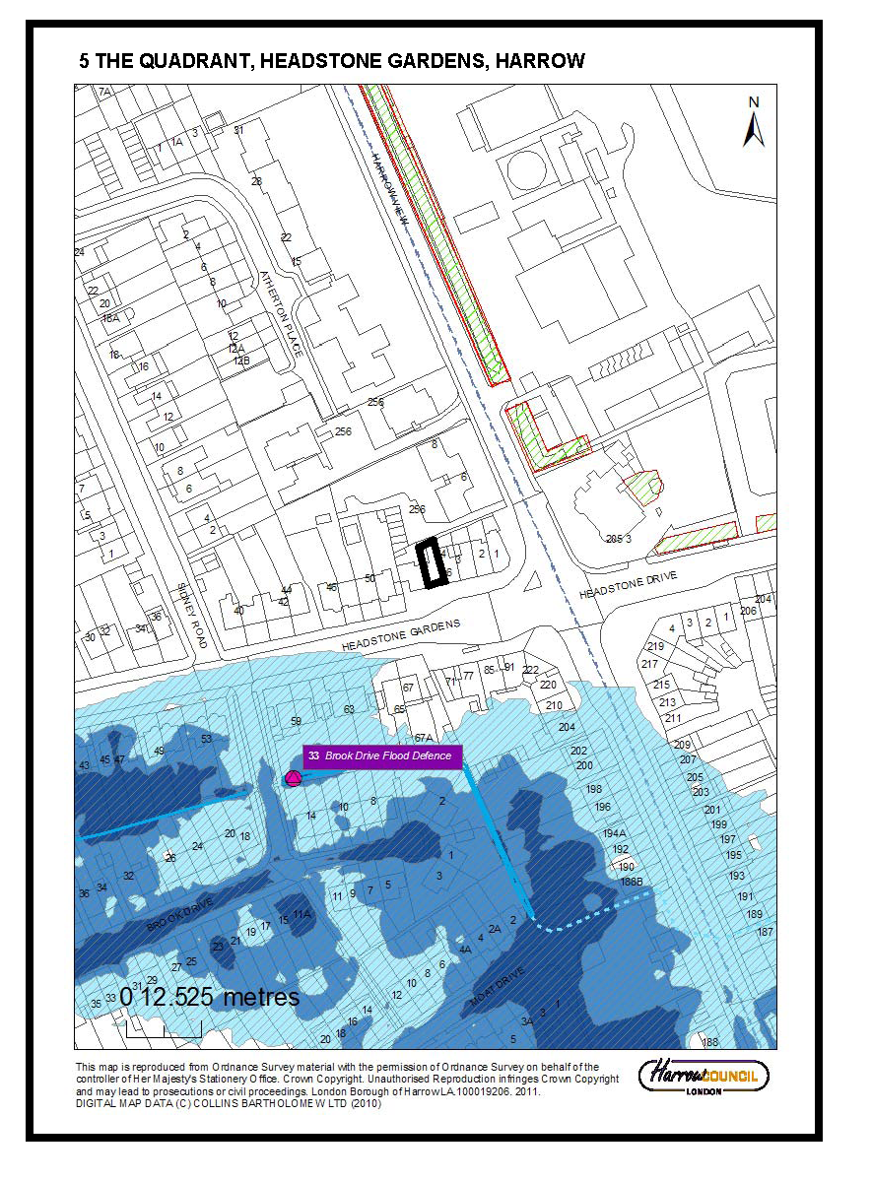

Item No: |  |  |  |  | 2/05
Address: |  |  |  |  | 17 GLANLEAM ROAD, STANMORE
Reference: |  |  |  |  | P/3175/13
Description: |  |  |  |  | THREE STOREY DETACHED DWELLINGHOUSE WITH SINGLE STOREY REAR PROJECTION AND BASEMENT (RETROSPECTIVE APPLICATION) PROPOSED ALTERATIONS INCLUDING REMOVAL OF FRONT ATRIUM AND REDUCTION TO SECOND FLOOR
Ward: |  |  |  |  | CANONS
Applicant: |  |  |  |  | Mr J Halai
Agent: |  |  |  |  | Malcolm Pawley Architects
Case Officer: |  |  |  |  | GERARD LIVETT
Expiry Date: |  |  |  |  | 25-DEC-13
RECOMMENDATION
GRANT planning permission, subject to conditions:
INFORMATION
This application is reported to Planning Committee as, in the opinion of the Director of Planning, it is potentially controversial and is of significant public interest and therefore falls outside Category 1 of the Scheme of Delegation.
Summary

Statutory Return Type: Minor Dwellings

Council Interest: None

Gross Floorspace: 708 square metres
GLA Community Infrastructure Levy (CIL) Contribution (provisional): £24,780
Harrow Community Infrastructure Levy (CIL) Contribution (provisional): £77,880

Site Description
- The application site is occupied by a three storey modern detached dwellinghouse located on the northern side of Glanleam Road.
- The dwellinghouse currently has a glazed atrium which projects 2m forward of the main front wall and is the full height of the building.
- The second floor is finished in timber cladding and is setback from the main walls at lower levels which are finished in white render.
- The dwellinghouse has wraparound corner windows in the front elevation at first and second floor levels.
- The frontage of the property has been primarily hardsurfaced and forms a carriage driveway with a central planted area.
- The dwellinghouse is built forward of and at a lower level than the adjacent dwellinghouses at Nos.15 and 17.
- There is a single storey rear projection at the rear of the dwellinghouse and steps down to a basement.
- At the rear of the dwellinghouse are a series of terraced patios, with steps leading up to the garden at the rear of the site.
- There are balconies with clear glazed balustrades on the first and second floor at the rear, the first floor balcony having an obscure glazed screen on its western side.
- The majority of the rear elevation of the property contains floor to ceiling glazing.
- The surrounding area is characterised by medium to large two-storey detached dwellings of different shapes and architectural styles with large rear gardens.
- The Green Belt and the Harrow Weald Ridge Area of Special Character lie immediately to the north of the site.
- At the rear of the site, adjacent to two trees which are subject to a TPO, a single storey outbuilding and raised decking have been constructed.
Proposal Details
- Retention of the dwellinghouse described above with the following alterations:
- Removal of front atrium and its replacement with glazed front doors with side bars and a first floor full height window with a powder-coated grey aluminium panel between the ground and first floor and render above the first floor window
- Set in of the second floor front elevation by an additional 1m, making a total set in of 1.9m from the main front elevation
- Provision of privacy screens to first floor balconies on east and west elevations (full details of such screens not supplied.

Revisions to previous application
Following the previous refusal of planning permission (P/2123/10), the amendments noted in the ‘Proposal Details’ section above have been made
Relevant History

P/2812/07 – Replacement 3 storey detached house with single storey rear projection and basement

Withdrawn – 10-Oct-2007

P/3505/07 – Replacement three storey detached house with single storey rear projection and basement (revised)

Granted – 14-Dec-2007

P/0641/08 – Details of external materials, hard and soft landscaping, boundary treatment and refuse storage pursuant to conditions 2, 4, 7 and 13 of planning permission P/3505/07

P/2123/10 – Three storey detached house with single storey rear projection and basement (retrospective application)

Refused – 22-Dec-2011

Appeal Dismissed – 28-Feb-2013

Reasons for Refusal:
- The dwellinghouse as constructed on site, by reason of excessive size, bulk and prominent siting in comparison to neighbouring properties, is unduly obtrusive and overbearing in the streetscene and has an unsatisfactory relationship with neighbouring properties, to the detriment of the character and appearance of the area, contrary to The London Plan (2011) policies 7.4B and 7.6B, saved policy D4 of the Harrow Unitary Development Plan (2004) and the adopted Supplementary Planning Document: Residential Design Guide (2010).

- The dwellinghouse as constructed on site, by reason of its increased size, bulk, rearward projection and glazing in comparison to the approved proposal, results in the overshadowing of and a loss of light and outlook to the occupiers of adjacent properties, and actual and perceived overlooking of neighbouring occupiers from first and second floor windows and balconies, to the detriment of neighbouring residential amenity, contrary to The London Plan (2011) policy 7.6B, saved policy D5 of the Harrow Unitary Development Plan (2004) and the adopted Supplementary Planning Document: Residential Design Guide (2010).
- The application has failed to demonstrate how the dwellinghouse and associated hardsurfacing at the front and rear utilises sustainable drainage systems (SUDS), or why there are practical reasons for not doing so, in order to ensure that the surface water run-off from the development is managed and does not result in flooding of this or adjacent sites, contrary to the objectives of policy 5.13A of The London Plan (2011) and saved policy EP12 of the Harrow Unitary Development Plan (2004).

ENF/0352/09/P

Without planning permission the construction of a three storey detached dwelling house with a single storey rear projection and basement ("the unauthorised development")

Enforcement Notice dated 18-Oct-2013 – Effective 29-Nov-2013

Requirements of Notice: Demolish the Unauthorised Development, Restore the ground levels at the Land to the pre-existing levels; Permanently remove from the Land all materials and debris arising from compliance with the steps above

Period for Compliance: Twelve (12) calendar months after the Notice takes effect

Appeal lodged under ground (f) [Requirements of Notice are excessive] on 21-Nov-2013 with a start date of 27-Nov-2013

Pre-Application Discussion (P/0693/13/PREAPP)
- The atrium must be removed and the scale and prominence of the building must also be reduced. Officers consider that the proposed amendments adequately address the concerns of the Inspector in regard to visual impact.
- As concluded by the Inspector, the existing flank wall window arrangement is acceptable, subject to conditions requiring the obscure glazing and window splays to be retained in perpetuity. In relation to the overlooking from the rear terraces, the Inspector advised that this could be overcome by the imposition of conditions relating to balcony screening at the ends of the balconies. However, officers consider that these details should be included on the application submission for clarity and completeness.
- You are advised to submit full drainage details with the application to enable officers to make an assessment of this aspect of the scheme
Applicant Submission Documents
- Design and Access Statement: Application seeks to regularise the as built property by removing the three storey front elevation atrium, reducing the second storey by 1 metre from the front building line and installing privacy screens to the rear terrace at first floor level. Permeable paving would be provided at the rear to ensure surface water run-off does not increase from pre-development rate
- Energy Performance Certificate: Energy Efficiency Rating ‘B’
Consultations:
Warren House Estate Residents’ Association: No response received
Stanmore South Tenants’ Association: No response received
Highways Authority: No objection.
Drainage Engineers: Additional surface water storage and attenuation is required
Notifications:
Sent: 9
Replies: 2 (including one letter with 6 signatories)
Expiry: 29-Nov-2013

Addresses Consulted:
Glanleam Road: 8, 10, 12, 14, 16, 13, 15, 19, 21
Summary of Response:
General appearance, design, size, height and scale are incongruous with surrounding properties and amendments do not sufficiently mitigate the harm the building does to the street view. The previous Inspector’s conclusion still applies.
Removal of atrium does not sufficiently mitigate the harm to the street view as the significant bulk and mass of the building, caused in part by the protrusion at first floor level, would remain. Second floor is too high and dwarfs No. 19.
No amendments to the rear balconies have been proposed. No modifications to the wrap-around windows have been proposed. Concerns relating to adjacent properties and those facing No. 17, including intrusive cameras and lighting, floodlighting and exposed dangerous drops between adjacent properties, have also not been addressed.
Front building line would not be changed and eaves are too high. Boundaries are not accurately shown on the drawings.
Drainage cannot rely on pipes on third party land.
BACKGROUND INFORMATION
The amendments proposed to the unauthorised ‘as built’ development are intended to overcome the harm the dwellinghouse causes to the character of the area and the amenities of neighbouring occupiers.

An Enforcement Notice requiring the complete demolition of the property was to have come into effect on 29 November 2013. As a valid appeal against that Enforcement Notice was received before that date, the Enforcement Notice has not yet come into effect. The appeal against the Enforcement Notice in on ground (f), and the appellants have stated that the steps proposed with the current planning application would be sufficient to remedy the breach of planning control.

Should the appeal be allowed or dismissed, the Enforcement Notice would take effect on the date of the decision of the appeal either in its modified or original form. Should the appeal be withdrawn, then the Notice would take effect from 29 November 2013.

Should planning permission be granted, and the works required by the recommended conditions be completed in accordance with the terms of the conditions, then the Enforcement Notice would be redundant, irrespective of the outcome of the appeal.

APPRAISAL
Section 38(6) of the Planning and Compulsory Purchase Act 2004 requires that:

‘If regard is to be had to the Development Plan for the purpose of any determination to be made under the Planning Acts, the determination must be made in accordance with the Plan unless material considerations indicate otherwise.’

In this instance, the Development Plan comprises The London Plan 2011 [LP] and the Local Development Framework [LDF]. The LDF comprises The Harrow Core Strategy 2012 [CS], Harrow and Wealdstone Area Action Plan 2013 [AAP], the Development Management Policies Local Plan 2013 [DMP], the Site Allocations Local Plan [SALP] 2013 and Harrow Local Area Map 2013 [LAP].

On 11 October 2011, the Greater London Authority [GLA] published Revised Early Minor Alterations [REMA] to The London Plan 2011. From this date, the REMA are operative as formal alterations to The London Plan 2011 and therefore form part of the development plan for Harrow.

In relation to the policies of the LP which are relevant to this application, only policy 7.21 has been altered since the application was submitted.

MAIN CONSIDERATIONS
Character and Appearance of the Area
Residential Amenity
Trees and Drainage
Highways
Accessibility
Equalities Statement
s17 Crime and Disorder Act
Consultation Responses

Character and Appearance of the Area
The Council has adopted a Supplementary Planning Document: Residential Design Guide (2010) that supports design policies 7.4 and 7.6 of The London Plan, policy CS1.B of the Harrow Core Strategy and policy DM1 of the Development Management Policies (DMP).

The design policies of the development plan require that new development proposals should respect the scale and character of the area, and require the Council to ensure that all development proposals achieve a high standard of design and layout, taking into consideration, amongst other things, site and setting, and context, scale and character. New development should have regard to the character and landscape of the locality, and buildings should complement the wider area, and should respect the scale and character of the surrounding area.

Planning permission for a modern, flat-roofed dwellinghouse at the site was granted in 2007, and the principle of a modern design has been accepted.

However, with regard to the dwellinghouse that has been constructed, the Council considered that this was unduly obtrusive and overbearing in the street scene due to its excessive size, bulk and prominent siting and unsatisfactory relationship with neighbouring properties.

In dismissing the appeal against the refusal to grant retrospective permission for the ‘as built’ house, the Inspector noted that the approved dwelling (in 2007) was similar in form to the as built property. However, the property as built was set forward of the neighbouring property, No. 15 Glanleam Road, by 0.29 metres. The height of the main roof is similar to the ridge level of No. 15, and is significantly higher than the apex of the front gable of No. 19.

The Inspector noted that the ‘as built’ house is dominated by a centrally positioned glazed atrium, which projects forward of the main front wall of the property by 2m and has a height of 9.78 metres..

The Inspector considered that the modern style of the building increased its prominence in the street scene. This impact was heightened by the front atrium. The inspector concluded that the scale, forward projection and modern form of the building represents an awkward and obtrusive addition to the street scene and failed to achieve the high standard of design required by the National Planning Policy Framework and the design policies of the development plan.

With the current application, the applicants propose to remove the atrium in its entirety and to reduce the depth of the second floor from the front elevation of the property by 1m.

Officers consider that these changes would reduce the overall impact of the property in the streetscene and would reduce the overall scale and bulk of the property. As noted above, the atrium has been considered particularly obtrusive and its removal would result in a flat-fronted building that would have less impact on the streetscene.

The proposed reduction in depth of the second floor would also have the impact of making it less visible when viewed from ground level, further reducing the impact of the overall bulk of the building in the streetscene.

Officers consider that these changes would significantly contribute to overcoming the harm to the character and appearance of the area as identified above.

Given that the harm has been clearly identified, officers recommend that the works to remove the atrium, restore the front elevation and to reduce the depth of the second floor be required to be completed within six months of the date of permission.

The period for compliance with the Enforcement Notice, which has not come into effect, is twelve months. However, that Notice requires the total demolition of the property and the restoration of the site. Given that the works required would be relatively minor, and would not result in the loss of the family home, six months is considered an appropriate period in which to complete the works.

The applicants are proposing to use permeable paving for the front garden, which would overcome some of the concerns regarding drainage at the site. No details of the type of paving have been supplied, and a condition requiring the paving materials to be approved and installed within six months is recommended.

When planning permission was granted for a replacement dwellinghouse at the site, permitted development rights in classes A (extensions and alterations), B (extensions to the roof), C (alterations to the roof) and F (hard surface in front garden) were removed.

In this case, officers consider that these restrictions should apply in order to restrict any further increase in the overall bulk of the property. However, officers consider that the construction of a porch, which would be permitted development under Class D at the property, could, to a certain extent, re-introduce part of the harm that is caused by the current atrium. It is therefore recommended that permitted development rights in Class D be removed as well.

The applicants have constructed an outbuilding in the rear garden which is not included in this application. Had the original permission been properly implemented, then this outbuilding would have been permitted development. However, given that the substantive dwellinghouse is currently unauthorised, this outbuilding requires planning permission. An informative advising that planning permission for the outbuilding is required. In order to safeguard the openness of the site and to restrict further outbuildings that could be detrimental to the amenities of neighbouring occupiers, it is recommended that permitted development rights in Class E also be removed.

Residential Amenity
The dwellinghouse as constructed has a greater impact upon the residential amenities of neighbouring occupiers than the approved scheme. The dwellinghouse as constructed has additional elements such as wraparound corner windows at first and second floor levels and additional flank windows, and omits others such as obscure glazing to first floor flank windows and timber screening at the side of first and second floor balconies at the rear. The dwellinghouse as constructed on site is more prominently sited in terms of its position further forward and rearward of the adjacent properties than was portrayed in the approved plans of the earlier scheme. As a result, the property, which contains a high proportion of glazing, particularly at the rear, affords clear views over the front, side and rear of the adjacent properties at both Nos.15 and 19. The wraparound corner windows at first and second floor levels, the clear glazing in flank windows (which were subject to a condition requiring obscure glazing on the previously approved scheme) and the additional flank windows, particularly at upper levels, in combination with the large balconies at the rear which do not benefit from the full height and depth timber screens proposed as part of the approved scheme, have resulted in a development which results in actual and perceived overlooking of neighbouring occupiers from first and second floor windows and balconies, to the detriment of neighbouring residential amenity, contrary to The London Plan (2011) policy 7.6B, policy DM1 of the Harrow Development Management Policies Local Plan (2013) and the adopted Supplementary Planning Document: Residential Design Guide (2010).

With the current application, annotations of the submitted drawings indicate that privacy screens would be provided to the first floor balconies, which would overcome some of the concerns regarding overlooking as described above. However, full details of these screens have not been provided, and therefore a condition requiring details of the privacy screens to be submitted, approved and for the approved details to be implemented within six months is recommended.

Similarly, the advice given in discussions prior to this application also required the flank windows to be obscure glazed. This measure would also address the issues regarding overlooking described above. Therefore, a similar condition requiring details of obscure glazing to be submitted, approved and for the approved details to be implemented within six months is recommended.

The submitted drawings indicate wrap-around windows on the front elevation of the second floor and a central door to the flat roof over the first floor. These features would result in significant overlooking, and perceived overlooking, of neighbouring properties and gardens. Therefore, a condition requiring amended drawings omitting that door and the wraparound windows to be submitted approved and implemented. An operational condition preventing the use of the flat roof over the first floor as a balcony or roof terrace is also considered appropriate.

Trees and Drainage
With regards to the previous application, the Council’s arboricultural officer raised no objection to the development. Given that the works proposed with this application would mainly be to the front of the property, it is considered that the proposal would have no impact with respect to the safeguarded trees at the rear of the site.

The applicants have submitted details of drainage at the property. The Council’s drainage engineers note that insufficient surface water storage and attenuation facilities have been provided. A condition regarding the provision of surface water storage, attenuation and drainage is therefore recommended, in accordance with policy 5.13 of The London Plan and policies DM9 and DM10 of the DMP in order to ensure that the development does not give rise to flooding during a storm of critical duration.

Highways
The dwellinghouse has a carriage driveway similar to that which formed part of the previously approved scheme to which the Council’s Highways Engineer did not object. The proposal is therefore considered to be acceptable in this regard and would comply with policy 6.13 of The London Plan and policy DM42 of the DMP.

Accessibility
The development as built complies with the requirements of Lifetime Homes, as required by policies 3.5 and 7.2 of The London Plan, policy CS1.K of the Harrow Core Strategy and policy DM2 of the DMP.

Equalities Statement
Section 149 of the Equalities Act 2010 created the public sector equality duty.
Section149 states:-
(1) A public authority must, in the exercise of its functions, have due regard to
the need to:
(a) eliminate discrimination, harassment, victimisation and any other conduct
that is prohibited by or under this Act;
(b) advance equality of opportunity between persons who share a relevant
protected characteristic and persons who do not share it;
(c) foster good relations between persons who share a relevant protected characteristic and persons who do not share it.

When making policy decisions, the Council must take account of the equality duty and in particular any potential impact on protected groups.

On balance, it is considered that the proposal would have no impact with regard to section 149 of the Equalities Act 2010.

S17 Crime & Disorder Act
The proposed amendments to the scheme would not give rise to any additional concerns relating to secure by design considerations and the proposal is therefore considered to be acceptable in this regard.

Consultation Responses
- General appearance, design, size, height and scale are incongruous with surrounding properties and amendments do not sufficiently mitigate the harm the building does to the street view. The previous Inspector’s conclusion still applies – Officers consider that the proposed changes would significantly overcome the previous concerns
- Removal of atrium does not sufficiently mitigate the harm to the street view as the significant bulk and mass of the building, caused in part by the protrusion at first floor level, would remain. Second floor is too high and dwarfs No. 19 – Officers consider that the proposed changes would significantly overcome the previous concerns
- No amendments to the rear balconies have been proposed. No modifications to the wrap-around windows have been proposed. Concerns relating to adjacent properties and those facing No. 17, including intrusive cameras and lighting, floodlighting and exposed dangerous drops between adjacent properties, have also not been addressed. – Officers consider that the provision of the privacy screens to the balconies at first floor level and the use of obscure glazing in the flank windows would significantly address the concerns regarding overlooking. External lighting is not development and cameras can be installed without planning permission. These aspects of the proposal are dealt with by other legislation.
- Front building line would not be changed and eaves are too high. Boundaries are not accurately shown on the drawings – Officers consider that the proposal would reduce the harm of the building in the streetscene. The exact position of boundaries is a civil matter between adjoining occupiers.
- Drainage cannot rely on pipes on third party land – Details of surface water storage, attenuation and drainage would be required to be submitted, and the works implemented.

CONCLUSION
It is considered that the proposed changes to the existing, currently unauthorised, development, and the attached planning conditions, would significantly overcome the harm that is caused to the character and appearance of the area and the residential amenities of neighbouring occupiers.
For all the reasons considered above, and weighing up the development plan policies and proposals, and other material considerations, including comments received in response to notification and consultation as set out above, this application is recommended for grant.

CONDITIONS
1 The removal of the front atrium and the reduction in depth of the second floor, as shown on the approved drawings, shall be completed within a period of six (6) months from the date of this permission.
The external materials to be used in the altered part of the dwellinghouse shall match those of the existing dwellinghouse.
REASON: To ensure a satisfactory form of development and to safeguard the residential amenities of neighbouring occupiers, pursuant to policies 7.4 and 7.6 of The London Plan (2011), policy CS1.B of the Harrow Core Strategy (2012) and policy DM1 of the Harrow Development Management Policies Local Plan (2013).

2 Privacy screens for the first floor rear balconies of the development hereby permitted shall be installed within six months of the date of this permission in accordance with details to be submitted to, and approved in writing by, the local planning authority.
The privacy screens shall be retained and maintained in accordance with the approved details.
REASON: To safeguard the residential amenities of neighbouring occupiers, pursuant to policy 7.6 of The London Plan (2011), policy CS1.B of the Harrow Core Strategy (2012) and policy DM1 of the Harrow Development Management Policies Local Plan (2013).

4 Obscure glazing for the flank windows of the development hereby permitted shall be installed within six months of the date of this permission in accordance with details to be submitted to, and approved in writing by, the local planning authority.
The obscure glazing shall be retained and maintained in accordance with the approved details.
REASON: To safeguard the residential amenities of neighbouring occupiers, pursuant to policy 7.6 of The London Plan (2011), policy CS1.B of the Harrow Core Strategy (2012) and policy DM1 of the Harrow Development Management Policies Local Plan (2013).

5 Surface water storage, attenuation and drainage works for the development hereby permitted shall be installed within six months of the date of this permission in accordance with details to be submitted to, and approved in writing by, the local planning authority. The drainage works shall be retained and maintained in accordance with the approved details.
REASON: To ensure that the development does not give rise to flood risk, pursuant to policy 5.13 of The London Plan (2011) and policies DM9 and DM10 of the Harrow Development Management Policies Local Plan (2013).

6 Notwithstanding the provisions of the Town and Country Planning (General Permitted Development) Order 1995 (or any order revoking or re-enacting that order with or without modification), no development which would otherwise fall within Classes A, B, C, D, E or F in Part 1 of Schedule 2 to that Order shall be carried out without the prior written permission of the local planning authority.
REASON: To safeguard the character of the area and the amenities of neighbouring occupiers, pursuant to policies 7.4 and 7.6 of The London Plan (2011), policy CS1.B of the Harrow Core Strategy (2012) and policy DM1 of the Harrow Development Management Policies (2013).

7 Notwithstanding the details in the submitted drawings, revised drawings omitting the front door and wrap-around windows for the front and front side elevations of the second floor of the dwellinghouse hereby permitted shall be submitted to, and approved in writing by, the local planning authority. The development shall be completed in accordance with the approved details within six months of the date of this permission and thereafter retained.
REASON: To safeguard the residential amenities of neighbouring occupiers, pursuant to policy 7.6 of The London Plan (2011), policy CS1.B of the Harrow Core Strategy (2012) and policy DM1 of the Harrow Development Management Policies Local Plan (2013).

8 The roof area of the first floor at the front of the dwellinghouse hereby permitted shall not be used as a balcony, roof garden or similar amenity area without the grant of further specific permission from the local planning authority.
REASON: To safeguard the residential amenities of neighbouring occupiers, pursuant to policy 7.6 of The London Plan (2011), policy CS1.B of the Harrow Core Strategy (2012) and policy DM1 of the Harrow Development Management Policies Local Plan (2013).

9 Other than as required by conditions 1, 2, 3, 4, 5 and 7, the development hereby permitted shall be completed in accordance with the following approved plans:
LP01; P01; P02; P03; P04; P05; P06; P07; P08; P09; DL03; C01
REASON: For the avoidance of doubt and in the interest of proper planning.

INFORMATIVES
1 INFORMATIVE:
The following policies are relevant to this decision:
National Planning Policy

National Planning Policy Framework (2012)

The London Plan (2011)

3.5 Quality and design of housing developments
3.8 Housing Choice
5.12 Flood risk management
5.13 Sustainable drainage
6.13 Parking
7.2 An inclusive environment
7.3 Designing out crime
7.4 Local character
7.6 Architecture
7.16 Trees and new development

Harrow Core Strategy (2012)

Core Policy CS1 (A, B, K)

Harrow Development Management Policies Local Plan (2013)
DM1 Achieving a High Standard of Development
DM2 Achieving Lifetime Neighbourhoods
DM9 Managing Flood Risk
DM10 On Site Water Management and Surface Water Attenuation
DM22 Trees and Landscaping
DM23 Streetside Greenness and Forecourt Greenery
DM27 Amenity Space
DM42 Parking Standards

Supplementary Planning Document: Residential Design Guide (2010)
Supplementary Planning Document: accessible Homes (2010)

2 INFORMATIVE
Statement under Article 31 (1)(cc) of The Town and Country Planning (Development Management Procedure) (England) Order 2010 (as amended)"
This decision has been taken in accordance with paragraphs 187-189 of The National Planning Policy Framework. Pre-application advice was sought and provided and the submitted application was in accordance with that advice.

3 INFORMATIVE: MAYOR OF LONDON COMMUNITY INFRASTRUCTURE LEVY
Please be advised that approval of this application (either by Harrow Council, or subsequently by PINS if allowed on Appeal following a Refusal by Harrow Council) will attract a liability payment of £24,780 of Community Infrastructure Levy. This charge has been levied under Greater London Authority CIL charging schedule and s211 of the Planning Act 2008.

Harrow Council as CIL collecting authority on commencement of development
will be collecting the Mayoral Community Infrastructure Levy (CIL).
Your proposal is subject to a CIL Liability Notice indicating a levy of £24,780 for the application, based on the levy rate for Harrow of £35/sqm and the stated floorspace of 708 sqm
You are advised to visit the planningportal website where you can download the appropriate document templates.

http://www.planningportal.gov.uk/planning/applications/howtoapply/whattosubmit/cil

4 INFORMATIVE: HARROW COMMUNITY INFRASTRUCTURE LEVY
Harrow has a Community Infrastructure Levy which will apply Borough wide for certain uses of over 100sqm gross internal floor space. The CIL has been examined by the Planning Inspectorate and found to be legally compliant. It will be charged from the 1st October 2013. Any planning application determined after this date will be charged accordingly.
Harrow's Charges are:
Residential (Use Class C3) - £110 per sqm;
Hotels (Use Class C1), Residential Institutions except Hospitals, (Use Class C2), Student Accommodation, Hostels and HMOs (Sui generis)- £55 per sqm;
Retail (Use Class A1), Financial & Professional Services (Use Class A2), Restaurants and Cafes (Use Class A3) Drinking Establishments (Use Class A4) Hot Food Takeaways (Use Class A5) - £100 per sqm
All other uses - Nil.

The Harrow CIL Liability for this development is: £77,880

5 INFORMATIVE
The applicant is advised that the outbuilding in the rear garden is unauthorised, and planning permission is required for its retention.
Plan Nos: |  |  |  | LP01; AB01; AB02; AB03; AB04; AB05; AB06; AB07; AB08; AB09; P01; P02; P03; P04; P05; P06; P07; P08; P09; DL03; C01; Design and Access Statement; SAP Energy Assessment

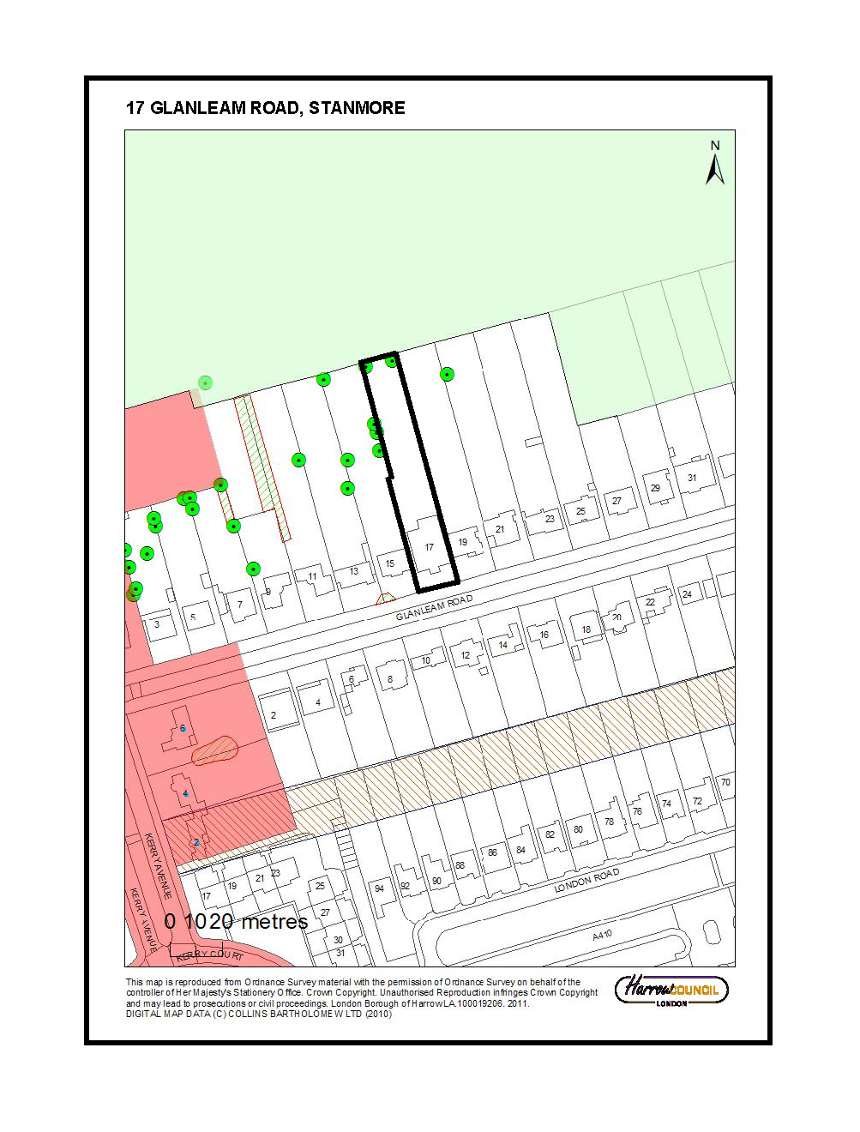

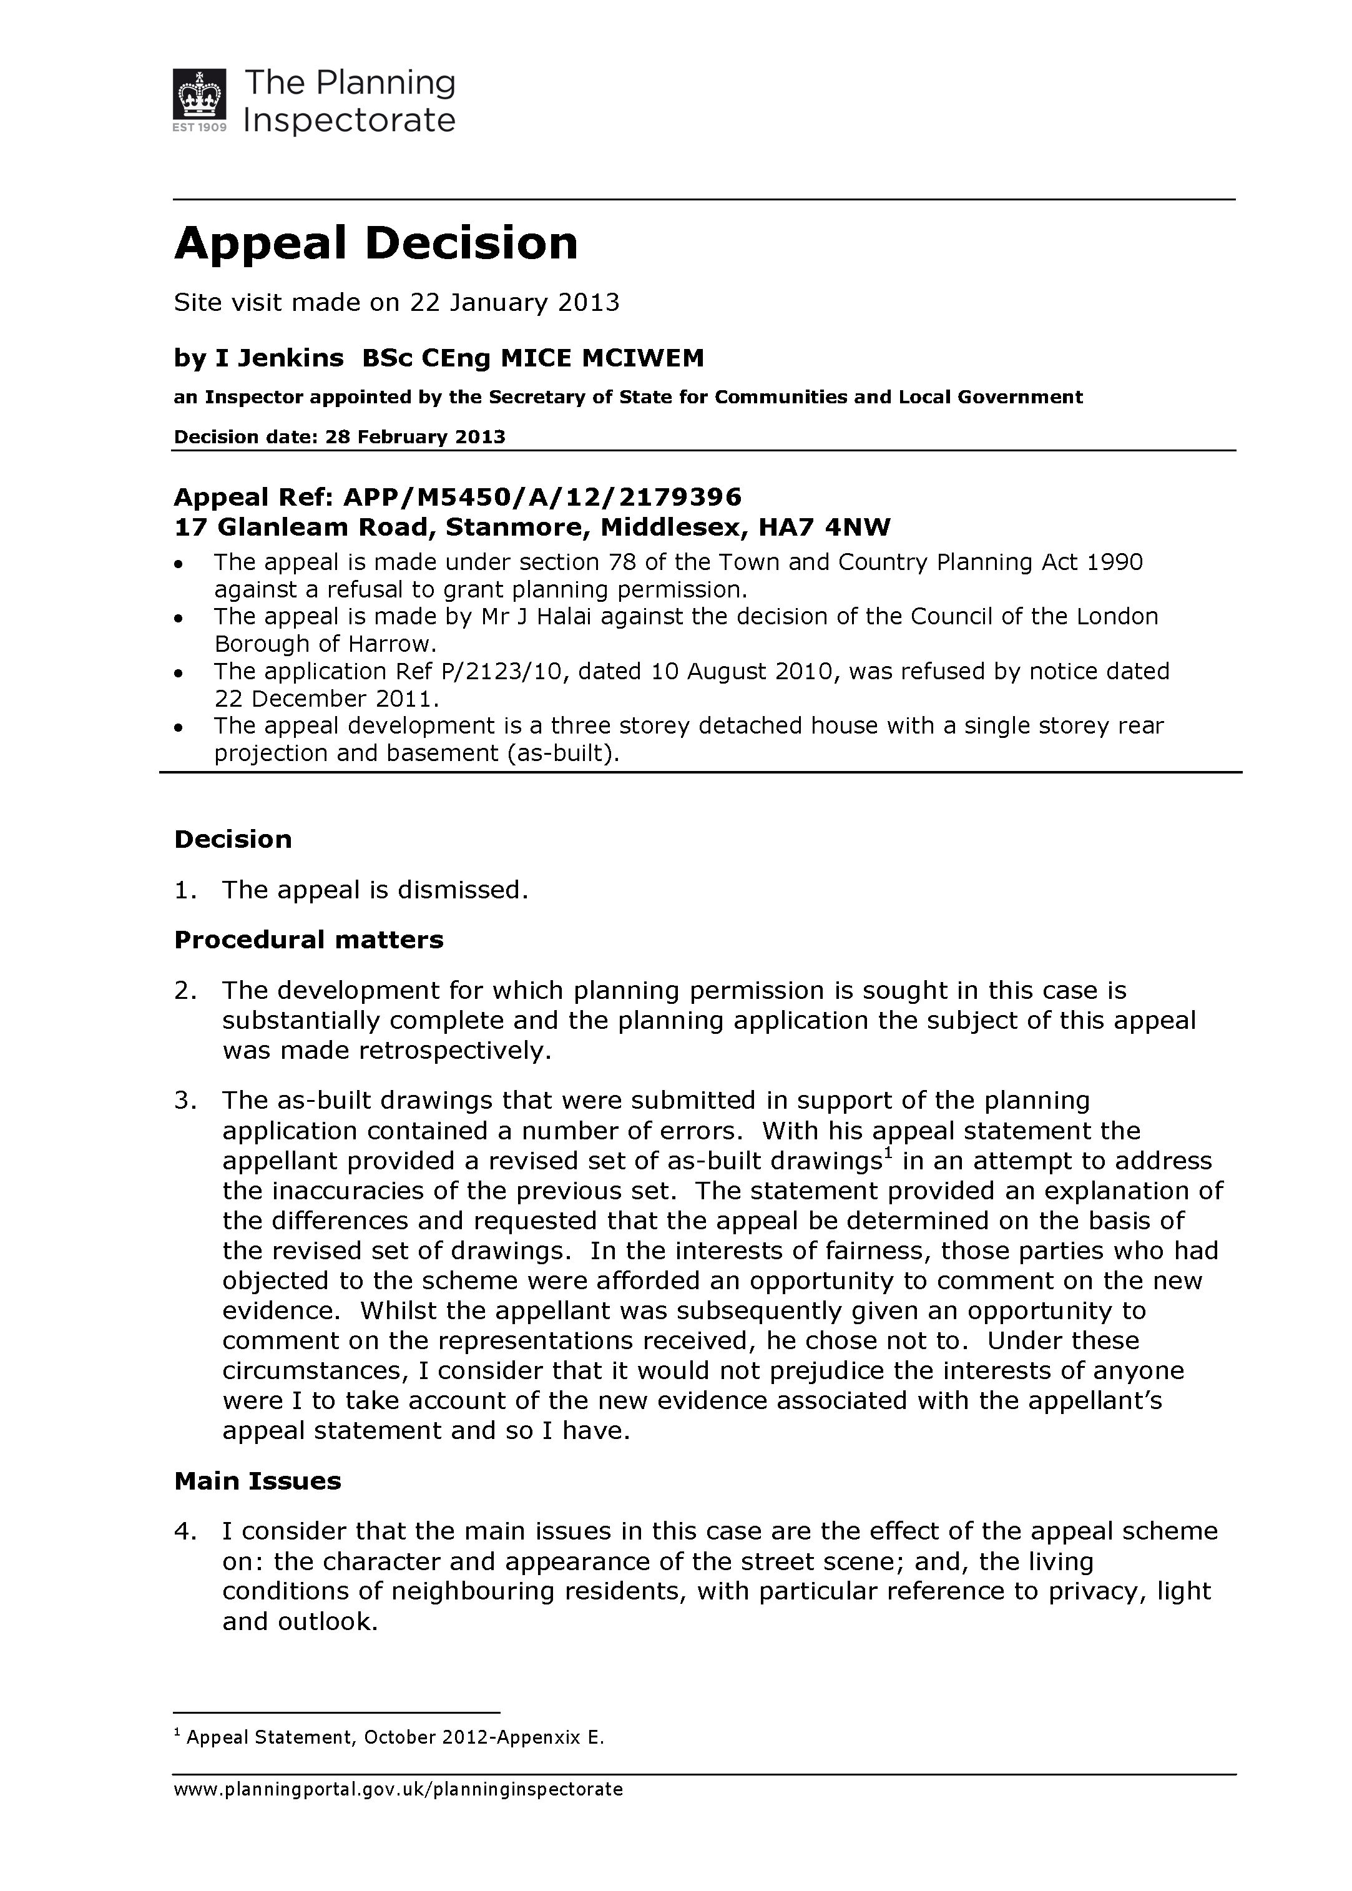
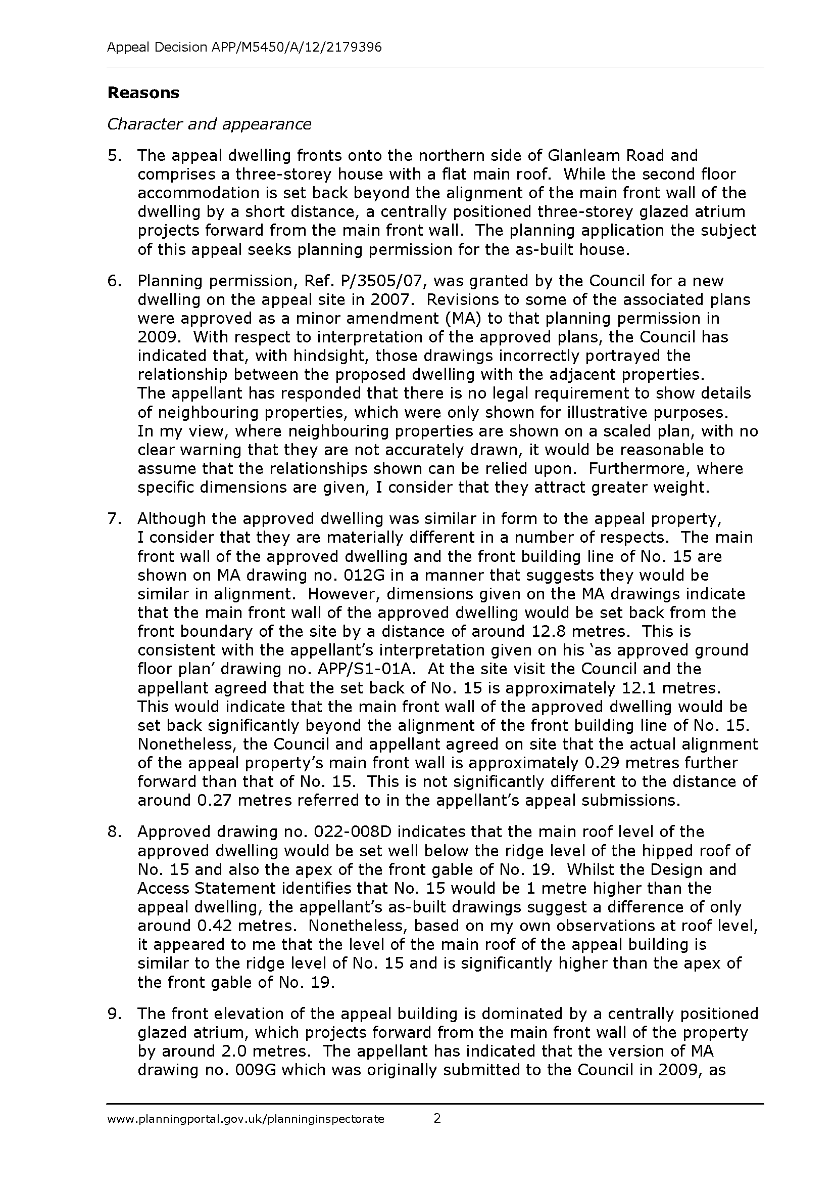
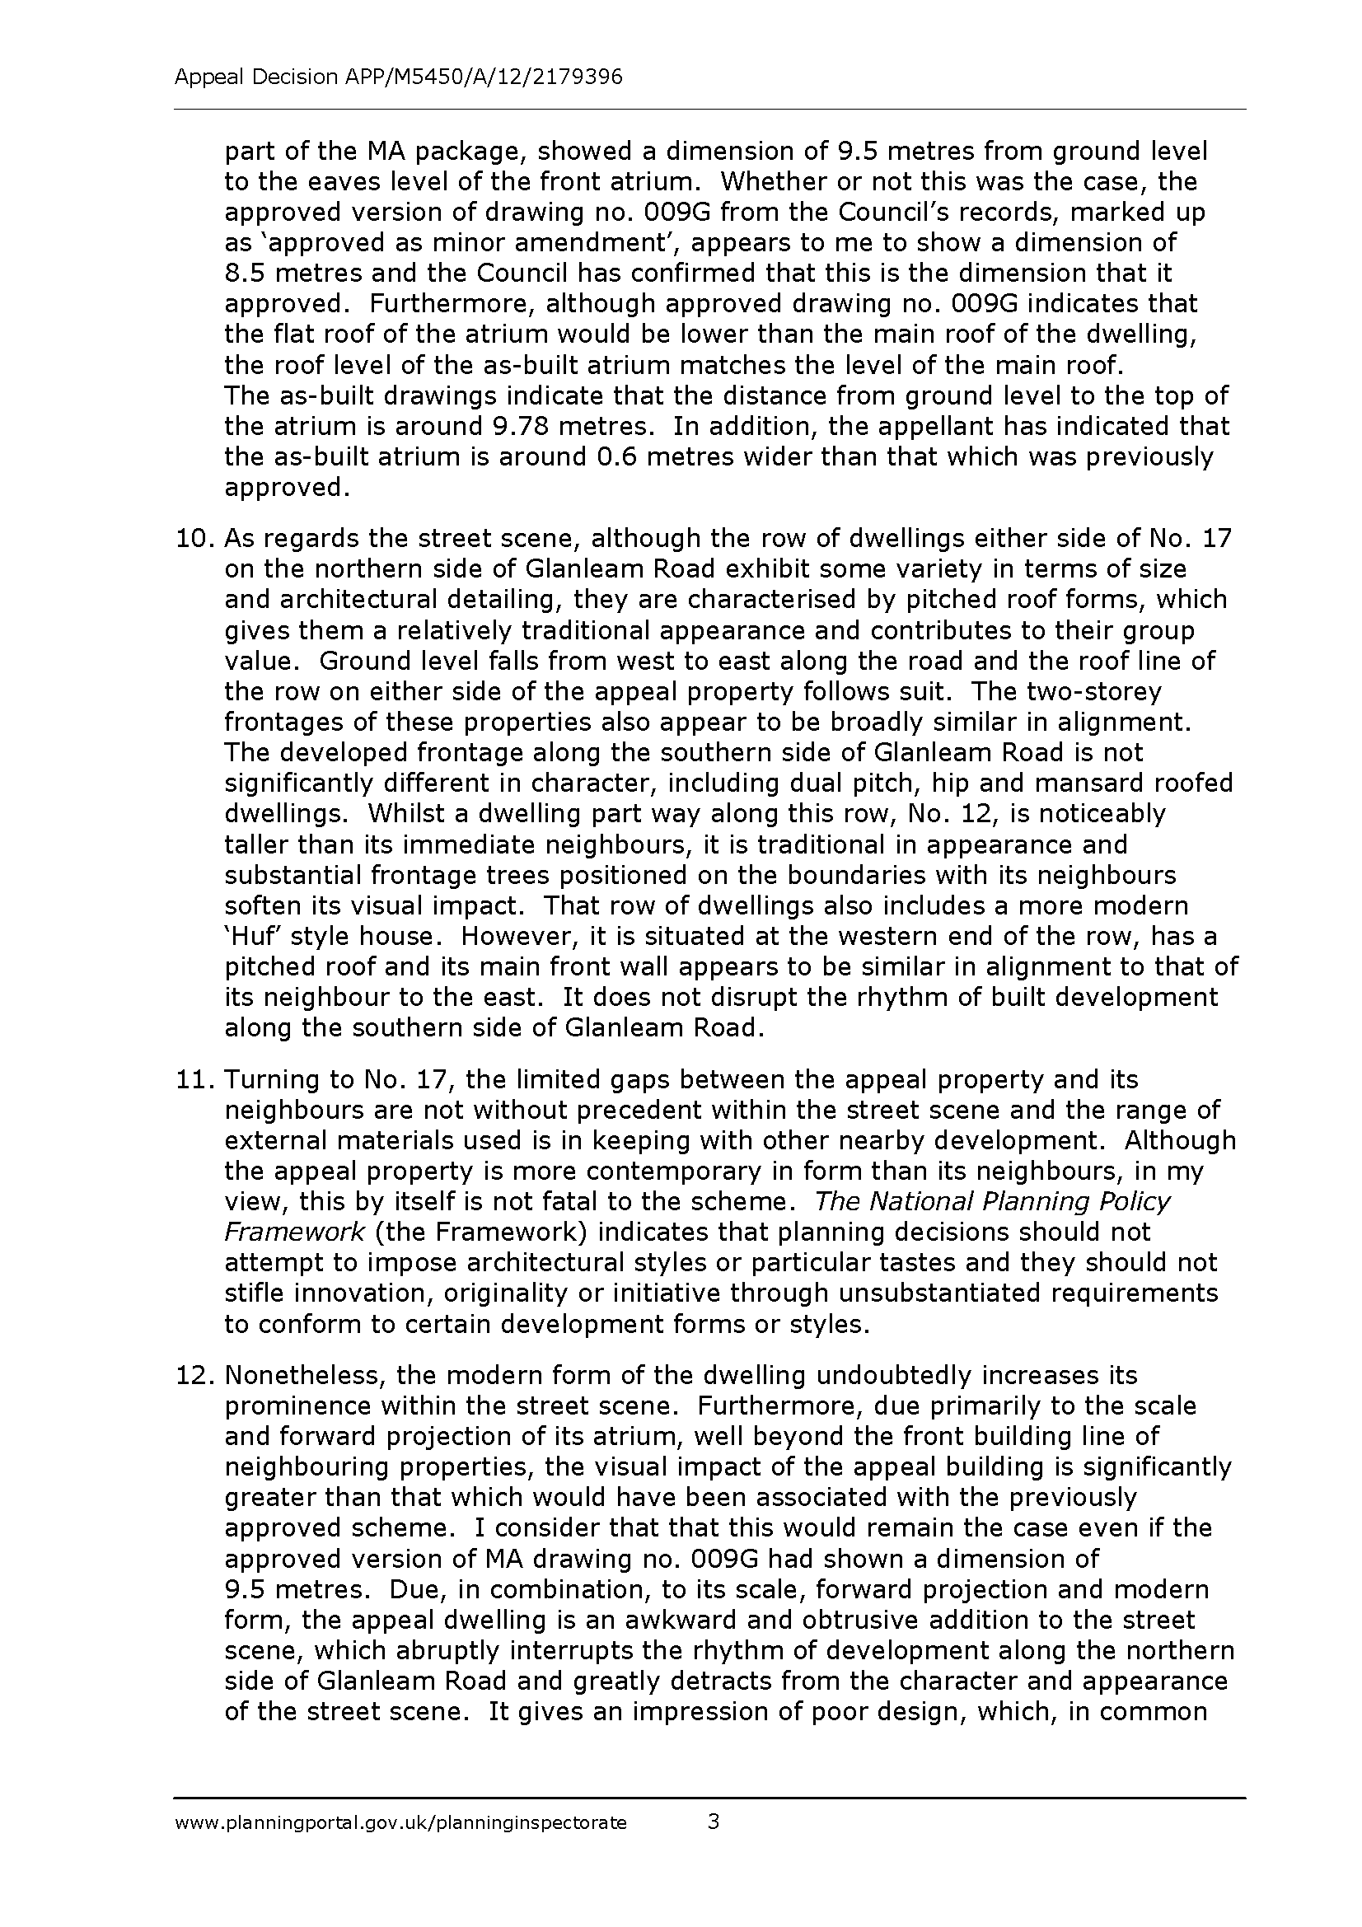
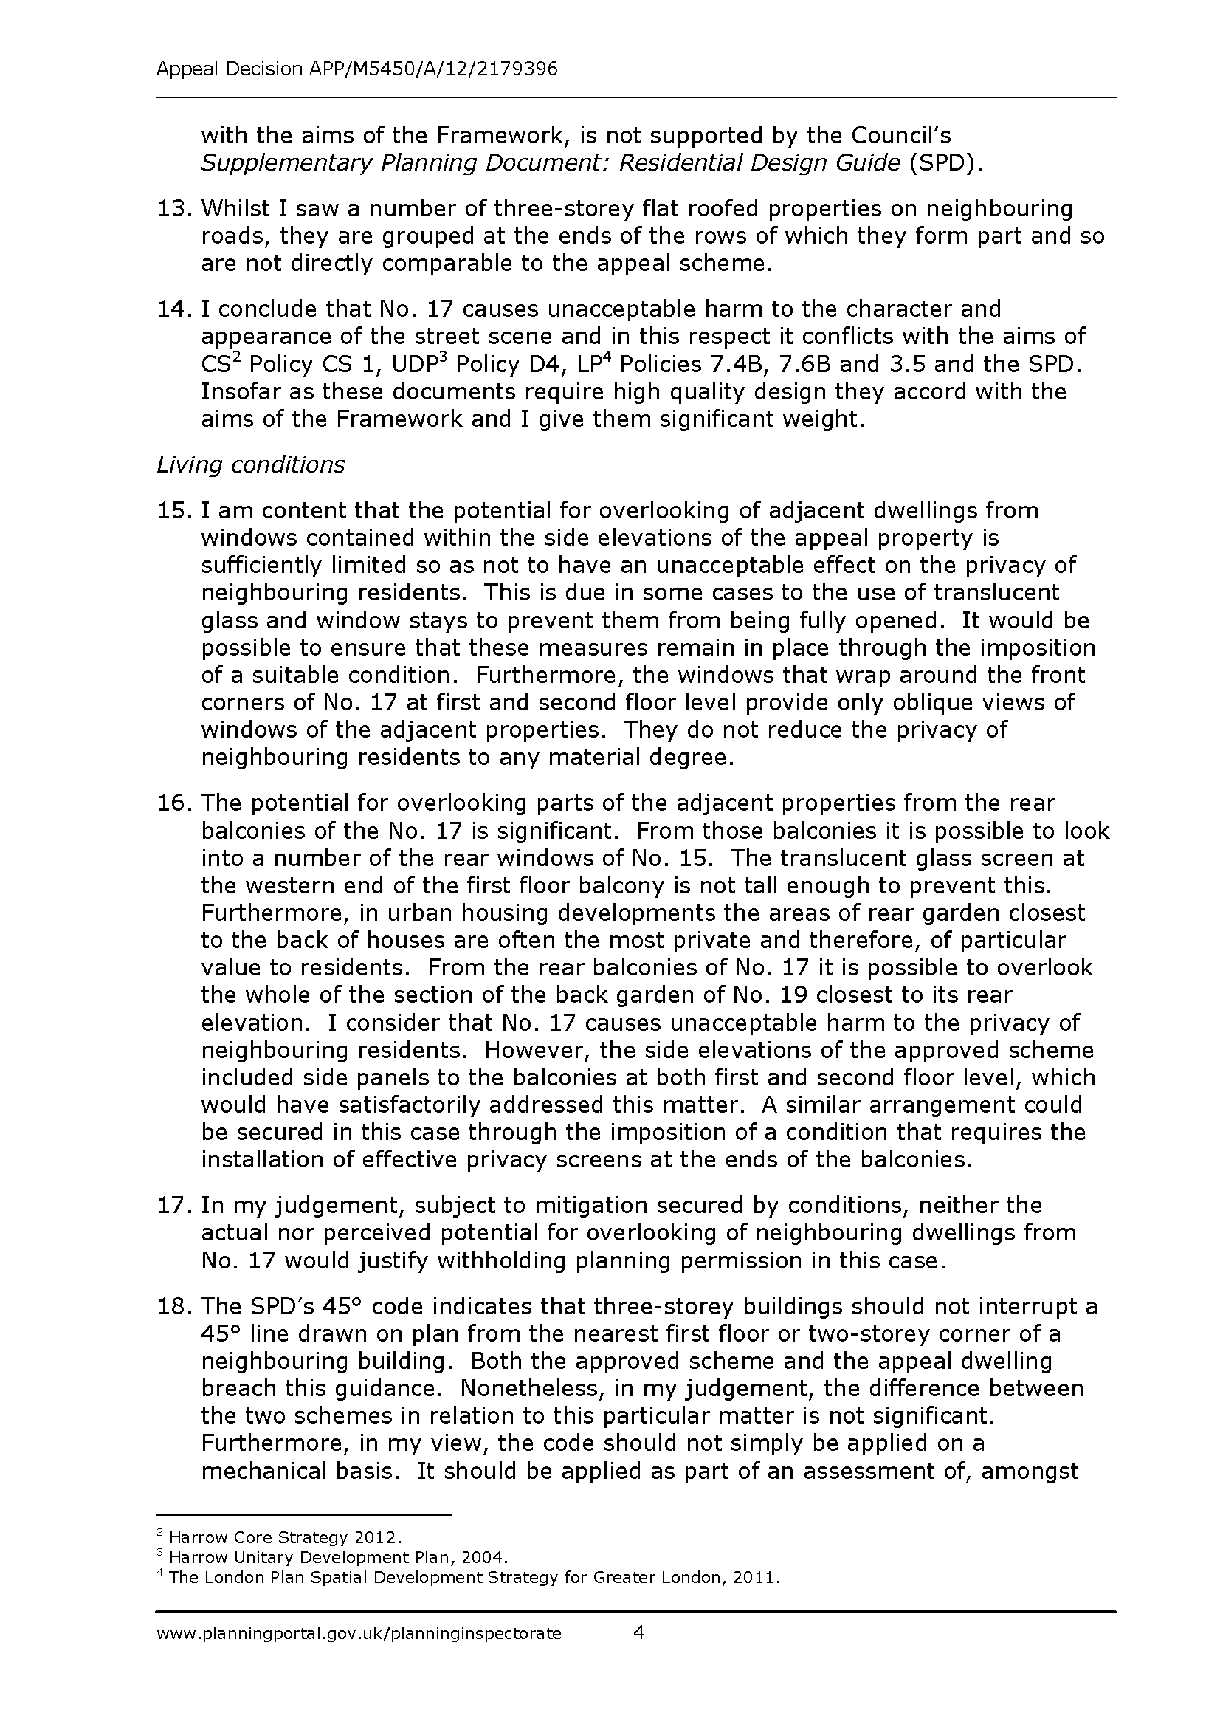
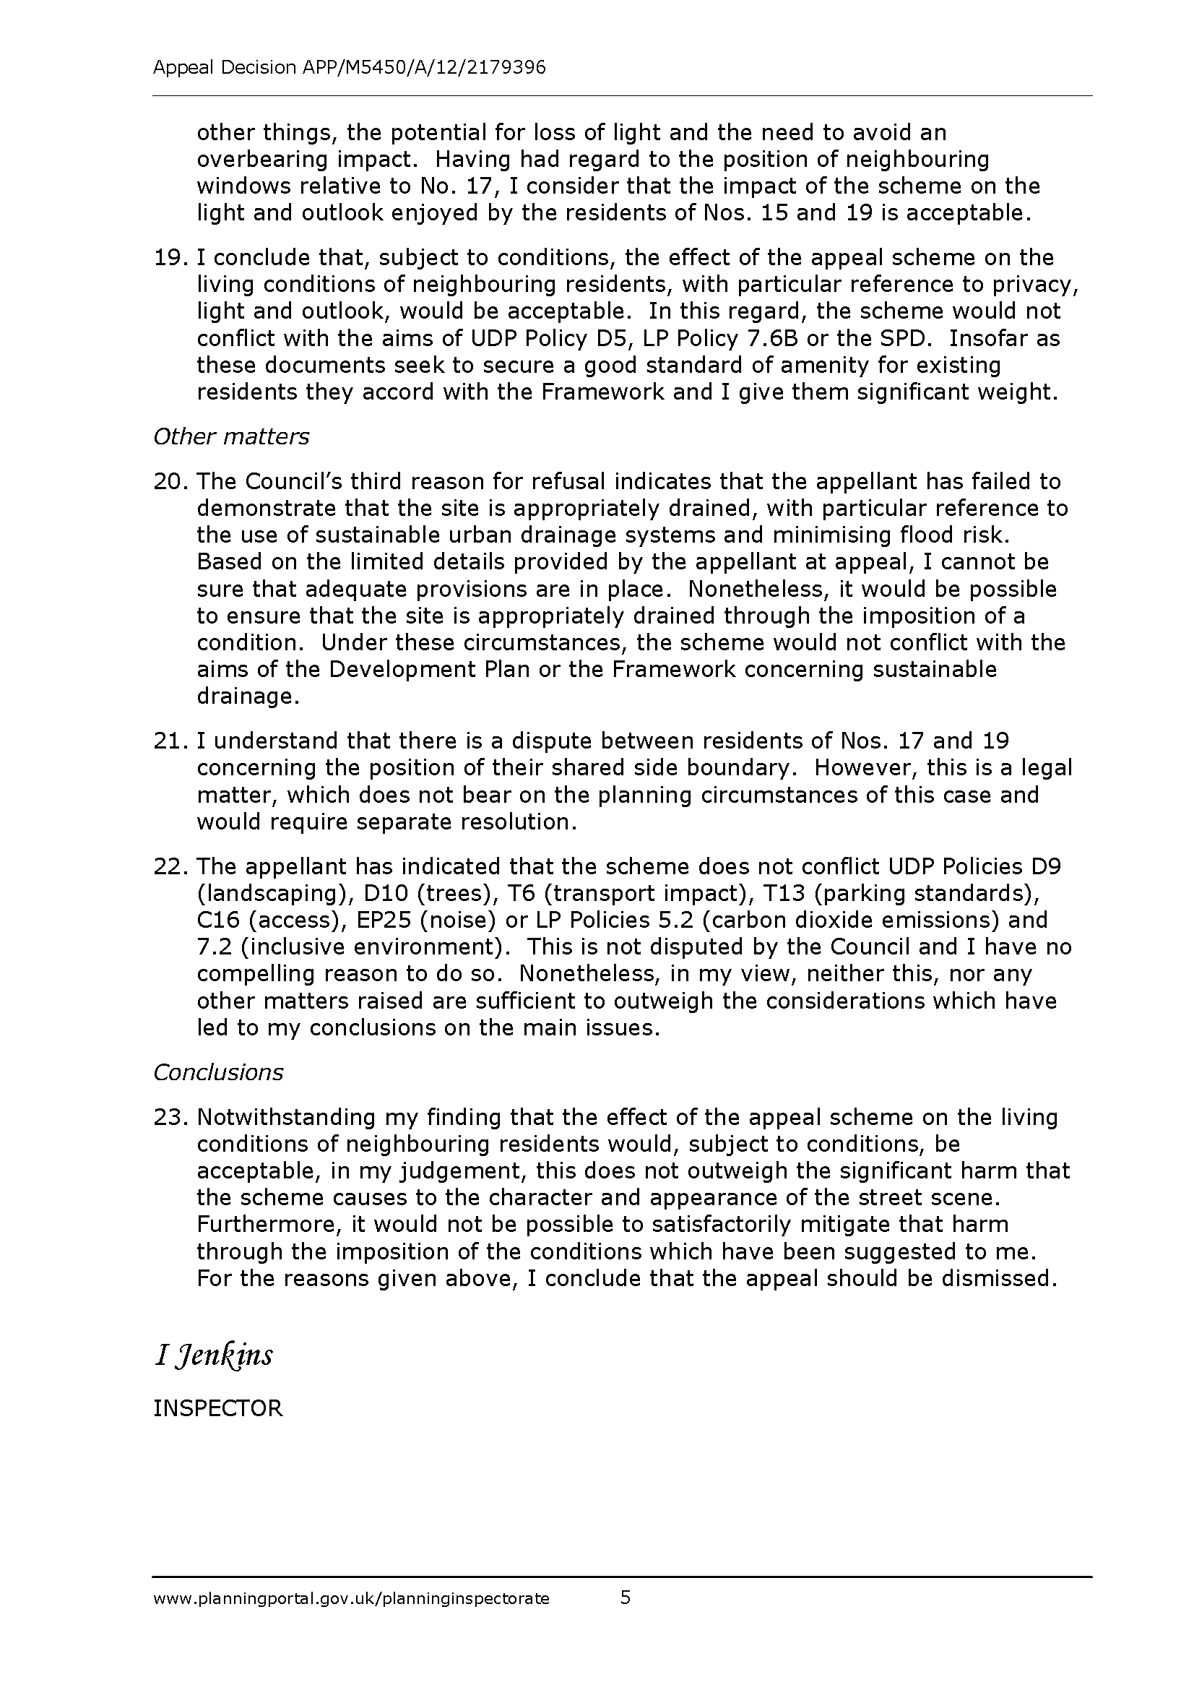

Item No: | 2/06
Address: | 5 CANONS CORNER, EDGWARE
Reference: | P/1614/13
Description: | CHANGE OF USE RETAIL TO RESTAURANT AND TAKE - AWAY (USE CLASS A1 TO USE CLASS A3/A5); INSTALLATION OF VENTILATION DUCTS AT REAR
Ward: | CANONS
Applicant: | MR MUHAMMAD SHAMI
Case Officer: | GERARD LIVETT
Expiry Date: | 09 DECEMBER 2013
RECOMMENDATION
GRANT planning permission subject to conditions:

INFORMATION
The application is reported to the Planning Committee at the request of a nominated member and is therefore excluded by proviso B from the Scheme of Delegation dated 29 May 2013.

Statutory Return Type: 20 – Change of Use
Council Interest: None
GLA Community Infrastructure Levy (CIL) Contribution (provisional): n/a
Harrow Community Infrastructure Levy (CIL) Contribution (provisional): n/a

Site Description
- Site is located within the Canons Corner neighbourhood parade, which comprises 10 retail units at ground floor level with residential units on the first and second floors above.
- The property on the site is a three-storey terraced property with retail use on the ground floor and residential accommodation on the floors above.
- The ground floor retail unit that is the subject of this application is currently vacant. The previous use was a delicatessen (A1 Use Class).
- The parade is a non-designated neighbourhood parade and is not within a Town Centre.
- The parade features a mix of shops which all fall within the A1 Use Class apart from an Estate Agents (A2).
- The opening times of the shops within the parade are varied. The earliest opening time observed was 06:00 Monday-Saturday and 07:00 Sunday. The latest closing time observed was 18:30 Monday-Wednesday, 19:00 Thursday and Friday, 18:30 Saturday and 14:00 Sunday.
- The parade fronts London Road, a London Distributor Road, with Canons Corner roundabout to the north-east. There is an A3/A5 use (McDonald’s) on the opposite site of the roundabout, within the Borough of Barnet,
- A service road runs to the rear of No.’s 1-5 Canons Corner.
- On the opposite site of the service road is a pair of semi-detached properties: 1B and 1C Court Drive. Beyond these are a number of residential roads and a block of flats, London House, which lies to the East.

Proposal Details
- Change of use of ground floor commercial premises from a shop (A1) to a restaurant (A3) and hot food takeaway (A5).
- The restaurant would have a capacity of 40 seated customers.
- Installation of two ventilation ducts at ground floor level at the rear. These would be fitted with a three-stage carbon filtration unit and external noise reduction units.
- Three new parking spaces and a rubbish/recycling store area would be provided at the rear of the site.
- The front access for customers would remain unchanged.

Revisions to Previous Proposal
Following the previous grant of planning permission (P/2412/12), the following changes have been made:
Application is now retrospective as the change of use has been implemented without complying with condition 9 which required details of fume extraction to be submitted and approved in writing by the local planning authority prior to the implementation of the change of use.
Details of fume extraction have been provided with this application.

Relevant History
HAR/7276/J - ERECT SHOP FRONT
Grant – 19/10/55

HAR/7276/M - ILLUMINATED FASCIA SIGN
Grant – 19/6/57

HAR/7276/O - ERECT DOMESTIC GARAGES
Refuse – 15/4/58

LBH/22399 - CHANGE OF USE TO RESTAURANT WITH TAKE-AWAY SERVICE,SINGLE STOREY REAR EXTENSION AND EXTRACTOR TRUNKING
Refuse 2/12/82

P/1435/09 - REPLACEMENT SINGLE STOREY REAR EXTENSION
Grant – 27/8/09

P/2142/12 – CHANGE OF USE RETAIL TO RESTAURANT AND TAKE - AWAY (USE CLASS A1 TO USE CLASS A3/A5); INSTALLATION OF VENTILATION DUCTS AT REAR
Granted – 28-Sep-2012

Pre-Application Discussion (Ref.)
None specific to this application

Applicant Submission Documents
- Design and Access Statement: Proposal is for change of use to provide restaurant and takeaway. Proposal includes an extraction system using three-stage carbon filters. Premises has a refuse storage area at the rear
- Noise Reports detailing noise from extract fans

Consultations
Environmental Health: No response received

Highways Authority: There are no specific concerns with this Change of Use from A1 to A3/A5 due to the location which is likely to contribute to linked trips to the site given the established use attractions in this shopping parade. As a result it is unlikely that given the scale of the proposal there would be a measurable change in use profile which would, in any event, be partly controlled by the stringent waiting restrictions in the area which promote parking restraint and use of sustainable transport. However there are on street parking provisions in the vicinity fronting this address which will allow for the opportunity for patrons visiting this and other uses within the parade to park as is the case at present. In summary, there is no objection

Notifications
Sent: 39
Replies: 60 objections, 36 in support
Expiry: 11-Nov-2013

Addresses Consulted
7 Partridge Close
Court Drive: Zero, 1b, 1c, 2, 5, 6, 8, 17, 20, 23, 26
Canons Corner: 3, 3a, 4, 4a, 5, 5a, 6, 6a, 7, 7a
Snaresbrook Drive: 3, 29
London House, Canons Corner: 26, 27
The Spinny: 1, 9, 14
London Road: 5, 11, 82
Brockley Close: 2, 8, 15
Stonegrove: 121
Regents Court, Stonegrove: 25
Dalkeith Grove: 2, 4
Please note: Addresses consulted include those who responded to the previous application

Summary of Responses
The following points of objection have been raised:
- Applicant has abandoned idea of running a restaurant and is fitting out the premises as a take away
- Odour from cooking smells
- Noise from extract fans
- Lack of trade is detrimental to amenities of neighbouring occupiers
- Loss of a retail unit
- Not healthy food
- Takeaway at No.2 Canons Corner refused
- Applicant is selling fried rather than grilled fish
- Nearby school with healthy eating policy not consulted

The following points of support have been raised:
- Support the proposal as there are many retail shops in the area. Applicant must be made to adhere to guidelines regarding fumes
- It will be a great business for the area subject to safeguards to protect residential amenity.

BACKGROUND INFORMATION

This application has been made as the applicant implemented the change of use before submitting details of the fume extraction system required by condition 9 of planning permission P/2142/12 dated 28-Sep-2012. Therefore, the principle of the change of use has been established.

With this application, the applicant has submitted details of the fume extraction, which is the primary consideration with this application.

APPRAISAL

Section 38(6) of the Planning and Compulsory Purchase Act 2004 requires that:

‘If regard is to be had to the Development Plan for the purpose of any determination to be made under the Planning Acts, the determination must be made in accordance with the Plan unless material considerations indicate otherwise.’

In this instance, the Development Plan comprises The London Plan 2011 [LP] and the Local Development Framework [LDF]. The LDF comprises The Harrow Core Strategy 2012 [CS], Harrow and Wealdstone Area Action Plan 2013 [AAP], the Development Management Policies Local Plan 2013 [DMP], the Site Allocations Local Plan [SALP] 2013 and Harrow Local Area Map 2013 [LAP].

On 11 October 2011, the Greater London Authority [GLA] published Revised Early Minor Alterations [REMA] to The London Plan 2011. From this date, the REMA are operative as formal alterations to The London Plan 2011 and therefore form part of the development plan for Harrow.

In relation to the policies of the LP which are relevant to this application, none have been altered since the application was submitted.

MAIN CONSIDERATIONS
Change of Use
Character and Appearance of the Area
Residential Amenity
Traffic, Refuse and Access
Equalities Statement
S17 Crime & Disorder Act
Consultation Responses

Change of Use
As noted in the ‘Background Information’ section above, the principle of the change of use at the premises has been established.

Since the previous grant of planning permission, the Harrow Development Management Policies Local Plan has been adopted.

The application site is located in a Neighbourhood Parade, to which policy DM38 applies. This policy notes that within non-designated parades the use of ground floor premises for purposes that are appropriate town centre, community and economic uses will be permitted provided the use would not be detrimental to the amenity of neighbouring occupiers or highway safety.

As with the previous application, it is considered that the use of suitable fume extraction facilities and limits on the hours of operation of the premises would be sufficient to safeguard the amenities of neighbouring occupiers. The Council’s Highway Authority considers that the proposal would have no significant impact in terms of highway safety.

A representation has been received noting that the applicant is currently fitting out the premises for exclusive A5 use. A site visit to the premises in November 2013 indicated that the premises was not trading, and there was no evidence that the restaurant layout as shown on the submitted drawings would not be provided. On the basis of the submitted drawings and documents, officers consider that the proposal is consistent with an A3 / A5 use. Notwithstanding this, there is no restriction in policy DM38 that would preclude consideration of an application for use of the premises as a take-away.

A representation has been received noting that the nature of the food to be prepared is misleading and that the fish would be fried and not grilled. The planning application is for the change of use to a restaurant / take away. A restriction on the type of food that could be prepared would be unreasonable and inappropriate.

It is noted that a recent High Court decision held that local planning authorities must have regard to the impact of a proposed takeaway on local schools. Mr Justice Cranston said that the London Borough of Tower Hamlets 'acted unlawfully' by not taking into consideration the proximity of a school with a healthy eating / healthy living policy to a proposed hot food take away. The High Court stated that proximity of a hot food takeaway to a school was capable of being a material consideration since it relates to the use of land.

The subject site is close to the London Academy secondary school. However, there is an existing, major restaurant/hot food takeaway (McDonald’s) in closer proximity to the school. It is considered, therefore, that the proposed restaurant/hot food takeaway facilities would not have a material impact on the availability of takeaway food around the school, and the conflict with the School’s health eating policy would not be a material consideration of sufficient weight to outweigh policy DM38 of the Development Management Policies Local Plan.

It is therefore considered that, subject to satisfying the criteria in relation to residential amenity and highways, the use is appropriate in this location.

Character and Appearance of the Area
The application proposes a number of physical alterations to the rear of the property, including the installation of two ventilation ducts at ground floor level, three new parking spaces and a rubbish/recycling store area. It is noted that the area to the rear of the subject unit is currently used for the storage of bins and containers and also for informal parking. The adjacent unit, currently in use as a butchers has an external ventilation unit at ground floor level. The proposed physical alterations would therefore be in keeping with the existing character to the rear of these commercial properties and are considered to be consistent with Core Policy CS1B of the Harrow Core Strategy (2012) and policy DM1 of the Harrow Development Management Policies Local Plan (2013).

Residential Amenity
Policy DM1 requires proposals for change of use to safeguard the amenities of neighbouring occupiers.

In assessing applications for changes of use to restaurant / take-away use, regard will be given to the proximity of residential properties, particularly flats above the premises, the hours of operation and arrangements for fume extraction, or any other plant or machinery.

To protect the amenity of the occupiers of surrounding residential properties, particularly those above the subject unit, it is considered reasonable to attach a condition to any grant of planning permission restricting the hours of opening to between the hours of 10:30 and 23:00. The subject premises is in the middle of a parade of commercial properties and is sited on a busy London Distributor Road. Furthermore, there are no other A3 or A5 uses within the parade so there would be no cumulative impact created. For these reasons, it is considered that the proposed use of the unit as a restaurant and takeaway during these hours of operation would be acceptable in amenity terms given the background noise and activity from traffic and pedestrians along London Road.

The proposed extract duct at the rear would be located 12m from the rear elevation of the residential properties above the unit and over 10m from the side boundary of the garden at 1B Court Drive. The comments in relation to odour from the property are noted. However, the use commenced before the details of the fume extract system were submitted, and the complaint relates to the period prior to the installation of the fume extraction system. Conditions have been attached to ensure that the proposal would not give rise to undue noise, disturbance, odour or fumes that would compromise the residential amenities of neighbouring occupiers.

The siting of the extract duct is such that it would minimise the impacts of any fumes which would be extracted as a result of the use and the extraction and ventilation systems would accord with current British standards and legislation relating to flues. The only ventilation machinery noted within the parade was on the adjacent butcher’s shop. Therefore, it is considered that one additional extract duct would not create an undue cumulative impact in terms of noise or odour. The Council’s Environmental Health Department has not objected to the principle of the development. With the previous application, conditions requiring details of measures to minimise noise from the extract duct and for the continued maintenance of the duct were required in order to comply with noise level requirements. Similar conditions have been attached to this recommendation.

For these reasons, the proposal is considered to be consistent with policy DM1 of the Harrow Development Management Policies Local Plan (2013).

Traffic, Refuse and Access
The Council’s Highways Authority has no objection to the proposal as the location is likely to contribute to linked trips to the site, due to the other commercial uses within the parade. Given the scale of the proposal, it is unlikely that there would be a measurable change in traffic generation or cars parked in the locality, which would, in any event, be partly controlled by the stringent waiting restrictions in the area which promote parking restraint and use of sustainable transport. Notwithstanding this, there are on-street parking provisions in the vicinity fronting the site which allow patrons visiting this and other uses within the parade to park. For these reasons, the proposal is considered to comply with policy DM42 of the Harrow Development Management Policies Local Plan (2013).

Refuse storage would be provided within the site boundary at the rear of the site and refuse collections made via the service / access road, as with the previous use. It is considered that this refuse arrangement would ensure that the premises can be adequately serviced without causing harm to highway safety and convenience, in accordance with saved policies DM44 of the Harrow Development Management Policies Local Plan (2013).

The unit was previously open to members of the public and would be able to provide a level entrance in accordance with saved policy DM2 of the Harrow Development Management Policies Local Plan (2013) and policies 7.2 and 7.6 of the London Plan (2011).

Equalities Statement
Section 149 of the Equalities Act 2010 created the public sector equality duty.
Section149 states:-
(1) A public authority must, in the exercise of its functions, have due regard to
the need to:
(a) eliminate discrimination, harassment, victimisation and any other conduct
that is prohibited by or under this Act;
(b) advance equality of opportunity between persons who share a relevant
protected characteristic and persons who do not share it;
(c) foster good relations between persons who share a relevant protected characteristic and persons who do not share it.

When making policy decisions, the Council must take account of the equality duty and in particular any potential impact on protected groups.

On balance, it is considered that the proposal would have no impact with regard to section 149 of the Equalities Act 2010.

S17 Crime & Disorder Act
The development does not have any material impact with respect to this legislation.

Consultation Responses
Applicant has abandoned idea of running a restaurant and is fitting out the premises as a take away – This has been addressed in the ‘Change of Use’ section of the appraisal’
Odour from cooking smells – This has been addressed in the ‘Residential Amenity’ section of the appraisal
Noise from extract fans – the extract fans comply with the required standards
Lack of trade is detrimental to amenities of neighbouring occupiers – the proposal would allow the premises to re-open
Loss of a retail unit – This has been addressed in the ‘Change of Use’ section of the appraisal’
Not healthy food – This has been addressed in the ‘Change of Use’ section of the appraisal’
Takeaway at No.2 Canons Corner refused – planning policies have changed since that application was refused in 2003
Applicant is selling fried rather than grilled fish – This has been addressed in the ‘Change of Use’ section of the appraisal’
Nearby school with healthy eating policy not consulted – The Council has no statutory duty to consult the school, and this matter has been considered in the ‘Change of Use’ section of the appraisal’

CONCLUSION
The proposed change of use of the subject unit from an A1 shop to an A3 restaurant and A5 hot food takeaway is considered to be an appropriate use for the premises. The proposal would harmonise with the character and appearance of the area and subject to the conditions attached, would not have an undue impact on residential amenity or raise any significant issues in relation to traffic, parking, refuse, storage and disposal or accessibility.

For all the reasons considered above, and weighing up the development plan policies and proposals, and other material considerations including comments received in response to notification and consultation as set out above, this application is recommended for grant.

CONDITIONS
1 The development hereby permitted shall be begun before the expiration of three years from the date of this permission.
REASON: To comply with the provisions of Section 91 of the Town and Country Planning Act 1990.

2 The use hereby permitted shall not be open to customers outside the following times:-
- 10.30 hours to 23.00 hours, Monday to Saturday inclusive
- 10.30 hours to 22.30 hours on Sundays
without the prior written permission of the local planning authority.
REASON: To safeguard the amenity of neighbouring residents in accordance with policy DM1 of the Harrow Development Management Policies Local Plan (2013).

3 The level of noise emitted from the new extract duct shall be lower than the existing background level by at least 10 LpA. Noise levels shall be determined at one metre from the window of the nearest noise sensitive premises. The measurements and assessments shall be made in accordance with B.S. 4142. The background noise level shall be expressed as the lowest LA90. Following installation but before the new extract duct comes into operation a report demonstrating compliance with the above condition must be submitted to and approved in writing by the Local Planning Authority before the extract duct comes into operation.
REASON: To ensure that the proposed development does not give rise to noise and odour / fume nuisance to neighbouring residents in accordance with policy DM1 of the Harrow Development Management Policies Local Plan (2013).

4 All constituent parts of the new extract duct shall be maintained and replaced in whole or in part as often as required to ensure compliance with the noise levels approved by the Local Planning Authority.
REASON: To ensure that the proposed development does not give rise to noise and odour / fume nuisance to neighbouring residents in accordance with policy DM1 of the Harrow Development Management Policies Local Plan (2013).

5 Any plant and machinery, including that for fume extraction, ventilation, refrigeration and air conditioning, which may be used by reason of granting this permission, shall be so installed, used and thereafter retained as to prevent the transmission of noise, vibration, and odour / fume into any neighbouring premises.
REASON: To ensure that the proposed development does not give rise to noise and odour / fume nuisance to neighbouring residents in accordance with policy DM1 of the Harrow Development Management Policies Local Plan (2013).

6 The refuse bins shall be stored at all times, other than on collection days, in the designated refuse storage area, as shown on the approved drawing.
REASON: to safeguard the appearance of the locality and to comply with saved policy DM1 of the Harrow Development Management Policies Local Plan (2013).

7 The development hereby permitted shall be carried out in accordance with the following approved plans:
JC-LC-EP, JC-LC-EE, JC-LC-FE, Design and Access Statement, Noise Report by Northern Fan supplies dated 8 October 2013; Noise report regarding Standard Circular Silencer Insertion Loss Data
REASON: For the avoidance of doubt and in the interests of proper planning.

8 Deliveries to the premises shall not take place on Sundays or Bank/Public Holidays. Deliveries to the premises shall only take place between the following hours on the following days:
- 07:00 to 21:00 Mondays to Fridays
- 08:00 to 18:00 Saturdays.
REASON: To safeguard neighbouring occupiers from undue levels of noise and disturbance, thereby according with saved policy EM25 Harrow Unitary Development Plan 2004.

INFORMATIVES
1 THE FOLLOWING POLICIES ARE RELEVANT TO THIS DECISION

National Planning Policy Framework (2012)

The London Plan (2011)
7.2 An inclusive environment
7.3 Designing out crime
7.4 Local character
7.6 Architecture
7.15 Reducing noise and enhancing soundscapes

Harrow Core Strategy (2012)
Policy CS1, CS7

Harrow Development Management Policies Local Plan (2013)
DM1 Achieving a high standard of development
DM2 Achieving lifetime neighbourhoods
DM38 Other town centre frontages and neighbourhood parades
DM42 Parking standards
DM44 Servicing

Supplementary Planning Document: Access for All (2006)

2 CONSIDERATE CONTRACTOR CODE OF PRACTICE
The applicant's attention is drawn to the requirements in the attached Considerate Contractor Code of Practice, in the interests of minimising any adverse effects arising from building operations, and in particular the limitations on hours of working.

3 PARTY WALL ACT:
The Party Wall etc. Act 1996 requires a building owner to notify and obtain formal agreement from adjoining owner(s) where the building owner intends to carry out building work which involves:
1. work on an existing wall shared with another property;
2. building on the boundary with a neighbouring property;
3. excavating near a neighbouring building,
and that work falls within the scope of the Act.
Procedures under this Act are quite separate from the need for planning permission or building regulations approval.
“The Party Wall etc. Act 1996: Explanatory booklet” is available free of charge from:
Communities and Local Government Publications, PO Box 236, Wetherby, LS23 7NB
Please quote Product code: 02 BR 00862 when ordering
Also available for download from the CLG website:
http://www.communities.gov.uk/documents/planningandbuilding/pdf/133214.pdf
Tel: 0870 1226 236 Fax: 0870 1226 237
Textphone: 0870 1207 405
E-mail: communities@twoten.com
4 COMPLIANCE WITH PLANNING CONDITIONS
IMPORTANT: Compliance With Planning Conditions Requiring Submission and Approval of Details Before Development Commences
- You will be in breach of planning permission if you start development without complying with a condition requiring you to do something before you start. For example, that a scheme or details of the development must first be approved by the Local Planning Authority.
- Carrying out works in breach of such a condition will not satisfy the requirement to commence the development within the time permitted.
- Beginning development in breach of a planning condition will invalidate your planning permission.
- If you require confirmation as to whether the works you have carried out are acceptable, then you should apply to the Local Planning Authority for a certificate of lawfulness.

5 LITTER BIN OUTSIDE PREMISES
INFORMATIVE: the applicant is requested to liaise with the Council’s Highways Enforcement Section with regard to the provision of an additional litter bin, or appropriate alternative, outside the premises. The applicant is asked to ensure that this is emptied at regular intervals and that the Public Highway outside the premises is kept litter-free, preferably through regular litter-picking patrols.

6 INFORMATIVE:
The applicant is informed that additional toilet facilities for staff and customers are likely to be required under Environmental Health legislation. Please contact this department for more information.

Plan Nos: JC-LC-EP, JC-LC-EE, JC-LC-FE, Design and Access Statement, Noise Report by Northern Fan supplies dated 8 October 2013; Noise report regarding Standard Circular Silencer Insertion Loss Data.

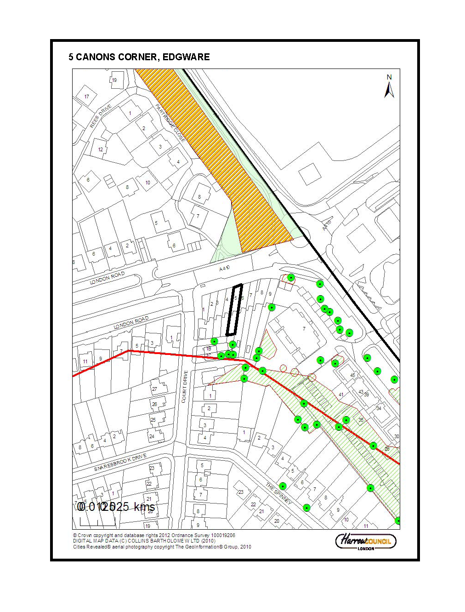

Item No: | 2/07
Address: | WHITMORE HIGH SCHOOL, PORLOCK AVENUE, HARROW
Reference: | P/3088/13
Description: | CONSTRUCTION OF TWO STOREY CLASSROOM 6TH FORM BLOCK WITHIN COURTYARD
Ward: | HARROW ON THE HILL
Applicant: | MS S HAMMOND
Agent: | HOWARD FAIRBAIRN MHK
Case Officer: | SARAH MACAVOY
Expiry Date: | 03/12/2013
RECOMMENDATION
The decision to GRANT permission for the new sixth form block has been taken having regard to all relevant material considerations including the impact on the character of the area and neighbouring amenity and for other matters including any comments received in response to publicity and consultation, All matters have been considered with regard to the policies and proposals in the London Plan, the Harrow Core Strategy (2012) and the Harrow Development Management Policies Local Plan (2013) Plan.

INFORMATION
The application is reported to the Planning Committee because Whitmore High School is a Council owned site. The application therefore falls outside of category C of the Scheme of Delegation dated 29th May 2013.

Statutory Return Type: Minor Other
Council Interest: Council owned site
Net additional Floorspace: 1080 sqm
GLA Community Infrastructure Levy (CIL) Contribution (provisional): N/A
Harrow CIL: N/A

Site Description
- The site is a school on a large triangular site to the north of Porlock Avenue, to the
- south of Whitmore Road, and to the east of Shaftesbury Avenue.
- The school is comprised of a two and three-storey building to the east of the site
- incorporating classrooms, library, kitchen and dining facilities, main hall, sports hall,
- and a fitness centre.
- A variety of outdoor space is provided, including multi-purpose tennis/netball courts, a
- multi-purpose football pitch and athletics track, and open and covered play space.
- The main access to the site is off Porlock Avenue and a second, emergency access
- runs along the eastern boundary.
- To the south west of the site is an electricity substation and McDonald’s restaurant to
- the west and north are residential dwellings.
- To the south (on the opposite side of Porlock Avenue) are residential dwellings, and
- more dwellings lie to the east.
- The School is located opposite the Metropolitan Open Land relating to Harrow School
- playing fields.

Proposal Details
- The proposed new building would be used by the 6th form at Whitmore High School.
- It would have a maximum width of 37m and a maximum depth of 17.6m.
- It would be two storeys high and would have a flat roof with a height of 12m.
- The new building would be located in the courtyard and would almost enclose the existing school building.
- The new building would be constructed using similar materials as the existing school building on the site.
- It would accommodate 6 classrooms, an office, WC facilities and a study and social area.

Revisions to Previous Application
- N/A

Relevant History
LBH/43521 - Application under regulation 4(5) of the town and country planning regulations 1976: three tennis courts with 10m high floodlighting
Granted - 05-Nov-1991

P/0892/08COU - Outline: redevelopment to provide new two and three storey building along with indoor and outdoor sports and recreational facilities, internal roads and footpaths, access and parking, and ancillary facilities
Granted - 23-May-08

P/0392/10 -Variation to conditions 4, 6, 9, 13, 17, 19, 20 and 21 of outline planning permission ref: P/0892/08 dated 23 may 2008 for redevelopment to provide new two and three-storey
building along with indoor and outdoor sports and recreational facilities, internal roads and
footpaths, access and parking, and ancillary facilities.
Granted - 27-Apr-2010

P/0458/10 - Revisions to vehicular and pedestrian access off Porlock Avenue of application ref: P/0892/08/cou dated 23/5/2008 for 'outline: redevelopment to provide new two and three storey building along with indoor and outdoor sports and recreational facilities, internal
roads and footpaths, access and parking, and ancillary
facilities'.
Granted – 21-Jun-2010

P/1159/10 - Variation to condition 16 of planning permission ref: p/0892/08 dated 23.05.2008 for 'outline: redevelopment to provide new two and three storey building along with indoor
and outdoor sports and recreational facilities, internal roads and footpaths, access and
parking, and ancillary facilities' to allow revisions to car parking layout and the
implementation of the revised layout prior to the occupation of the development
Granted – 15-Jun-2010

P/3389/10 - Variation of condition 23 attached to outline permission p/0892/08cou dated 23/05/2008 to allow an extension of opening hours of the site for community purposes until 2300 on Fridays and Saturdays
Granted - 22-Mar-2011

P/1243/11 - Non-material amendment to planning permission p/0892/08cou dated 23/05/2008 to reinstate the area allocated for a sports pitch at rear with an artificial playing surface
Approved - 16-Jun-2011

P/0063/12 - Installation Of 8 X 10M High Lighting Columns To Provide Floodlighting To Tennis Courts And 6 X 14M High Lighting Column To Provide Floodlighting To Multi Use Games Area
Refused – 16/7/12
Allowed at Appeal.

Pre-Application Discussion
- N/A

Applicant Submission Documents
The submitted Design and Access Statement can be summarised as follows:
- Erection of a 2 storey teaching block at Whitmore High School.
- The proposed block is to be erected within the courtyard of the existing school. Although it will be separated from the existing buildings it is to be an extension of the present uses.
- The sixth form spaces need to be re-evaluated. The new block will accommodate a sixth form area, combining study and social functions and include a base for the Sixth form Mentor thereby using their space more efficiently and 3 smaller tutorial classrooms plus a Faculty Office for one of the new vocational courses and ancillary facilities.
- The separation officers the Sixth Form its own identity.
- It is stressed that the School’s published admission number is not changing.

Consultations
Drainage Engineer: No Objection

Advertisement
N/A

1st Notification
Sent: 140
Replies: 1 (in support)
Expiry: 13-Nov-2013
Summary of Responses
- No fundamental objection to the proposal. However we ask that serious consideration to the main vehicular access route in and out of the building site to the new proposed two storey 6th form block.
- Noise and pollution nuisance will undoubtedly affect us more than any other residential property surrounding the whole of the entire school site. We ask that due consideration be given to us throughout the build.
- We ask that the entrance to the site and the slip road immediately beside our house be completely reinstated as it is of now, at the completion of the new build. This will of course include item 1/02:P/0458/10 of the June 2010 Planning Committee consent to the rebuild of Whitmore High School “the vehicular access between the School House and Millook (House) will be closed to school traffic and will serve the School House garage only”.
- We ask that the slip road and pedestrian path beside the caretakers house and the mature landscaping beside Millook House be reinstated as of present and that any damage caused to the street verges and driveways outside Milook House and the Caretaker’s House be reinstated as of now. We ask that photographs be taken of the entire slip road are prior to commencement of “Keepmoat” moving onto the site.

APPRAISAL

Section 38(6) of the Planning and Compulsory Purchase Act 2004 requires that:

‘If regard is to be had to the Development Plan for the purpose of any determination to be made under the Planning Acts, the determination must be made in accordance with the Plan unless material considerations indicate otherwise.’

The Government has issued the National Planning Policy Framework [NPPF] which consolidates national planning policy and is a material consideration in the determination of this application.

In this instance, the Development Plan comprises The London Plan 2011 [LP] and the Local Development Framework [LDF]. The LDF comprises The Harrow Core Strategy 2012 [CS], Harrow and Wealdstone Area Action Plan 2013 [AAP], the Development Management Policies Local Plan 2013 [DMP], the Site Allocations Local Plan [SALP] 2013 and Harrow Local Area Map 2013 [LAP].

Revised Early Minor Alterations [REMA] to The London Plan 2011
On 11 October 2011, the Greater London Authority [GLA] published Revised Early Minor Alterations [REMA] to The London Plan 2011. From this date, the REMA are operative as formal alterations to The London Plan 2011 and therefore form part of the development plan for Harrow.

In relation to the policies of the LP which are relevant to this application, only policies 3.19 (Sports Facilities), 5.12 (Flood Risk), 5.13 (Sustainable Drainage) and 7.17 Metropolitan Open Land have been altered since the application was reported to the Planning Committee agenda on 16 October 2013. Officers consider that the content of the alterations to this policies do not materially alter the conclusions of the report on the agenda. No alterations to the conclusions in the report on the agenda in relation to sports facilities, flood risk or Metropolitan Open Land, the overall conclusions or the reported conditions are therefore suggested.

MAIN CONSIDERATIONS
Principle of Development
Policy DM 46 of the Development Management Policies Local Plan states that proposals for the provision of new community, sport and educational facilities will be supported where:
- They are located within the community that they are intended to serve.
- Subject to (a) they are safe and located in an area of good public transport accessibility or in town centres.
- There would be no adverse impact on residential amenity or highway safety.

A dedicated 6th form block is necessary for the school to be used to its full potential. The proposal would see suitable facilities for sole use of the 6th form being constructed. The proposal would not involve an increase in pupil numbers. Whitmore High School is located on a bus route and is considered to have a good level of public transport accessibility. The proposal would have no undue impact on residential amenity or highway safety as discussed in the paragraphs below. As such, the principle of the development is considered to be acceptable and in accordance with Development Management Policies Local Plan (2013) - Policy DM46.
Character of the Area and Impact on the Adjacent Metropolitan Open Land
Policy 7.4 of the London Plan (2011) requires development to have regard to the form, function and structure of an area, place or street and the scale, mass and orientation of surrounding buildings. Policy 7.6 of the London Plan (2011) requires buildings to make a positive contribution to a coherent public realm, streetscape and wider cityscape.

Policy DM1 of the Development Management Policies Local Plan seeks to ensure a high standard of development.

The proposal would be in keeping with the character, form and design of the existing school building. It would be located in between the existing two wings of the existing school building, enclosing most of the school building which would give the appearance of the building being complete in its design. Particularly as the proposed materials would match those used on the main school building. Its two storey design would ensure that it would be subordinate to the existing three storey school building.

Some additional planting is proposed in a planter. Notwithstanding these details, a landscaping condition has been placed on this application requesting plant species, sizes and locations to ensure that the proposal would have an acceptable impact on the character of the area.

It is considered that the proposed new sixth form block would be in keeping with the character of the site and would have no undue impact on the character of the area in accordance with the NPPF (2012), Harrow Core Strategy (2012) CS1.B, policies 7.4.B and 7.6.B of The London Plan and the Development Management Policies Local Plan (2013) - Policy DM1.

Whitmore High School is located opposite to the MOL relating to Harrow School playing fields. However, the location of the new building is considered to be located a sufficient distance away from the MOL to ensure that the proposal would have no undue impact on the MOL. In addition, the existing school building would screen the proposal from the MOL. As such, it is considered that the openness of the MOL would be maintained. Therefore, it is considered that there would be no undue impact on the MOL as a result of the proposals in accordance with London Plan policy 7.17 and Development Management Policy DM16.

Residential Amenity
The proposal would not be sited any closer to the property boundaries that the existing school building. There would be a minimum separation distance of approximately 10m from the proposed new building to the garden boundaries with the properties adjoining the site along Whitmore Road. These separation distances are considered to be acceptable and would sufficiently mitigate any undue impact in terms of overlooking, loss of light or loss of outlook onto these neighbouring properties. In addition, the windows to the north would be high level.

It is considered the proposal would not have an adverse impact on the residential amenities of adjoining occupiers in accordance with London Plan policy 7.6B and Development Management Policies Local Plan (2013) - Policy DM1 and would therefore have an acceptable impact on neighbouring amenity.

Highway safety
The travel plan is considered to be robust as it has been demonstrated that there has been an increase in the use of sustainable travel modes such as public transport, car sharing, cycling & walking over the past two years of monitoring albeit with a minor increase in private car use. The school have stated that they will progress their efforts to promote sustainable travel with appropriate yearly travel plan monitoring by the Council. This will ensure continuity of effort.

The design and access statement states that the School’s published admission number (PAN) is not changing. Therefore, it is considered that the proposal would have no additional undue impact on highway safety. The Council’s Highways Authority is satisfied with the proposal subject to the submitted construction management plan being secured via condition. Subject to this condition, the proposal would have no undue impact on highway safety in accordance with London Plan policy 6.3 and Development Management Policies Local Plan (2013) - Policy DM43 and would therefore have an acceptable impact on highway safety.

Drainage
The Council’s Drainage Engineer is satisfied with the drainage details provided which would ensure that surface water runoff is sufficiently controlled. Therefore it is considered that the proposal would have no undue impact on flooding in accordance with London Plan policies 5.12 and 5.13 and policy DM9 of the Development Management Policies Local Plan (2013).

Sustainable Design and Construction
An energy statement has been provided with this application which indicates that the proposal will utilise natural systems and make provision for natural ventilation to ensure that the scheme would be sustainable to an acceptable level. The proposal would sufficiently comply with London Plan policy 5.3 and policy DM12 of the Development Management Policies Local Plan (2013).

Accessibility
Policy 7.2 of The London Plan (2011), policy CS1.K of the Harrow Core Strategy and policies DM1 and DM2 of the Development Management Policies DPD require all future development to meet the highest standards of accessibility and inclusion. To amplify these policies, the Council has adopted the Supplementary Planning Document: Access for All which stipulates certain requirements to ensure that the needs of children, disabled, visually impaired and elderly people are addressed.

The proposal is considered to be compliant with the SPD: Access for All and is therefore considered to be acceptable from an accessibility perspective.

Equalities Statement
Equalities Implications
Section 149 of the Equalities Act 2010 created the public sector equality duty.
Section149 states:-
(1) A public authority must, in the exercise of its functions, have due regard to
the need to:
(a) eliminate discrimination, harassment, victimisation and any other conduct
that is prohibited by or under this Act;
(b) advance equality of opportunity between persons who share a relevant
protected characteristic and persons who do not share it;
(c) foster good relations between persons who share a relevant protected characteristic and persons who do not share it.

When making policy decisions, the Council must take account of the equality duty and in particular any potential impact on protected groups.

It is considered that the proposal would have no impact with regard to section 149 of the Equalities Act 2010.

S17 Crime & Disorder Act
The proposal is not anticipated to have any impact on Crime or Disorder.

Consultation Responses
- A construction management plan has been provided with this application. This deals with all aspects of the construction including noise, dust, disturbance, security, highway safety and emergency access.
- Reinstatement of the slip road and pedestrian paths has been requested via a condition recommended on this application. Photographs have been taken of the site to ensure compliance with this condition.

CONCLUSION
It is considered that the proposal would provide necessary facilities for use of the 6 form at the School and would not unduly impact on the character of the area, neighbouring amenity, highway safety or flooding.

CONDITIONS
1 The development hereby permitted shall be begun before the expiration of three years from the date of this permission.
REASON: To comply with the provisions of Section 91 of the Town and Country Planning Act 1990.

2 The materials to be used in the construction of the external surfaces of the extension hereby permitted shall match those used in the existing building.
Reason: To ensure the external materials of the development match those used in the existing school building in accordance with policy DM1 of the Harrow Development Management Policies Local Plan (2013).

3 The development hereby permitted shall be carried out in accordance with the following approved plans:
Site Management Plan; Planning, Design and Access Statement; 1/2; 2/2; Attenuation; 6296/100; 6296-102; 6296-103; 6296-104; 6296-105; Energy Statement; proposed materials; School Travel Plan
REASON: For the avoidance of doubt and in the interests of proper planning.

4 The proposal shall be constructed in accordance with the construction management plan submitted with the application.
REASON: This condition is required to safeguard the amenity of the area, character of the area and highway safety in accordance with policies DM1 and DM43 of the Harrow Development Management Policies Local Plan (2013).

5 The existing footpaths and access roads shall be reinstated following completion of development.
REASON: This condition is required to safeguard the amenity of the area and highway safety in accordance with policies DM1 and DM43 of the Harrow Development Management Policies Local Plan (2013).

6 The development hereby permitted shall not be occupied until there has been submitted to, and approved in writing by, the local planning authority, a scheme of hard and soft landscape works for the forecourt of the site. Soft landscape works shall include: planting plans, and schedules of plants, noting species, plant sizes and proposed numbers / densities.
REASON: To safeguard the character and appearance of the area, in accordance with policies DM1 and DM22 of the Harrow Development Management Policies Local Plan (2013).

7 All planting, seeding or turfing comprised in the approved details of landscaping shall be carried out in the first planting and seeding seasons following the occupation of the building(s), or the completion of the development, whichever is the sooner. Any existing or new trees or shrubs which, within a period of 5 years from the completion of the development, die, are removed, or become seriously damaged or diseased, shall be replaced in the next planting season, with others of a similar size and species, unless the local authority agrees any variation in writing.
REASON: To safeguard the character and appearance of the area, in accordance with policies DM1 and DM22 of the Harrow Development Management Policies Local Plan (2013).

INFORMATIVES
1 The following policies are relevant to this decision:-

National Planning Policy Framework (2012)

The London Plan (2011)

3.18 Education Facilities
7.2 An Inclusive Environment
7.4 Local Character
7.6 Architecture
5.12 Flood risk management
5.13 Sustainable Drainage
5.3 Sustainable Design and Construction
6.3 Assessing effects of development on transport capacity
7.17 Metropolitan Open Land

Harrow Core Strategy (2012)
Core Policies CS1.B/E
Core Policy CS5

Harrow Development Management Policies Local Plan (2013)
DM1 – Achieving a High Standard of Design and Layout
DM2 - Achieving Lifetime Neighbourhoods
DM9 – Managing Flood Risk
DM12 - Sustainable Design and Construction
DM16 – Maintaining the Openness of the Green Belt and Metropolitan Open Land
DM22 – Trees and Landscaping
DM46 – New Community, Sport and Education Facilities
DM43 – Transport Assessments and Travel Plans

2 CONSIDERATE CONTRACTOR CODE OF PRACTICE
The applicant's attention is drawn to the requirements in the attached Considerate Contractor Code of Practice, in the interests of minimising any adverse effects arising from building operations, and in particular the limitations on hours of working.

3 This decision has been taken in accordance with paragraphs 187-189 of The National Planning Policy Framework. Harrow Council has a pre-application advice service and actively encourages applicants to use this service. Please note this for future reference prior to submitting any future planning applications.

4 You are advised that the proposed 1.8m high chain link fence with a full height double gate does not form part of the development description for this application in the application form and as such has not been assessed. This would require a new planning application. However, you are advised that a 1.8m high chain link fence is unlikely to be acceptable as this type of fence would likely be considered to be obtrusive, overbearing and out of character with the area.

Plan Nos: Site Management Plan; Planning, Design and Access Statement; 1/2, 2/2; Attenuation; 6296/100; 6296-102; 6296-103; 6296-104; 6296-105; Energy Statement; proposed materials; School Travel Plan

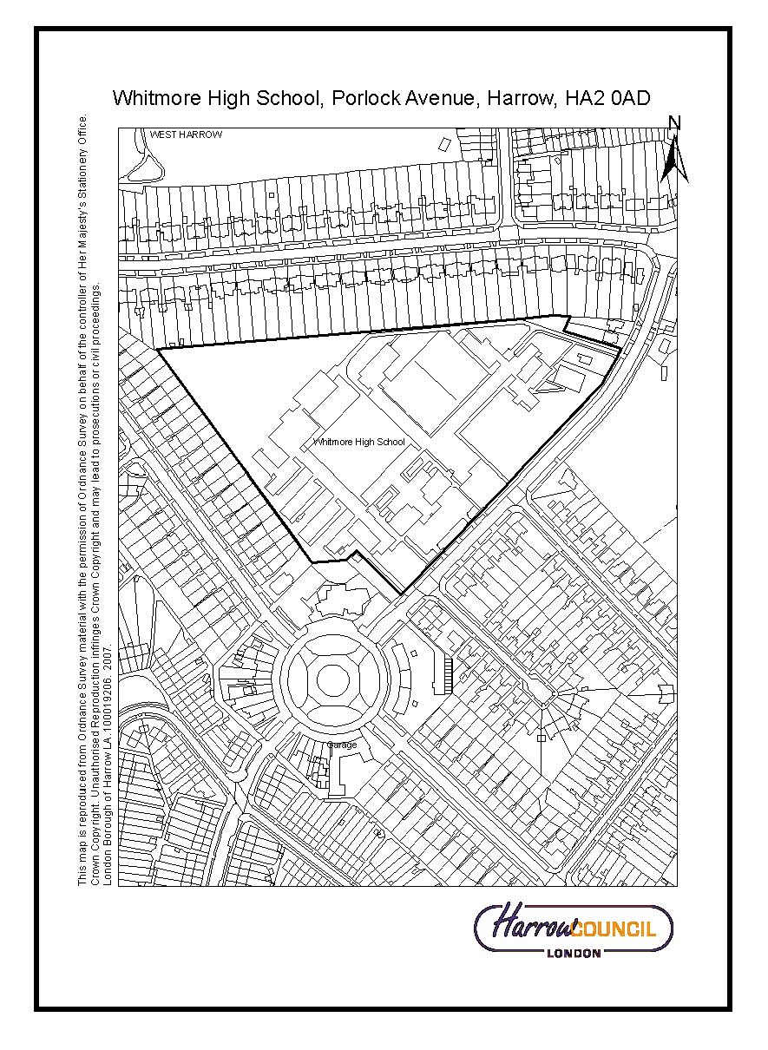
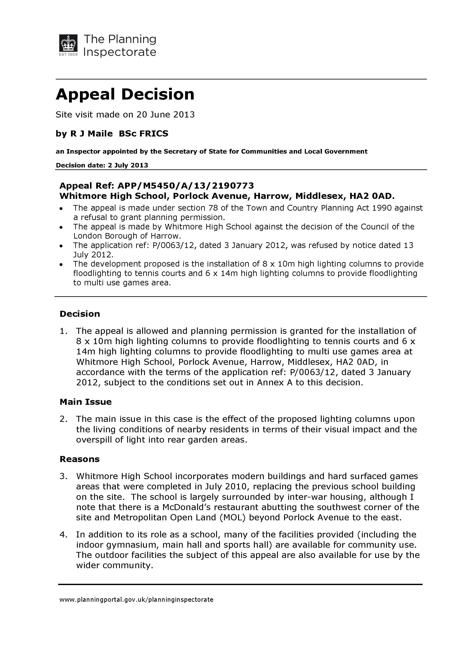
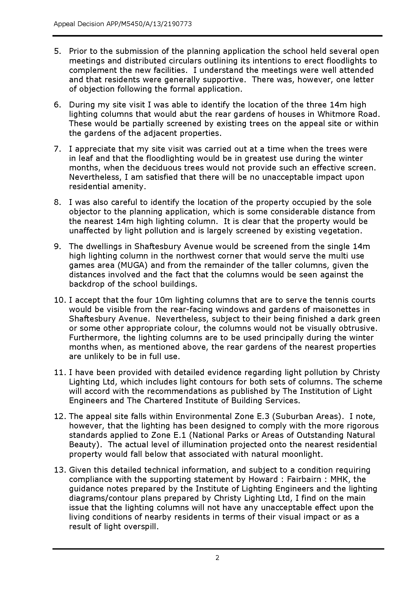
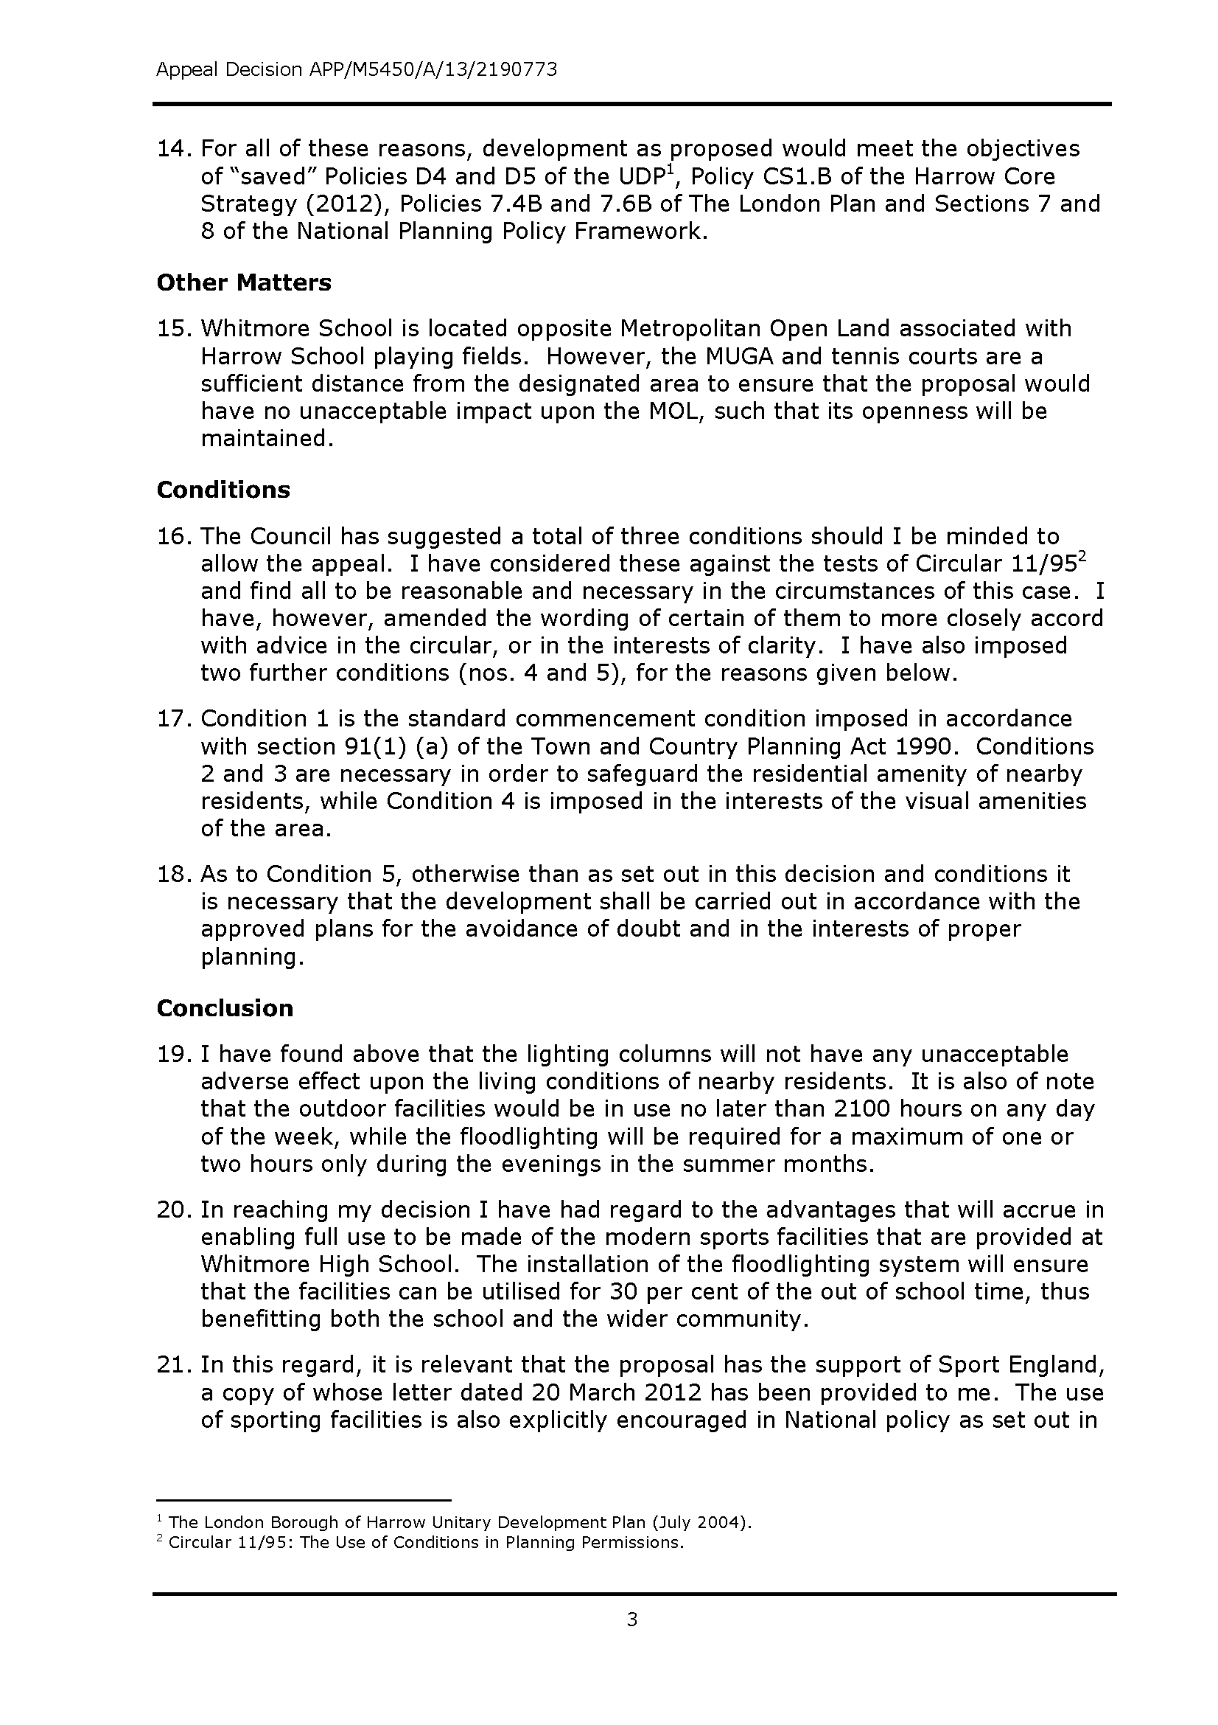
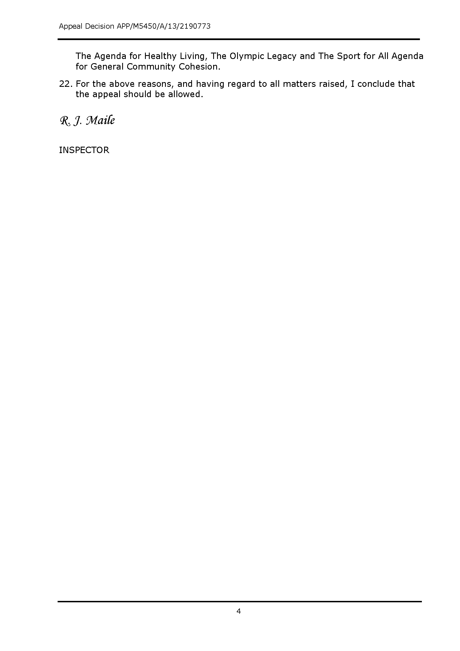
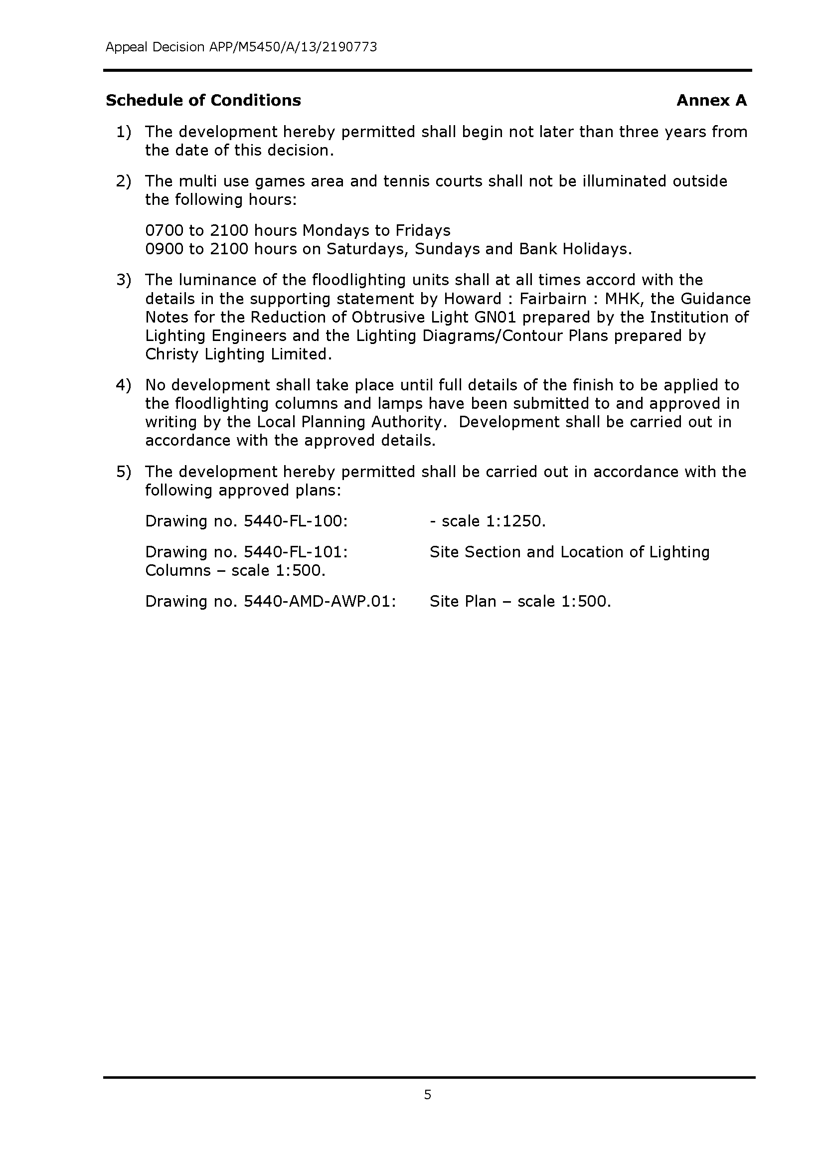
SECTION 3 - OTHER APPLICATIONS RECOMMENDED FOR REFUSAL

Item No. | 3/01
Address: | 43 - 55 WEST STREET, HARROW
Reference: | P/3259/12
Description: | DEMOLITION OF EXISTING FORMER PRINTWORKS BUILDINGS AT 43-49 WEST STREET AND REFURBISHMENT OF 51 WEST STREET TO CREATE NEW MIXED USE DEVELOPMENT FOR PRINT WORKS AND PRINT MUSEUM, WITH ANCILLARY COFFEE SHOP AND OFFICES (SUI GENERIS USE) WITH FIRST FLOOR LINK TO NO.51 WEST STREET; PART DEMOLITION & REBUILD AT 53-55 WEST STREET TO PROVIDE 2 X DWELLINGHOUSES AND 1 DETACHED DWELLINGHOUSE TO THE REAR OF 43-55 WEST STREET WITH TWO-STOREY BUILDING TO PROVIDE CAR PARKING ON GROUND FLOOR & 3 X B1 USE CLASS STUDIO WORKSHOPS ABOVE; ASSOCIATED LANDSCAPING, PARKING AND REFUSE STORAGE
Ward: | HARROW ON THE HILL
Applicant: | MR GRAHAM HARWOOD
Agent: | COTTERELL THOMAS & THOMAS
Case Officer: | SUSHILA BHANDARI
Expiry Date: | 18/02/2013
Item No. | 3/02
Address: | 43 - 49 WEST STREET, HARROW
Reference: | P/0182/13
Description: | PARTIAL DEMOLITION OF FORMER PRINTWORKS BUILDINGS AT 43-49 WEST STREET AND 53-55 WEST STREET (STREET FRONTAGES TO BE RETAINED); DEMOLITION OF BRICK AND TIMBER SHEDS TO THE REAR OF NOS 43-55 WEST STREET
Ward: | HARROW ON THE HILL
Applicant: | MR GRAHAM HARWOOD
Agent: | COTTERELL THOMAS & THOMAS
Case Officer: | SUSHILA BHANDARI
Expiry Date: | 18/02/2013
P/3259/12
RECOMMENDATION
REFUSE planning permission for the following reasons:

REASON
1. The proposed development comprising the construction of the new dwellinghouses on Plots B and C, by reason of their siting, design, overall scale and provision of habitable room windows in the north elevation of the development in close proximity to the site boundaries with the dwellinghouses in Yew Walk together with the significant site level changes which would elevate the overall scale and appearance of the development, would result in an unduly bulky and an overbearing form of development which would also give rise to direct and perceived overlooking of the rear gardens and rear elevations of the dwellinghouses in Yew Walk. The proposals would therefore be harmful to the residential amenities of the occupiers of these neighbouring dwellinghouses, contrary to policy 7.6B of The London Plan 2011, policy DM1 of the Development Management Policies Local Plan 2013 and the adopted Supplementary Planning Document: Residential Design Guide 2010.

2. Insufficient information has been submitted in order to enable a comprehensive assessment of the impact of the development on the designated Archaeological Priority Area, as required by the policy DM7 the Development Management Policies Local Plan 2013.

P/0182/13
RECOMMENDATION
REFUSE conservation area consent for the following reason:

REASON
1. The proposed partial demolition of Nos.43 to 55 West Street, in the absence of an acceptable proposal for the replacement of the buildings, would be inappropriate and detrimental to the appearance and character of this part of the Harrow on the Hill Village Conservation Area, contrary to policies contained within the National Planning Policy Framework 2012, policies 7.4B, 7.6B and 7.8C/D of The London Plan 2011, core policies CS1.B and D of the Harrow Core Strategy 2012, policies DM1 and DM7 of the Development Management Policies Local Plan 2013 and the adopted Harrow on the Hill Village Conservation Area Appraisal and Management Strategy 2008.

INFORMATION
The application is reported to the Planning Committee because the application falls outside of the scheme of delegation and because of the public interest on the proposed redevelopment of the site.

The applications were deferred form the Planning Committee meeting of the 23rd September 2013 for further consideration of the proposal in light of the applicant’s decision to retain houses on Plots B and C and further reconsideration of the scheme by Officers following further representations received from local residents.

As of the 1st October 2013, the requirement for conservation area consent for the demolition of most buildings in conservation areas was revoked where such demolition is required in conjunction with a planning application. As this application for conservation area consent was received and registered prior to this date, the application remains to be determined.

Statutory Return Type: Minor Development

Council Interest: None

Gross Floorspace:
House A – 67.96 sqm
House B – 121.78 sqm
House C – 124.52 sqm
House No.53 – 117.11 sqm
House No.55 – 124.13 sqm
Plot D – 120.24
Print Museum (including coffee chop/ offices/ storage) – 431.81 sqm

Total Area 1107.55 sqm

Net additional Floorspace: as above sqm

GLA Community Infrastructure Levy (CIL) Contribution (provisional): £38,764.25

Harrow CIL Contribution: £61,105 based on net floor area of 555.5 sqm for C3 dwellinghouses only. There is no CIL liability for uses falling within the other uses

Site Description
- The application site is situated on a steep part of West Street and comprises two group of buildings predominately used as B1 print work studios. The site also wraps around the rear of Nos.39, 41 and 57 to 69 West Street.
- The application is located in the Harrow on the Hill Village Conservation Area,
- West Street rises from north to south and the buildings fronting the street and to the rear “step up” the street towards the south. Nos.43 to 49 West Street comprise a row of four terraced properties that have been linked internally. These properties are two storeys high at street level but, because of the falling levels to the rear (Northwest) of the site, are three storeys high at the rear. No.49 has been extended at the side with a single storey side extension with basement, which was added in the 1950’s.
- Nos.51 to 55 comprises 4 units further down the hill that forms part of a terrace of two storey high buildings. These units are also used as part of the Print Works.
- There are a number of ancillary disused buildings and garages located within the rear part of the site. This area is also very overgrown as a consequence of lack of use. The land to the rear also slopes down to the north and west and there are significant level changes across the site.
- There are a large number of trees on this site that are predominantly self-seeded. The site is not covered by a Tree Preservation Order (TPO). The more mature trees on this site are subject to control by virtue of them being located in a Conservation Area.
- The application site is predominantly bounded by residential development. Nos.57 to 63 West Street continue the terraced residential form of West Street and reflect the modest residential scale and character of properties on West Street and nearby. Nos.69 and 67 comprise a pair of three storey Victorian villas. To the north (rear) of the site is a more modern built development, Yew Walk which comprises two storey terraced dwellinghouses laid out as a cul-de-sac. These buildings, with their deeper floorplans, large gables and substantial scale are markedly different to the more modest properties on West Street in scale, appearance and form. No. 39 and 41 abutting the eastern side boundary comprise two storey semi detached houses, of modest scale.
- The northern side boundary is densely vegetated with a mature hedgerow which provides screening between the Yew Walk development and the older development along West Street. There is an existing private path running parallel with the northern site boundary which can be accessed from the side of No.69 West Street or from the side of the row of garages located in Yew Walk. Part of the path located along the rear boundaries of Nos.1 to 4 Yew Walk is overgrown and inaccessible. The path provides private access only to Nos. 1 to 4 Yew Walk.
- Nos.31-35 West Street, located 25m to the east are Grade II Listed Buildings.Nos.43-49 and No.51 West Street and Nos.39, 41, 40 to 60 West Street, Old Mission Hall on West Street, Edwardian Post Box on the corner of West Street and Victoria Terrace and 2 Crown Street are locally listed.
- Directly opposite the site is The Castle Public House, a Grade II Listed Building
- There are three storey buildings located on the corner junction of West Street and Crown Street.
- The application site is located within the Harrow on the Hill Area of Special Character and is sited within an archaeological priority area designation.
- The site is also located some 30m south of a site of nature conservation importance.
- Most parts of West Street and Crown Street are not subject to a controlled parking zone. Yew Walk is within a private estate and has its own parking control measures in place.

Proposal Details
- The proposal seeks to demolish the rear walls (including relevant party walls) of Nos.43 to 49 and 53 to 55 West Street, and the existing single storey side extension at No.49 and retain the façade of these buildings along West Street. A new two storey wing (Plot D) is proposed at the rear of Nos.43-45, which would link into the main building along West Street. Two new semi-detached, two storey dwellinghouses are proposed (Plots B and C) on the northern section of the plot which would link with the new two wing site on Plot D. A further two storey building is proposed within the north-western section (Plot A) of the site (in parallel to the rear garden of No.67 West Street). A first floor link extension is proposed between No.49 and No.51 West Street (following the demolition of the existing single storey side extension).
- It is proposed to rebuild Nos.43 to 49 and No. 51 (rear only) as a mix used development which would comprise a classic car collection and part of Hardwood Print Works Museum at basement level, Pint Museum, Art gallery and Coffee Shop at ground floor level and 2 office suites at first floor level.
- The frontage of Nos.43-55 would be restored and the windows would either be repaired or replaced with timber framed sash windows to match the existing. The first floor link extension (between No.49 and 51) would be constructed in brick work to match the existing façade and a flat roof over. The pitched roof over the buildings would be constructed with slate tiles.
- The new rear wing (Plot D) would provide car parking spaces at ground floor level (for up to 4 cars) and an Art Museum at first floor level, which would have a direct link from the main building along West Street. This rear wing would be constructed in part rendered walls with tile hanging above. A gable pitched roof is proposed over this building which would have a total of 8 roof lights inserted within the roof slope.
- No.53 West Street would be converted into a 3 bedroom, 5 person unit with a Gross Internal Area (GIA) of 117.11 sqm.
- No.55 West Street would also be converted into a 3 bedroom, 5 person Unit with a GIA of 124.13 sqm.
- The new two storey house within the north-western section of the site (located on Plot A) would be a 2 Bedroom, 3 Person unit with a GIA of 67.96 sqm. The building is shown to have part rendered walls with red/brown tile hanging above. The roof would either be constructed with slate or clay tiles. A gable end roof is proposed over the dwellinghouse, which would include solar panels on the southern roof slope.
- The new two storey dwellinghouse located on Plot C which would link into the new two storey wing on Plot D would be a 3 bedroom 5 person unit with a GIA of 124.52 sqm.
- The new two storey dwellinghouse on Plot B would be a 3 bedroom, 6 person unit which a GIA of 121.78 sqm.
- The external finish to the dwellinghouses on Plots B and C would be similar to that of the new two wing extension on Plot D.
- Each new dwellinghouse would have access to its own private rear garden.
- The parking for the Commercial use would be accessed from the new widened access located between No.49 and 51, which would lead to a private courtyard. A new metal railing gate is proposed to access the courtyard. There is no parking proposed for the dwellinghouses along West Street or that proposed on Plot A. Two parking spaces have been shown for the new dwellinghouses on Plots B and C, which would be accommodated within a integral carport linked both dwellings. .
- The heights of the buildings along West Street would remain as same as the existing.
- The proposal would also include the rebuilding of the existing retaining wall along the eastern and northern site boundaries and a new timber fence above.

Revisions to Previous Application
Following the previous withdrawn application (P/1054/10) the following amendments have been made:
- Light industrial (B2) building at the rear removed and replaced with parking and Art Museum.
- Previously proposed flats removed.

The following amendments have been made to this current application:
- The façade of the building fronting West Street to be retained.
- The western elevation of the new house on Plot A has been amended to show yellow stock brickwork in place of the self coloured lime render and red/brown plan tile hanging.

Relevant History
P/1054/10 - Demolition of existing former printworks buildings; creation of printworks museum (use class d1), associated mix use development including offices (b1), light industry (b2), storage (b8), retail (a1), three dwelling houses and two self contained flats (c3); refuse, landscaping; new vehicular access and associated parking
Withdrawn – 14/07/2010

P/1115/10 - Demolition of existing printworks buildings
Withdrawn – 14/07/2010

Pre-Application Discussion (Ref.)
- Informal discussions were held with the Council’s Conservation Officer prior to the submission of this current application.

Applicant Submission Documents
- Design and Access Statement (summarised as follows)
  - Site was last used as a printworks with ancillary offices and an extensive courtyard to the rear that has become overgrown in more recent times.
  - The applicant still operates a small print facility from of the existing buildings.
  - The remainder are unused and in various states of disrepair and dereliction.
  - Only the frontages are to be retained if 43 to 49 and 53 and 55 West Street, with new fabric to the rear, the properties will be upgraded to some extent (achieving improved energy efficiency) wile also enhancing the conservation area.
  - It is proposed to retain those trees deemed capable of long term retention and to plant further trees in suitable locations as part of an agreed scheme of landscaping which can be secured by way of suitably worded planning conditions.
  - Aim is to develop a sustainable scheme for the development and use of the site that will contribute positively to the character, appearance, vitality and viability of the Conservation Area.
  - Scheme has been designed to respond to the very strong presentation of the site in the street scene of West Street and the dominance of the more recent 3 storey development in Yew Walk to the rear.
  - Scheme has been designed to be subservient to these two, more dominant, local townscape influences.
  - All interventions to the architecture on the frontage buildings have therefore been minimised so that the essential characteristics of the appearance of the site within the street scene are maintained.
  - The new build elements to the rear have been designed to be no more than two storey in height so that they can be largely concealed behind existing buildings to the front and rear.
  - New development would not appear against the skyline from any vantage point and it is proposed to safeguard a number of more mature trees on the site.
  - The scheme has been prepared having regard to the guidance set out in Safer Places.
  - The association of museum and the café to the print works is considered appropriate in the area and will contribute to providing vitality and viability to the development scheme itself as well as to the wider Conservation Area.
  - Landscaped area is proposed in the courtyard
  - All building will be designed to achieve the highest standards of sustainability with regard to materials, energy and water use.
  - Reasonable level of parking is proposed having regard to the availability of alternative travel options and the need to minimise traffic generation in the interest of the character of the area.
  - Existing bus services provide good links to nearby commercial and shopping centres.
  - The site is located almost equidistant between the London Underground Stations of South Harrow and Harrow on the Hill station.
  - Proposed development will comply with part M of the building Regulations.
  - In respect of the proposed new dwellings, the development set out to meet the requirements of Lifetime Homes standards.

Consultations

English Heritage (summarised as follows) Dated 21 June 2013 – following second round of consultation
Application has been noted by the Greater London Archaeological Advisory Service (GLAAS) as potentially affecting a heritage asset of archaeological interest.
Paragraph 128 of the NPPF says that applicants should be required to submit appropriate desk-based assessments of heritage assets and how they would be affected by the proposed development. This information should be supplied to inform the planning decision.
Appraisal of this planning application using the Greater London Historical Environment Record and information submitted with the application indicates a need for further information to reach an informed judgement of its impact on heritage assets of archaeological interest.
The application lies within the Archaeological Priority Area for Historic Harrow; an area with potential for medieval and earlier archaeological remains.
The following further studies should be undertaken to inform this application:
Desk-based assessment.
The nature and scope of assessment and evaluation should be agreed with GLAAS and carried out by a developer appointed archaeological practice before any decision on the planning application is taken. The consultant’s report will need to establish the significance of the site and the impact of the proposed development. Once the archaeological impact of the proposal has been defined a recommendation will be made by the GLAAS.
If archaeological safeguards do prove necessary, these could involve design measures to preserve remains in situ or where that is not feasible archaeological investigation prior to development. If planning permission is to be refused then we recommend that the failure of the applicant to provide an adequate archaeological assessment be sited as a reason for refusal.

English Heritage (summarised as below) dated 27 March 2013
The site lies in an area where archaeological remains may be anticipated, and is within a designated archaeological priority area as defined by the borough. It is within the boundaries of the medieval settlement of Harrow, which was well established by the 12th century. West Street saw a great use and expansion in the post-medieval period, with many buildings from the 17th and 18th centuries still standing. The proposed development will not only affect the present buildings on the site, but will also introduce new buildings at the rear of the street frontage, where outbuildings, yards and ancillary activities are likely to have occurred.
In accordance with the recommendations given in NPPF paragraphs 135 and 141, and in the borough’s local policies, a record should be made of the heritage assets prior to development, in order to preserve and enhance understanding of the assets.
The archaeological position should be reserved by attaching a condition to any consent granted under this application.

Natural England (summarised as follows)
The ecological survey submitted with this application has not identified that there will be any significant impacts on statutorily protected sites, species or on priority Biodiversity Action Plan (BAP) habitats as a result of this proposal. However when considering this application, the council should encourage opportunities to incorporate biodiversity in and around the development. Example of which include green/ brown roof, landscaping, nesting and roosting sites, sustainable urban drainage systems and local wildlife site.

Biodiversity Officer:
Generally the Biodiversity Report is reasonably robust in its findings. It does miss out the London and Harrow BAPs and the Mayor's Biodiversity Strategy (2002) but the report's conclusions and recommendation would not have been altered significantly by this omission.

I support its findings and recommendations - as far as the latter is concerned I would expect bird and bat boxes to be provided on existing buildings and suitable trees, and regarding any new buildings I would want to see bird and bat boxes built into the fabric of such structures. Bird boxes should cater for Principal Species in England and London BAP Species such as house sparrow, starling, house martin and swift.

The biodiversity report also recommends the planting of nectar-rich, non-invasive plant species to increase the biodiversity value of the site for insects such as bumble bees and butterflies, which I also support and add that 'cottage garden' style planting would be most applicable here.

CAAC:
28.01.2013 meeting comments:
The proposal looks insensitive and over development and the following issues needs to be addressed:
- The buildings at the rear are very unneighbourly and too close to boundaries.
- The architectural character of the buildings at the rear are poor and bear no relation to anything else in this area
- They introduce alien features and uniformity with rather odd proportions, overhangs and shallow and monotonous roof pitch.
- There needs to be more articulation and variety to reflect the roofscapes and character of this part of the Hill.
- It is back garden/backland development which does not seem to be acceptable.
- The relationship with levels seems odd and awkward.
- The relationship with large trees seems to suggest trees will be lost. This would be unacceptable.

Though in principle the re-development of the site is welcomed, the revised application does not address previous concerns. The quantum of development is still problematic and the design fails to take the opportunity to enhance the character of the CA.

- This is a very prominent site. The pro argument seems to be predicated on the fact that the existing situation detracts from the character of the CA (which it does mainly due to neglect over a significant period of time), the buildings are falling down, and therefore the proposed re-development is bound to be an improvement.

- There is no evidence, in either the drawings or supplementary information, highlighting the intent of the design, the appropriate nature and longevity of the uses (print work museum, cafe, art rooms etc) or how the overall proposal fits within/ responds to the context (particularly in relation the development to the rear of the site).

- The impact on neighbouring amenity- needs to understand accurately the relationship of the site and proposals to neighbours- the drawings lack neighbouring context. Though this is a complex site, particularly with respect to how to use the curiously apportioned land to the rear, however the proposal does not seem to solve these problems and instead raises new issues. Less development to the rear would be appropriate, in the absence of a proposal that has clear benefits to the CA and does not impact adversely on the existing residents.

Concerns relating to houses A, B & C and the courtyard:
- Detrimental impact on neighbouring residents amenity due to proximity to Yew Walk properties & rear of West St houses.
- Architectural design is stated as taking reference from Yew Walk. Is it a positive precedent?
- The design of the houses do not appear to be borne out of a positive response to the context. The siting, form, materials and window placement all appear fairly arbitrary. They do not appear to respond to the idiosyncrasies of the hills architecture or topography. There is no information provided in the application to adequately support the scheme.
- The access to house A is problematic as it is accessed via a public path which is a dark alley at night. The siting and design of this house would detract from the character of the CA
- The gate to the courtyard is of poor design (based on limited information provided) and it is queried whether a gate is appropriate at all in this context
- The stair in the entrance to the courtyard is incongruous
- The courtyard and houses in the courtyard would be visible in the CA due to the wide access, therefore the design is very important.

- Despite the headings of these items, nos. 51-55 are clearly included in the application.
- Serious concerns were raised about the treatment of the facades. As The Harrow on the Hill Conservation Appraisal, Area Number 9 states: - Some facades of properties within the terraced rows show evidence of former integral shopfronts. Today, on West Street the period frontages with individual shopfronts only go as far as no. 63** on the north side before the street opens out onto a more suburban scale, but would once have continued the full length of the street. The shopfronts are an important characteristic of both West Street and Crown Street and should therefore be retained where possible, although it is accepted that the character of this area is now predominantly one of residential, and is unlikely to be used as a shopping street again. ** note ‘suburban scale’ relates to numbers higher than 63.
- As to numbers 43-49, it would be a great pity to lose the extension and the basement window at no.49. Otherwise the proposals will not make much difference to what is already a fairly uniform row.

- As to numbers 51-55, the point about these is the varied Victorian shop frontages of differing widths. The proposals will iron them out: no. 53, which seems to cover two original premises; in the uphill part the detailing would be lost such as upper window; the cambered head, doorcase and fascia of the pilasters; the new door pilasters are apparently plain. However, the lower window is an improvement and
- In the downhill part, the upper window; the cambered head, doorcase would be lost.
- The existing one is round headed, the new one will be square headed and a replica of the bland uphill door. Also the ground floor window, the pilastered sides and a shop fascia over it, both of which will be lost in favour of a plain fascia extending across the full frontage, and plain side pilasters.

- To no. 55 - This has a shop front extending across its whole width, embracing door and window, with pilasters to door and window and a fascia with brackets. The window sill is bowed; the window has 5 x 2 panes. The proposal provides a plain fascia, plain pilasters to door and window, and a narrower window of 3 x 2.

- The cumulative effect of the proposals is to produce three identical frontages, whose ground floors are virtual copies of the facades of nos. 43-49, except that the wider no.55 necessitates a greater area of window. The character of the original shop fronts of 53-4 to be retained.

17.06.2013 meeting comments:
It would be a shame to have to go across by creating the bridge element at first floor level. This should be omitted. The two buildings left and right are not on the same plane. The gap there at the moment is a natural gap and in many ways this should be retained at the moment as the natural entrance to this development. They should maintain that gap as it is a change of style. This is the wrong mix of development type in this location which is why they are proposing to put these at the back. Block A is unacceptable as it is alien. B and C is unacceptable too. D may be acceptable to some extent. The rest is overdevelopment, out of keeping and backland development. We repeat previous comments. A fresh approach is required. The drawing is wrong in relation to the Yew Walk properties as they almost all have conservatories. A redesign is required of all the new build buildings. All the comments that Harrow School made still apply. They have not addressed serious concerns that Harrow School have. This is a very important site. This would affect how the conservation area is perceived. This could add to the tourism element of the Hill in principle but this would be too dense and overdeveloped in the way they have proposed it.

Highways Authority
There are no specific concerns with the proposed mixed use of the development i.e sui generis,B1 and C3. The main difference from the submitted and previously withdrawn application P/1115/10 is the provision of single family residential units rather than flatted proposals.

The likely traffic generated by the whole development will be inherently constrained by the very nature of Harrow on the Hill whereby freely available parking is rare hence the parking provisions on-site will form the baseline of activity in traffic terms. The six spaces provided will be available for the proposed mixed uses and will therefore be self-regulating owing to this limited parking provision both on and off site. Patronage is likely to be off peak and possibly undertaken as part of existing linked trips to the area either by car or by more sustainable means. In summary traffic generation is unlikely to measurably impact on the local area given the limited physical scale of the attraction.

In principle the proposed access to the site is acceptable in positioning owing to the likely low usage of the facility. To facilitate the widened access the demolition of an adjacent building will be required and hence a full construction management plan will be required via appropriate condition given the traffic sensitivities of the location.

Refuse collection is expected to occur via West Street itself which is acceptable on the premise that the internal site management regime ensure that refuse bins are placed no further than 10m away from the site boundary with the highway on collection days in line with the council's refuse code of practise.

The residential units should facilitate 1 secure and accessible cycle space per unit as per The London Plan 2011 with at least one space for the B1 element.

Drainage Authority:
No objections subject to standard conditions

Environmental Health Officer:
Dust suppression methods to be employed during construction so as to minimize likelihood of nuisance being caused to neighbouring properties.

A scheme of measures for the control and suppression of dust emissions shall be submitted to and approved in writing by the L.P.A. Such agreed works shall be implemented in the approved form prior to the commencement of any use hereby permitted and shall be maintained in the approved form while the premises are in use for the permitted purpose

No materials produced as a result of the site development or clearance shall be burned on site. All reasonable steps, including damping down site roads, shall be taken to minimise dust and litter emissions from the site whilst works of construction and demolition are in progress.

Dust suppression methods to be employed during construction so as to minimize likelihood of nuisance being caused to neighbouring properties.

No vehicle connected with the works to arrive on site before 07:30 or leave after 19:00 (except in the case of emergency). Working hours to be restricted between 08:00 and 18:00 Monday to Saturday (finishing at 13:00 on Saturday) with no working of any kind permitted on Sundays or any Public/Bank Holidays unless agreed otherwise in writing by the LPA.
The selection and use of machinery to operate on site, and working practices to be adopted will, as a minimum requirement, be compliant with the standards laid out in British Standard 5228:1984.
Mobile plant to be resident on site during extended works shall be fitted with non-audible reversing alarms (subject to HSE agreement).

The use of barriers to mitigate the impact of noisy operations will be used where possible. This may include the retention of part(s) of the original buildings during the demolition process to act in this capacity.

All waste arising from the ground clearance and construction processes to be recycled or removed from the site subject to agreement with the Local Planning Authority and other relevant agencies.

No fires to be lit on site at any time.

A wheel-wash facility shall be provided for the duration of the works to ensure levels of soil on roadways near the site are minimised.

All bulk carrying vehicles accessing the site shall be suitably sheeted to prevent nuisance from dust in transit.

All building materials shall be stored within the site.

Advertisement
Character of Conservation Area, Demolition in Conservation Area and Setting of Listed Building
First Advertised: 31.01.2013
Expired: 21.02.2013

Second Advert: 20.06.2013
Expired: 11.07.2013

Notifications
Sent: 64
Replies: 11

1st Notification
Expiry: 13.02.2013

2nd Notification
Expiry 03.07.2013

Addresses Consulted
West Street - 29, 29a, 29b, 29c, 31, 33, 35, 39, 41, 55b, 57, 59, 61, 63, 67, 69, 71, 73,75, 6a, 26, 28, 30 (The Castle Public House), 30a, 32, 34, 38, 40, 42, 44 SRM Works
Crown Street – 1, 3, 5, 2, 2a, 2b
Victoria Terrace – 1, 2
Meadow View – 1, 2, 3
Yew Walk – 1 to 12

Summary of Responses

Response following 1st Notification
- Welcome the maintenance of the land buildings
- Loss of privacy from building on Plot A
- Noise and disturbance resulting from the use of the new house in close proximity
- Deep excavation and heavy building so close to existing 100 plus year old building
- Loss of trees
- Conservation of nature – land is an observable vital passageway for wildlife
- Extra generation of traffic – any commercial premises will generate an additional burden on parking situation which is also stretched to a limit
- Road access – inadequate provision for the extra parking for the commercial and the houses at A1 and Nos.53 and 55
- Permission planning decision for this same matter were refused
- Impact on existing drainage system
- Emergency service access for the building on Plot A on shown
- Any property placing their refuse bins in front of neighbouring property on collection day or obstructing the public footpath/ alleyway
- If the commercial premises fail – this is simply a prelude to these premises also being converted into yet further private accommodation
- Impact on conservation area and area of special character
- Plans do not reflect the correct geometry between No.57 and 55 and none show the boundaries between neighbouring gardens making it impossible to work out exactly what backs on to exactly whose garden
- No document to show the western elevation of No. 55, the existing exposed western wall forms a boundary with the garden of No.57.
- Legends on drawing do no match the symbols.
- Reference to the garden of No.61 is overgrown is untrue and should be amended
- Will accept no damage to No.57
- Impact of the demolition works on peaceful enjoyment and the length of the project
- Is not in keeping with the surrounding area both in size and style
- Would result in the loss of unique shop fronts
- Replacement buildings do little to conserve the original style of the properties
- Renovation would be preferable to maintain the character of the Conservation Area
- Density of building – construction of buildings A, B and C would represent an overdevelopment
- Site plan is inaccurate as Nos.61 and 63 have been extended and this is not shown
- Backland development – Building A constitute inappropriate development – garden grabbing
- Loss of light due to the close proximity of building A and overbearing
- Plans fail to show the shed located at the bottom of the garden of No.61 West Street – consequently inadequate provision made for the access to the structure as entry appears to be via the garden of Building A
- Would have adverse impact on asset value of properties
- Too many different use types and no though given to the viability nature and longevity of the uses
- House A is poorly sited with poor access, incongruous design inappropriate and unsympathetic
- Buildings at the rear sited too close to the boundaries and are unattractive
- Boundary shown on ordinance survey extract plan is incorrect and includes a garage owned by Harrow School

Response following 2nd Notification in addition to similar responses received as above the following comments were also made:
- Unclear what the use of the land at the rear of No.67 and 69 will be – if used as garden would lead to loss of privacy
- Land subject to knot weed – is this going to be eradicated
- Question why West Street needs a coffee shop – this street has a low footfall
- Museum will no add any value to the street
- Support the restoration of the frontage but still object to the new dwellings to the rear
- Offices cause more vehicular traffic as evident at the power house, 87 West Street
- There is already a coffee shop within 100 yards of the site
- Already difficult to access and negotiate the road due to excessive parking

Since reporting this application to the Planning Committee Meeting on the 23rd September 2013, a report outlining objections to the scheme has been received on behalf of the residents residing at Nos. 57, 61, 63, 67 and 69 West Street, which is summarised as follows (the comments made were only in relation to the House on Plot A as at the time of the previous committee report it was assumed that Houses on Plots B and C would be removed from the scheme, which is no longer the case) :

- Would have a detrimental impact upon the character of the conservation area due to its siting, poor design and loss of views.
- Would have a detrimental impact upon the amenity of existing neighbours in relation to privacy, overlooking and heightened sense of enclosure.
- Poor level of accommodation and not lifetime homes standards.
- Access is dangerous and contrary to important Secure by Design principles.
- Proposal does not form part of the historic pattern of development or urban grain.
- Proposed materials and overall design highlight the lack of design integrity and rigour.
- Conditioning the materials is totally unacceptable.
- The roof form with this low pitch is not characteristics of the CA.
- Not demonstrated how the proposal would respond to the listed building at The Old Pye House.
- The removal of trees would have an unacceptable harm to the character of the CA.
- The proposed solar panel would be visible from West Street.
- Loss of privacy to existing residents due to siting of windows in the elevations facing neighbouring dwellings.
- Overbearing nature of the proposal, due to height and width of the proposed building and its siting in relation to neighbouring properties. .
- General design of the house is poor, non lifetime homes compliance.
- Secure by Design has not been considered, which has a great implication as access to the dwelling is secluded. It is of great concern that no Secure by Deign officer has been consulted on this project.
- No provision made for refuse storage.
- Viability of the development is not justification for relaxation in standards
- There are other issues, although not planning related that also have implications on the development such as extant of Japanese Knotweed, Easements and rights of way, and presence of public sewer running through the site.

APPRAISAL
Section 38(6) of the Planning and Compulsory Purchase Act 2004 requires that:

‘If regard is to be had to the Development Plan for the purpose of any determination to be made under the Planning Acts, the determination must be made in accordance with the Plan unless material considerations indicate otherwise.’

The Government has issued the National Planning Policy Framework (NPPF), which consolidates national planning policy and is a material consideration in the determination of this application.

In this instance, the Development Plan comprises The London Plan 2011 and the Local Development Framework (LDF). The LDF comprises The Harrow Core Strategy 2012, Harrow and Wealdstone Area Action Plan (AAP) 2013, the Development Management Policies Local Plan (DMP) 2013, the Site Allocations Local Plan (SALP) 2013 and Harrow Local Area Map (LAP) 2013.

On 11 October 2013, the Greater London Authority [GLA] published Revised Early Minor Alterations [REMA] to The London Plan 2011. From this date, the REMA are operative as formal alterations to The London Plan 2011 and therefore form part of the development plan for Harrow.

MAIN CONSIDERATIONS
Principle of the Development
Character and Appearance of the Conservation Area/ Locally Listed Buildings/ Area of Special Character
Residential Amenity
Archaeological Priority Area
Traffic and Parking
Impact on Trees and Biodiversity
Accessibility
Sustainability
Equalities Impact
S17 Crime & Disorder Act
Consultation Responses

Background to the Current Application
The scheme that was submitted back in December 2012 sought to demolish all the buildings fronting West Street at Nos.43 to 55 and to rebuild them on a like for like basis with the addition of a first floor link extension between No.49 and 51. The proposal included the construction of a two storey rear extension at the rear of Nos.43-45 West Street and the construction of 3, two storey dwellinghouses located at the rear.

Following concerns raised about the demolition of the locally listed buildings along West Street, the applicant was able to demonstrate that the façade of the buildings could be retained and that only the rear of the buildings would need to be demolished. On this basis, the applicant submitted revised drawings showing the frontage of the buildings to be retained. These were received in June 2013 and a re-consultation was undertaken with all neighbouring residents and external consultees on the revised drawings.

In assessing the scheme in detail, it was officers opinion that whilst the redevelopment along West Street could be supported in principle, the construction of the new houses located on Plots B and C could not be supported given their proximity to the boundary with the dwellinghouses in Yew Walk and their elevated two storey position in relation to the boundary with Yew Walk. Accordingly, the applicant was advised to omit this aspect of the scheme.

A Committee Report was drafted and placed on the agenda for the 23rd September 2013 Committee meeting on the premise that the revised scheme would be forthcoming. However, prior to the meeting and just after the agenda had been published the applicant decided to retain the Houses on Plots B and C.. Consequently, the application was deferred from the meeting of the 23rd September 2013.

A meeting was held between the Council Officers and the applicant to seek a way forward, however an agreement could be reached and therefore the application that is now before the Planning Committee is the scheme showing all houses on Plots A, B and C.

Principle of the Development
The lawful use of the site as a whole including the ancillary buildings at the rear and the grounds attached to the buildings is use class B1 (light Industrial). The site has been vacant for a number of years and the buildings are in poor condition. The site is not located within any designated Business or Industrial Use Areas and therefore the loss of the existing light industrial use can be supported under policy DM 31 of the DMP subject to meeting the policy tests set out under criterion C and D of this policy which permit the loss of industrial uses where it can be demonstrated that the site is no longer suitable and viable as a industrial or business use. Whilst there has been no marketing information submitted with this application to support the loss of business use, the proposal does seek to retain some office space with at least half the site also being used for commercial purposes. In this regard, the loss of the existing light industrial use can be supported on the basis that, whilst noting the redevelopment would comprise primarily residential development, it would still retain some element of economic activity on the site.

National Planning Policy Framework (2012), The London Plan (2011), The Harrow Core Strategy (2012) and the recently adopted Development Management Policies Local Plan (2013) all seek to increase housing supply locally, regionally and nationally, and promote the provision of high quality mix of housing.

Policy 3.8 of The London Plan 2011 encourages the Council to provide a range of housing choices in order to take account of the various different groups who require different types of housing. This policy requires consideration to be given to the accessibility of the site to services and amenities.

The proposal would provide an increase in smaller to medium scale housing stock within the Borough. Policy 3.4 of The London Plan promotes the optimisation of housing output within different types of location and the development would accord with these aims.

Policy CS1.A of Harrow's Core Strategy 2012 undertakes to manage growth in accordance with the spatial strategy. The spatial strategy directs residential and other development to the Harrow & Wealdstone Intensification Area, town centres and, in suburban areas, to strategic previously developed sites. Policy CS1.B of the Core Strategy resists development on garden sites, recognising the propensity for such proposals to lead to unmanaged, incremental growth that undermines the spatial strategy. It also resists proposals that would harm the character of suburban areas.

As noted above the site in its current form is classified as a B1 light industrial use. The representations received suggest that the development itself is inappropriate garden land development. However, the site including its grounds would be regarded as brownfield, previously developed land. On this basis, there is no conflict with the policies stated above in terms of the proposed development of the land at the rear. Accordingly, the principle of development is considered to be acceptable.

Character and Appearance of the Conservation Area/ Locally Listed Buildings/ Area of Special Character
Character and Appearance of Conservation Area
Policy 7.4 (B) of the London Plan requires that buildings, streets and open spaces to provide a high quality design response that has regard to the pattern and grain of the existing spaces and streets in orientation, scale, proportion and mass.

Core Policy CS1.B specifies that ‘All development shall respond positively to the local and historic context in terms of design, siting, density and spacing, reinforce the positive attributes of local distinctiveness whilst promoting innovative design and/or enhancing areas of poor design; extensions should respect their host building.’

Policy DM1 of the DMP gives advice that ‘’all development proposals must achieve a high standard of design and layout. Proposals which fail to achieve a high standard of design and layout, or which are detrimental to local character and appearance, will be resisted.’’

Policy DM7 of the DMP in assessing proposals that affect heritage assets, including non designated heritage assets, seeks to secure the preservation, conservation or enhancement of a heritage asset and its setting, or which secure opportunities for sustainable enjoyment of the historic environment. It goes on to further state under sub-section E that in regards to Listed Buildings, the Council will pay special attention to the building’s character and any features of special architectural or historic interest which it possesses, and the role of the building's setting in these regards and exploit all opportunities to secure the future of listed buildings particularly those on the 'heritage at risk' register.

The Council has adopted a Supplementary Planning Document (SPD) on Residential Design (2010), which gives design guidance and requires new developments to harmonise with the scale and architectural style of the original dwellinghouse. Substantial weight is accorded to the SPD as a material planning consideration.

The site is within a Conservation Area (CA), includes numerous locally listed buildings and is within the immediate setting of many more locally listed and statutory listed (grade II) buildings (see above) The Conservation Area design Statement indicates that the special interest of the Harrow on the Hill Village Conservation Area relates to it forming ‘the historic core of the Hill, scattered with the area’s earliest buildings. Its unique townscape comprises a historical settlement of considerable antiquity and visual quality, set along an irregular network of ancient highways, and bounded by open spaces, which serve to accentuate its distinction from the surrounding London sprawl’.

The character and form of 43-49 and 51 West St are consistent with this prevailing character and therefore contribute to the appearance of the CA, the setting of nearby listed and locally listed buildings and are Locally Listed buildings themselves.

The Harrow on the Hill Conservation Area Appraisal, CAA, (adopted May, 2008 and forming Appendix 4H to the Harrow on the Hill Conservation Areas SPD adopted May 2008) identifies 43-49 West Street (see p16’s map) as locally listed and the buildings also form a part of the views within the CA, in particular as part of the setting of the settlement on the hillside seen in long-distance views from St Mary’s Church the Grove Metropolitan Open Land.

43-49 and 53-55 are two storey terraced cottages of a modest Victorian domestic style, similar to, and in harmony with, nearby listed and locally listed buildings. This provides a degree of architectural cohesion to the CA. The CAA states that ‘Residential terraces of West Street provide the area with considerable townscape value and special interest. Where buildings form dominant groups like these they make a positive contribution to the character and appearance of the area, especially where they demonstrate historic fabric or construction.’

The buildings fronting West Street also contain original shopfronts which the CAA state ‘once would have continued the full length of the street’ and so are ‘an important characteristic of both West St and Crown St [that] should therefore be retained wherever possible.’

Redevelopment of Nos.43-55 West Street
The scheme has been revised since its original submission, in that it now seeks to retain the façade of the buildings along West Street and seeks to restore the original features including the restoration of or new window details to match the original character and appearance of the buildings. The proposed first floor link extension between Nos.49 and 51, subject to the use of appropriate matching materials would preserve the character and appearance of the locally listed buildings and that of the Conservation Area.

Whilst it noted that it would have been desirable to retain the rear parts of the buildings fronting West Street, the existing buildings are in a poor state of repair and considerably dilapidated to the extent that the cost of the restoration of such would outweigh the viability of the scheme to bring the buildings back into use. Given that the applicant now seeks to retain the frontage of the buildings, including the restoration of the existing shop fronts which are an intrinsic features of the locally listed buildings, it is considered that subject to the rear walls including the party wall being built in appropriate materials to match the existing, the proposals along the West Street Frontage would make a positive contribution to the character and appearance of the Conservation Area. A new roof would be required and the new tiles would be visible within the street. Special care will therefore be necessary to ensure an appropriate system (given the shallow roof pitch) and appropriate slate tile is used to preserve the natural roof scale of the area in short and long views.

Two Storey Rear Extension (Plot D)
The proposed two storey link extension sited at the rear of Nos.43 to 47, due to the change in site levels (sloping downwards in a north-western direction) would as shown on the drawings form a subservient addition to the main building fronting West Street. This extension would be broadly sited on the location of the existing dilapidated garages and outhouses that form part of the former print works. Given that the sensitivity of the roofscape in views towards the site from the Metropolitan Open Land to the north and in glimpsed views from West Street and surrounding homes, the proposed shallow pitch of the roof will require careful design to meet building regulation requirements whilst deploying appropriate clay roof tiles. which would normally require a minimum pitch of 35 degrees. The rear extension is proposed to be partly tile hung – referencing the development at Yew Walk which are of significantly greater scale. Representations have been received about the over reliance on these buildings to inform the design for the proposals. In this circumstance, it is considered that the use of a tile hung elevation will erode the unity between the frontage building and the rear wing. An appropriate alternative finish, avoiding the potential harm to the character and appearance of the conservation area could nevertheless be secured by use of a planning condition.

Plots A, B and C
The three proposed buildings to the rear, whilst they share a relatively narrow floor plan, have a deliberate style and elevation design. The design and access statement describes the approach as…” to be of modern appearance taking their design cue from more recent developments on adjoining land in Yew Walk.” The CAA states that that ‘most buildings share similar traditional construction techniques and similar traditional materials predominantly red or yellow stock brick often combined with slate roofs’ and ‘the quality of the area’s architecture is generally very strong’ so buildings ‘combine to form an attractive … townscape’ (quotes from the CAA, p13). The proposed dwellings share a more contemporary form and detail, with shallow roofs and simple window openings and would be distinct to the houses proposed at the front of the site and surrounding.

The application of a shallower pitch roof, and decisions about materials across and between elevations is not fully resolved in the details submitted. The use of more contemporary materials, appropriate to the shallow pitch roofs might not be appropriate (the details are not specified) but the approach to materials on the different elevations of each building (such as on plot A) is considered to be unlikely to support the conservation areas objectives for unity amongst the more modest building forms in “backland” and infill sites within this conservation area. The materials appear to reflect the tile hanging of the buildings along Yew Walk, which is a distinct and recent development. These buildings are of larger proportions and have a markedly different relationship with the conservation area. The details of the materials could be covered by a planning condition, to overcome these objections but the certainty on this matter is cause for concern having regard to policy 7.8C/D of The London Plan, policies DM1 and DM7 of the DMP and the need to demonstrate how the proposals would preserve or enhance the character the conservation area.

The more contemporary form of the buildings, particularly window form and detailing would have, local but nevertheless important impacts on the character and appearance of the locality. The house on Plot A would have elevations (onto the pathway and glimpsed between No .63 AND No.69 West Street) that would be more visible in the public realm but its windows have in places, a contradictory form in terms of opening size and proportion and detailing. Had the applicant engaged in a fuller pre-application process, this matter might have been resolved and a planning condition might be appropriate to overcome such concerns. On balance officers are of the view that the design approach to the homes on plots A , B and C is in principle capable of preserving the character of the conservation area but that in this case, for the reasons above, conditions would be required to achieve this objective, and satisfy the statutory and policy requirements in this regard.

The proposed new two storey dwellinghouse located on Plot A would be located within the north western corner of the site and would be partially screened from views from West Street by the existing buildings (at Nos. 59 to 69). This new dwelling would be accessible from an existing public footpath which runs parallel with No.69 West Street. In the representations received, objections have been raised to this “backland” siting, on the basis of its impact upon amenity (see below) and the character and appearance of the conservation area. The CAA statement above, and views of the area from further away nevertheless indicate a wide range of building forms, densely packed on the slopes of the hillside. In this context, the development of land within these spaces is not considered to be “out of keeping” with the prevailing character of the conservation area – provided that the development itself is otherwise satisfactory.

The proposed new houses on Plots B and C would largely be screened from view of the streetscene along West Street, but there would be views of the development from Yew Walk, in particular from the rear gardens of the dwellinghouses along Yew Walk (which is discussed in detail under Residential Amenity below). Because of the changing levels, it is considered that the siting and layout of the dwellinghouses, together with their elevated position and relationship with the site boundary would lead to an overbearing form of development. The principle of the buildings by reason of their siting and overall height proposed is considered to be unacceptable.

The development includes solar panels on the south roof slope of buildings A, B and C. This has prompted concerns in the representations from local residents. The Harrow on the Hill CAs SPD states that (page 16) ‘If well designed and integrated, these measures should be able to be accommodated without detriment to the character of the conservation area’ . With the exception of the solar panel on Plot A, which would be visible to some degree from the gap between Nos.63 and 67 West Street, the other solar panels shown on Plots B and C would probably be largely concealed from most views. However, they are likely to be visible from the public courtyard (at least partially), within the rear gardens of the dwellings along West Street, and from some long distance views, for example, from higher land on the Hill. The latter are labelled as key views in the CAA (p.10). They would be immediately next to the locally listed 51. Their very modern character would be obtrusive and were the development otherwise acceptable, a condition requiring their deletion from this position, and the exploration of other less obtrusive methods of increasing energy efficiency would be required to safeguard the special character and appearance of the conservation area.

Areas of Special Character
Policy DM 6 of the DMP when considering development proposals in areas of special character will have regard to, inter alia, the desirability of preserving or enhancing the environmental, architectural, historic and the protected views to and from areas of special character.

The application site is located within the Harrow on the Hill Area of Special Character which is defined by the prominence of the Hill that provides a historic hilltop settlement, in particular St. Mary’s Church and historic Harrow School Buildings and the setting created by the major open areas, including contribution of groups and individual trees.

The buildings along West Street forming part of the application would retain the façade and there are no changes to the height of the existing buildings proposed and accordingly this aspect of the proposal would preserve the character of the special area. The first floor extension proposed to link No.49 and 51 West Street would not exceed the height of the existing buildings. The two storey wing extension at the rear would form a subservient addition to the existing building and would due to the change is site levels would be located at a lower site level than the West Street buildings. Similarly, the new dwellinghouses proposed on Plots A, B and C would also be located on lower site level than the main buildings along West Street. In this regard, subject to the qualification above regarding appropriate materials, the proposal would have no detrimental impact upon the protected views of the historic development on the Hill top and accordingly would have no significant impact beyond those identified above, upon the special character of the area.

Refuse Storage
As noted, DM1 of the DMP specifies that the Council will expect a high standard of design and layout in all developments including adequate refuse storage. The applicant has shown that the refuse bins for Nos.43 to 55 would be located adjacent to the flank wall of No.49 West Street and would be accessible from the new access gated of West Street leading into the new courtyard. It is considered that the location of the bins is appropriate and would safeguard the appearance of the development and that of the area. However, no refuse and recycling bin details have been shown for the new house located on plot A or what arrangement would be in place, given that this site would have no street frontage and only accessible by a public footpath. There is nevertheless space to the side of the building to enable any bins to be located out of sight from the footpath users and only brought out on collection day. Had this application been considered acceptable in other regards, a condition would have been attached requesting such details to be submitted to the LPA for approval.

Landscaping
Policy DM23 of the DMP specifies that the Council will seek to achieve and retain a high quality of streetside greenness and forecourt greenery in the Borough. The frontages of the buildings along West Street are set hard up against the adjacent footpath and therefore there is no forecourt for the development. The dwellinghouses proposed at Nos.53 and 55 West Street would have private rear gardens only, which would have some soft landscape treatment. The dwellinghouse located on plot A would not be visible in the public realm, although the applicant has shown some level of soft landscaping in the front and rear gardens of this new dwellinghouse. The central courtyard located at the rear of No.45 to 51 West Street would be private and with the exception of part glimpses of the courtyard from the access drive between Nos.49 and 51 West Street, the courtyard would be largely screened from view of the street scene. The applicant has shown this area to be laid with hard and soft landscape works.

The existing overgrown trees on the site do play a small part in the mix of buildings and greenery that characterise longer views of the site. The development will result in some change to this through the removal of self seeded and unmanaged growth, but will not, officers consider, transform or adversely affect the balance of building and greenery in such views to the extent that the quality or character of the view is changed. The level proposed is considered to be acceptable and detailed landscaping can be controlled by condition.

Residential Amenity
Residential Amenity of Future Occupiers
Room Size and Layout
Policy DM1 of the DMP seeks to ensure that “proposals that would be detrimental to the privacy and amenity of neighbouring occupiers, or that would fail to achieve satisfactory privacy and amenity for future occupiers of the development, will be resisted”.

Policy 7.6B, subsection D, of The London Plan (2011) states that new buildings and structures should not cause unacceptable harm to the amenity of surrounding land and buildings, particularly residential buildings, in relation to privacy, overshadowing, wind and microclimate.

Policy 3.5C of The London Plan requires all new residential development to provide, amongst other things, accommodation which is adequate to meet people’s needs. In this regard, minimum gross internal areas (GIA) are required for different types of accommodation, and new residential accommodation should have a layout that provides a functional space. Table 3.3 of The London Plan specifies minimum GIAs for residential units and advises that these minimum sizes should be exceeded where possible. The use of these residential unit GIA’s as minima is also reiterated in Appendix 1 of the Residential Design Guide SPD. This is supported by policy DM1 of the DMP.

The dwellinghouse located at No.53 West Street would have a GIA of 117 sqm and the dwellinghouse located at No.55 West Street would have a GIA of 124 sqm. Both these dwellinghouses are shown to have 3 bedrooms which can accommodate up to 5 persons and both would exceed the minimum GIA of 96 sqm set out in the adopted SPD and The London plan. In this regard, the proposed dwellinghouses would provide generous living space for the future occupiers of the site.

The proposed new dwellinghouse on plot A would have a GIA of just less than 68 sqm. Whilst the adopted SPD and The London Plan does not set out the GIA for a 2 bedroom, 3 person dwellinghouse (two storey house), the proposed floor area would meet the GIA of 61 sqm for a flat of a similar size. In this regard, the proposal is considered to be acceptable.

The proposed new dwellinghouse on plot B would have a GIA of 121.78 sqm. Again the adopted SPD and The London Plan does not set out the GIA for a 3 bedroom, 6 person dwellinghouse (two storey house), the proposed floor area would meet the GIA of 95 sqm for a flat of a similar size. In this regard, the proposal is considered to be acceptable.

The proposed new dwellinghouse on Plot C would have a GIA of 124.52, which would meet the GIA of 96 sqm set out in the adopted SPD and The London Plan.

In respect of the dwellings proposed on Plots A, B and C the proposals will fail to meet the requirements for minimum floor to ceiling heights in all cases. Achieving this requirement would nevertheless result in buildings that were taller and more dominant than the dwellings proposed. Given that the character of the conservation area is informed by more modest homes with lower roof and eves, the requirements for greater room heights is not considered to be as important as safeguarding the character and appearance of the conservation area in this case.

Outdoor Amenity Space
It is noted that Policy DM27 of the DMP and paragraph 4.64 of the SPD requires that residential development should provide appropriate amenity space. In case of town centre locations, alternative forms of outdoor amenity such as balconies should be explored.

The proposal would include the sub-division of the existing plot to provide a private amenity space for each of the proposed dwellinghouses. On this basis, the proposal is considered to be acceptable with regards to the above policy.

Impact on neighbouring properties
The proposed new dwellinghouses behind the elevation on West Street will contribute towards overlooking across the street that happens throughout this area. Given the limitations associated with the retention of the elevation and patterns of development locally, this relationship between existing and new homes is considered to be acceptable.

The new home proposed on plot A would face Nos.59 to 63 West Street and be at an oblique angle with Nos.67 and 69 West Street. In assessing the impact of the proposed dwellinghouse on the residential amenities of Nos.59 to 63, the boundary to the proposed new dwellinghouse would be sited 8m to the rear of these dwellinghouses and a further distance of 1.5m would be retained between the site boundary and the proposed southern elevation of the proposed dwellinghouse. There has been representations regarding this proposed dwellinghouse and its impact upon No 59 – 63.,The site levels fall towards the new home. There are 3 side windows proposed in this elevation (2 ground floor and 1 obscure glazed first floor window). Taken together with the orientation of the proposed dwelling being to the north of these neighbouring dwellinghouses, it is considered that the proposed development would not have an unreasonable impact in terms of loss of light or outlook.

In respect to overlooking, concerns have been expressed that the proximity and design of the homes would lead to a loss of privacy. The new dwelling is certainly less than the 21 metres back to back distance used as a proxy for acceptable overlooking on greenfield sites. However, new development is required to have regard to the pattern of development as well as established levels of privacy within the vicinity. West Street is predominately characterised by shallow depth rear gardens, with irregular garden layouts. The conservation area as a whole is characterised by groups of housing that are arranged very close together. Undoubtedly the existing pattern of development is one that allows some degree of overlooking of neighbouring gardens albeit at oblique angles. It is also not uncommon to find small pockets of backland developments within the CA, as noted earlier, similar to that being proposed at the subject site.

The southern elevation of House A would have habitable room windows and a door at ground floor level. However, these windows would be largely screened from the view of Nos.59 to 63, by the proposed boundary fencing and as such there would be no unreasonable loss of privacy in either direction. The window proposed at first floor would serve a bathroom and can be conditioned to be obscure glazed and fixed. As such, it is considered that there would be no unreasonable level of overlooking of the neighbouring properties as a result of this window. The windows in the western (front) elevation would maintain a distance of at least 7.6m to the nearest corner of No.67 and due to its siting at a right angle to the rear elevations of Nos.67 and 69, the proposed window would have an oblique relationship with the dwellinghouses located on Nos.67 and 69 West Street. Officers consider that the impact on the privacy of No 67 and 69 given the relationship between the proposed and existing properties would be acceptable, notwithstanding the reduced distance. The windows in the northern elevation of Plot A would be sufficiently sited away from No.71 West Street and No.5 Yew Walk that they are unlikely to have a significant impact upon these neighbouring dwellinghouses.

In assessing the impact of the proposed development on the residential amenities of the occupiers of Nos. 1 to 4 Yew Walk, the proposed dwellinghouses located on Plots B and C are considered to be unacceptable. The proposed dwellinghouses would be sited within 1.2m of the boundary adjoining the rear gardens of these dwellinghouses and taking into consideration the significant drop in ground levels between the subject site and the gardens of these dwellings, together with the short depth of these gardens would amount a development which would be unduly bulky and overbearing when viewed from the rear gardens and rear facing windows of these neighbouring dwellinghouses. It is considered that the proposed site plan is not actuality reflected correctly as it does not show the rear conservatories to the dwellinghouses in Yew Walk, which further narrows the gaps between the proposed development and the protected rear facing windows.

This impact would be further exacerbated due to the elevated nature of the subject site and the proposed first floor habitable windows, of which two would be primary windows serving bedrooms to houses B and C. These windows would directly face the rear gardens and the dwellinghouses in Yew Walk and would permit direct and perceived overlooking of the rear gardens and dwellinghouses in Yew Walk. Overall, it is considered that the siting and scale of the development on plots B and C would have an unacceptable impact upon the adjoining neighbouring occupiers.

The proposed two storey rear wing would be sited a minimum distance of 8.5m from the closest boundary with No.2 Yew Walk. This part of the proposal would be screened by the proposed houses on Plots B and C and so there would not be an unreasonable impact in this regard.

In relation to Nos. 39 and 41 West Street, whilst it is acknowledged that the outlook from the rear windows and the rear garden of these dwellinghouses would be affected by the proposed two storey rear wing extension, this extension would essentially replace the existing outbuildings and stores located on the site. The additional height of the building would be mitigated by the changes in site levels, whereby the land slopes steeply from east to west and to the north and as such the proposed extension would be sited on lower ground level to the site level of the neighbouring site. Together with the provision of a pitched roof which would slope away from the boundaries adjoining both of these dwellinghouses, it is considered that the impact of the proposed extension would not be significantly overbearing beyond the existing situation to warrant a refusal. There are no windows proposed in the eastern elevation of the proposed extension. The roof lights in the eastern roof slope would have an oblique relationship with the neighbouring sites and as such would not give rise to an unreasonable level of overlooking of the neighbouring dwellings.

In relation to the impact of the proposed development on No.57 West Street, the rebuilding of the flank and rear walls of No.55 West Street would be broadly on a like for like basis, as currently the layout of No.55 is such that it wraps around the rear wall of No.57 in a ‘L’ shape layout at both ground and first floor levels. The proposal would follow a similar layout. It is considered that the proposed rebuild works at the rear and the conversion of the property at No.55 into a single family dwellinghouse would have no detrimental impact upon the residential amenities of the occupiers at No.57 West Street in terms of loss of light, outlook or privacy.

In assessing the impact of the proposed use of No.43 to 51 as a print works museum, coffee shop, art gallery and offices, it is acknowledged that the proposal would increase activity on the site through comings and goings. However, the level of associated activity is unlikely to be greater then what can be associated with the existing lawful use of the site as use class B1 – light industrial, if it were to be in full operational use, as such, whilst there would be a perceivable increase in the actual use of the site, when compared to the capacity of the existing site, the levels of usage would not be dissimilar, It would therefore be unreasonable to recommend refusal on these grounds. A condition would have been required however to ensure that external lighting (to ensure safety for visitors) was properly managed.

For the above reasons, whilst a number of the elements surrounding the scheme need not have an adverse impact upon residential amenity, several key components, associated with the proposed dwellings on plots B and C will give rise to unacceptable impacts upon residential amenity. This would be contrary to policy 7.6B of The London Plan 2011, policy DM1 of the Development Management Policies Local Plan 2013 and the adopted Supplementary Planning Document: Residential Design Guide 2010.

Archaeological Priority Area
Policy DM7 of the DMP indicates that when considering proposals affecting an archaeological priority area, the Council will have regard to:
a. the known or anticipated significance of the archaeology;
b. the likely implications of the proposal upon the archaeology; and
c. the need to preserve the archaeology in situ; or
d. the adequacy of arrangements for the investigation, recording, archiving and (where
appropriate) curation of archaeology not requiring preservation in situ.

The applicant has not provided a desktop assessment of the impact the proposal could have on archaeology within the area and as such it is not possible to asses the implications of the proposal on the archaeological priority area. In the first consultation response received from English Heritage, it was considered that in light of the condition of the existing buildings and in order to bring forward the renovation project of these buildings, a desktop assessment could be controlled by condition. Following the receipt of revised drawings showing the retention of the façade of the building along West Street a second of round consultation was undertaken by the LPA.

In the second consultation response, English Heritage raised an objection on ground of insufficient information. Given that the only changes shown on the revised drawings related to the façade of the drawing, there was no significant change to warrant a different opinion to that raised under the first round of consultation. This difference in response is nevertheless unhelpful in helping officers to conclude that the development meets the requirements of Policy DM7. Accordingly, having reflected on the requirements of this adopted policy, officers consider that the assessment of the archaeological impacts cannot be achieved without an appropriate desktop study and the application must therefore be rejected on this basis.

Traffic and Parking
Policy DM42 of the DMP gives advice that developments should make adequate provision for parking and safe access to and within the site and not lead to any material increase in substandard vehicular access.

The proposal has shown 4 parking spaces for the proposed commercial use, which the Council’s Highway authority considers to be acceptable given the relevantly low footfall the proposed uses would attract. It is acknowledged that on street parking along West Street is at a premium, given that there are limited free parking spaces along West Street on first-come-first-served basis. The proposal does show two parking spaces for the dwellinghouses on Plots B and C, but does not show any off-street parking provision for the proposed dwellinghouse on Plot A, so the demand for such would have to be met by on-street parking.

In considering whether the traffic and parking impacts are acceptable, because the site is not a greenfield development, the Council is required to consider the “fall-back” position. The site has a lawful use as a printers works. This is a commercial use that would involve deliveries and staff traveling to the site from elsewhere – potentially by car. There is currently only limited off street parking space. Were the use to re-start, officers are of the view that the net change in parking between the printing use and the residential use would be marginal. Given this “fall back” argument the Council’s Highway Authority has raised no objection to the proposal and accordingly the proposal is considered acceptable in traffic terms.

Impact on Trees and Biodiversity

Trees
The site is not subject to a Tree Preservation Order (TPO). However the mature trees on this site are safeguarded from removal without consent by virtue of them being located in a Conservation Area. The applicant has submitted a Tree Report in support of this application, which concludes that majority of the trees within the site are of low quality of which many are self sown. Consequently the development proposal would require a removal of large number of trees on the site, including those that are causing physical damage to the existing buildings.

The Council’s Tree Officer has raised no objection to the proposed development and had this application been considered acceptable in all other regards, a condition would have been imposed to ensure that a tree protection plan was submitted for the trees to be retained. In addition as part of the landscape proposal, planting of new species can be controlled by condition to ensure that the development makes provision for the trees that would be lost as a consequence of the development.

Biodiversity
The application site is not itself located in a designated Site of Importance for Nature Conservation (SINC).

The applicant has submitted a full Ecological survey, including a bat survey to support this application. The bat survey concludes that there is no presence of bat roosts or activity within the existing roof space of the buildings. The survey has identified that there is a problem of Japanese Knotweed on the site and recommends that this should be eradicated in line with the advice provided in the knotweed code of practice.

The presence of Japanese knotweed does not prevent development from taking place – and the Council cannot refuse planning permission on that basis. Treatment to remove and eradicate the plant from a site is nevertheless complicated and does require control via planning conditions.

The report has also concluded that the site lacks habitat connectivity. However flying animals such as bats and birds and stag beetles are likely to utilise the site and specifically its mature trees for commuting and foraging. The site lies a significant distance from the nearest designated SINC located some 1km to the north of the site and as such the future plans for the site would be unlikely to affect the integrity of the habitats found within the designated sites. The survey has nevertheless made a number of recommendations with regard to the demolition process and what should be done if a bat or bats are found during the development. The Council’s Biodiversity Officer has raised no objections to the findings of this survey is satisfied with the information provided.

In conclusion, subject to control and mitigation, the proposal would not harm the objectives set out policies DM21 and DM22 of the DMP. .

Accessibility

Residential Development
Policy DM2 of the DMP and policies 3.5 and 3.8 of The London Plan (2011) seek to ensure that all new housing is built to ‘Lifetime Homes’ standards. Furthermore, The London Plan policy 7.2 requires all future development to meet the highest standards of accessibility and inclusion.

Policy CS1.K of the Harrow Core Strategy requires all new dwellings to comply with the requirements of Lifetime Homes. Supplementary Planning Document Accessible Homes 2010 (SPD) outlines the necessary criteria for a ‘Lifetime Home’

Whilst details of Lifetimes Homes has not been shown on plan, the supporting Design and Access statement shows that the proposed dwellinghouses would meet all relevant Lifetime Homes Standards. The representations received contest this assumption. It is noted that that the existing properties along West Street are on a hill and that it is unlikely that level access to the two dwellinghouses at Nos.53 and 55 could be achieved. This is a physical barrier beyond the applicant’s control. Departures from the guidance are justified in such circumstances, provide that the internal layout strives towards meeting the other Lifetime homes standards. Accordingly a condition could be attached to ensure the new dwellinghouse are built to meet all achievable standards.

Commercial development
Policy DM2 of the DMP and policy 7.2 The London Plan requires all future development and change of use proposals to meet the highest standards of accessibility and inclusion. The Council’s has adopted a Supplementary Planning Document ‘Access for All’ 2006, which provides detailed guidance on achieving an accessible design.

The proposal seeks to provide level threshold entrance to the museum and the proposed coffee shop. The accompanying Design and Access statement states that all internal doors and WC facilities would be accessible.

In this regard, the proposal is considered to be acceptable.

Sustainability
Policy 5.1 of The London Plan 2011 seeks to achieve an overall reduction in London’s carbon dioxide emissions of 60 per cent by 2025. Harrow Council has adopted a Supplementary Planning Document on Sustainable Building Design (adopted May 2009).

For minor development proposals, the development plan does not set out energy and sustainability targets greater than those required by Building Regulations. As these standards will be secured through other legislation, no conditions are required in relation to sustainability measures. The proposal would include the provision of solar panels as part of applicant’s measures to incorporate sustainable development. However, for the reasons outlined under section 2 of the above report it is considered that the siting of the proposed solar panels within the context of the CA is considered to be unacceptable.

Equalities Impact
Section 149 of the Equalities Act 2010 created the public sector equality duty. Section149 states:-
(1) A public authority must, in the exercise of its functions, have due regard to the need to:
(a) eliminate discrimination, harassment, victimisation and any other conduct that is prohibited by or under this Act;
(b) advance equality of opportunity between persons who share a relevant protected characteristic and persons who do not share it;
(c) foster good relations between persons who share a relevant protected characteristic and persons who do not share it.
When making policy decisions, the Council must take account of the equality duty and in particular any potential impact on protected groups. The proposals do promote a form of development that is, in places, less acceptable by virtue of the changing levels and slopes, than would be the case on a flat site. However, as discussed above, in this circumstances, the shortcoming, and accordingly the impact on protected groups is considered to be justified having regard to the wider objectives of the development plan.

S17 Crime & Disorder Act
Policies 7.3.B and 7.13.B of The London Plan, saved policy D4 of the UDP and emerging policy DM1 of the DM DPD require all new developments to have regard to safety and the measures to reduce crime in the design of development proposal.

The proposed layout of the development would result in natural surveillance of each property between each of the dwellinghouses and from the street scene. In this regards, the proposal is considered not to give rise to any conflict with regards to the above stated policies. Whilst it is noted that representations have been made in respect of the security in relation to the new house on Plot A, as the access to the property would be from the existing public footpath which provides access to Nos.73 and 71 West Street and this footpath is also used by other pedestrians it would be afforded some natural surveillance. This footpath also has street lighting. Given these factors, it is considered that a refusal on grounds of safety could not be justified. .

Consultation Responses
All matters raised in the consultation responses that are relevant to planning policy have been addressed in the above appraisal, including those that were received after the 23rd September 2013 committee meeting. Matters relating to the party wall and property values are not material planning considerations.

CONCLUSION
For all the reasons considered above, and weighing up the development plan policies and proposals, and other material considerations, as set out above: This application is recommended for refusal.

INFORMATIVES
1 The following policies are relevant to this decision:

National Planning Policy Framework (2012)

The London Plan (2011)
Policies 3.1, 3.5, 3.8, 5.2, 5.3, 5.12, 5.13, 6.9, 7.1, 7.2, 7.3, 7.4, 7.6, 7.8

The Harrow Core Strategy (2012)
Core Policies CS1.B, K, X, U

Development Management Policies Local Plan (2013)
Policies DM1, DM2, DM6, DM7, DM10, DM22, DM23, DM31, DM42.

Supplementary Planning Document – Residential Design Guide (2010)
Supplementary Planning Document – Accessible Homes (2010)
Supplementary Planning Document – Access for All (2006)
Code of Practice for Storage and Collection of Refuse and Materials for Recycling in Domestic Properties (2008).
Supplementary Planning Document – Garden Land Development (2013)
Harrow on the Hill Village Conservation Area Appraisal and Management Strategy (2008)

2 Refuse without pre-application advice
Statement under Article 31 (1)(cc) of The Town and Country Planning (Development Management Procedure) (England) Order 2010 (as amended)
This decision has been taken in accordance with paragraphs 187-189 of The National Planning Policy Framework. Harrow Council has a pre-application advice service and actively encourages applicants to use this service. Please note this for future reference prior to submitting any future planning applications.

3 Please be advised that approval of this application (either by Harrow Council, or subsequently by PINS if allowed on Appeal following a Refusal by Harrow Council) will attract a GLA liability payment of £38,764.25 of Community Infrastructure Levy. This charge has been levied under Greater London Authority CIL charging schedule and s211 of the Planning Act 2008.
Harrow Council as CIL collecting authority on commencement of development
will be collecting the Mayoral Community Infrastructure Levy (CIL).
Your proposal is subject to a CIL Liability Notice indicating a levy of £38,764.25for the application, based on the levy rate for Harrow of £35/sqm and the stated increase in floorspace of 1107.55 sqm
You are advised to visit the planningportal website where you can download the appropriate document templates.
http://www.planningportal.gov.uk/planning/applications/howtoapply/whattosubmit/ci

4 Harrow has a Community Infrastructure Levy which will apply Borough wide for certain uses of over 100sqm gross internal floor space. The CIL has been examined by the Planning Inspectorate and found to be legally compliant. It will be charged from the 1st October 2013. Any planning application determined after this date will be charged accordingly.
Harrow's Charges are:

Residential (Use Class C3) - £110 per sqm;
Hotels (Use Class C1), Residential Institutions except Hospitals, (Use Class C2), Student Accommodation, Hostels and HMOs (Sui generis)- £55 per sqm;
Retail (Use Class A1), Financial & Professional Services (Use Class A2), Restaurants and Cafes (Use Class A3) Drinking Establishments (Use Class A4) Hot Food Takeaways (Use Class A5) - £100 per sqm
All other uses - Nil.

The Harrow CIL contribution for this development is £61,105

P/3259/12
Plan Nos: 07/1138/02; 07/1138/03C; 07/1138/04C; 07/1138/05C; 07/1138/06; 07/1138/07; 07/1138/08A (Proposed Front Façade Elevation); 07/1138/08C (Existing and Proposed Front Façade Elevations); 07/1138/09; 07/1138/10B; 07/1138/11A; 07/1138/12A; 07/1138/13C; 07/1138/14B; 07/1138/15B; 07/1138/16B; 07/1138/17; 07/1138/23A; Design and Access Statement (Ref: 0077/WE435/PDA); Structural Engineering Report Ref: BJM/3191; Structural Inspection Report Ref: 090/011; Ecological Habitat Survey Report Dated 6 Oct 2012; Tree Survey Dated 27 Oct 2009; Arboricultural Impact Assessment Drawing; Tree Constraints Plan

P/0182/13
Plan Nos: 07/1138/02; 07/1138/03C; 07/1138/04C; 07/1138/05C; 07/1138/06; 07/1138/07; 07/1138/08A; 07/1138/09; 07/1138/10B; 07/1138/11A; 07/1138/12A; 07/1138/13C; 07/1138/14B; 07/1138/15B; 07/1138/16B; 07/1138/17; 07/1138/23A; Design and Access Statement (Ref: 0077/WE435/PDA); Structural Engineering Report Ref: BJM/3191; Structural Inspection Report Ref: 090/011; Ecological Habitat Survey Report Dated 6 Oct 2012; Tree Survey Dated 27 Oct 2009; Arboricultural Impact Assessment Drawing; Tree Constraints Plan

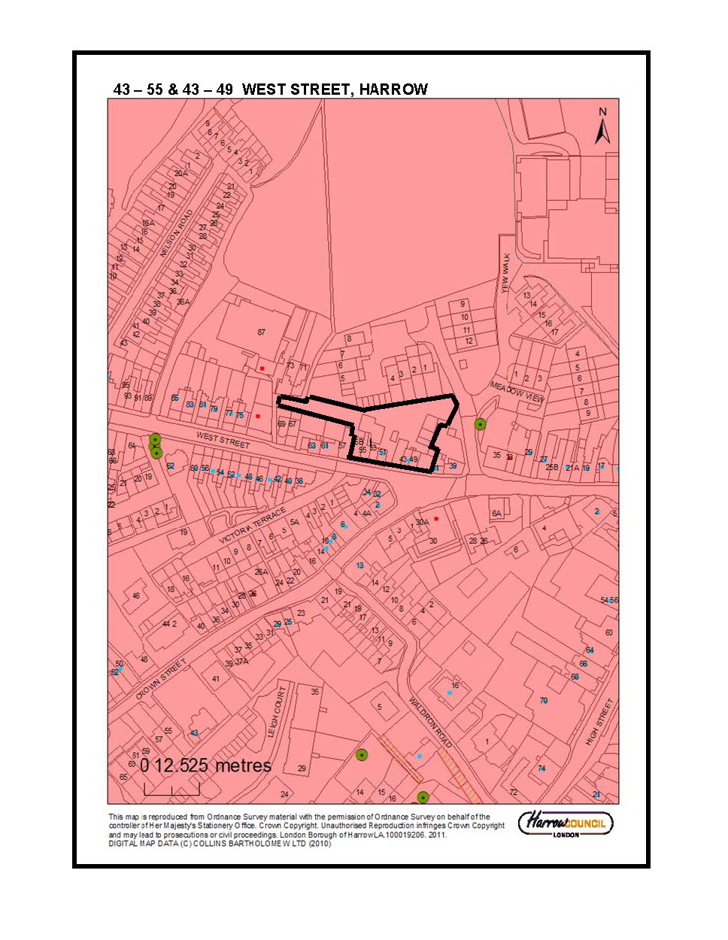

Item No. | 3/03
Address: | 23 JESMOND WAY, STANMORE
Reference: | P/2616/13
Description: | SINGLE STOREY REAR TWO STOREY SIDE AND FIRST FLOOR OTHER SIDE EXTENSIONS; CONVERSION OF GARAGE TO ROOM; REAR DORMER; RAISING OF GROUND LEVEL TO CREATE RAMP AT FRONT; PROPOSED RAISED DECKING AT REAR ; EXTERNAL ALTERATIONS
Ward: | CANONS
Applicant: | MR IRVING CAPLAN
Agent: | JEFF KAHANE AND ASSOCIATES
Case Officer: | NICOLA RANKIN
Expiry Date: | 28/10/2013
RECOMMENDATION
REFUSE permission for the development described in the application and submitted plans for the following reason(s):

REASON
- The proposal, by reason of the cumulative impact of the existing and proposed extensions, overall excessive width and unacceptable roof design, would give rise to a dwellinghouse of excessive scale, mass and bulk, and would introduce an overly dominant, incongruous and obtrusive form of development that would completely subsume the original character and scale of the dwellinghouse and would not be in keeping with the predominant pattern of development in the surrounding area, to the detriment of the character and appearance of the existing dwellinghouse on site, the surrounding locality and the visual amenities of the surrounding neighbouring occupiers, contrary to policies 7.4 B and 7.6 B of The London Plan (2011), core policy CS1 (B) of the Harrow Core Strategy (2012), policy DM 1 of the Harrow Development Management Policies Local Plan (2013) and the Council’s Supplementary Planning Document - Residential Design Guide (2010).

INFORMATION
The application is reported to the Planning Committee because it has been called in by a nominated member of the committee.

Statutory Return Type: Householder
Council Interest: None
Gross Floorspace: n/a
Net additional Floorspace: 82.59sqm
GLA Community Infrastructure Levy (CIL) Contribution (provisional): None
Harrow Community Infrastructure Levy (CIL) Contribution (provisional): None

Additional Information
The application was considered at the Planning Committee on 20th November 2013. The application was deferred to enable officers to carry out further consultation with neighbouring residents on the resolution to grant the application.

Letters were sent to neighbouring residents on the 25th November to inform them that members had opted to defer the decision of the application, following the committee resolution to grant the application. No comments have yet been received. Any comments received will be reported to the planning committee via the addendum.

Site Description
- The application site relates to a two storey detached dwellinghouse on the southern side of Jesmond Way.
- The property has a catslide roof on its north eastern side while the rest of the original roofslope is hipped.
- The property has a garage attached to the south west flank wall.
- Although there is no planning history for the site, the property has been previously extended with the addition of a first floor flat roofed side extension over the garage on the south western side of the dwellinghouse.
- The majority of the front garden is soft landscaped as is the rear garden which extends to a depth of approximately 21 metres beyond the main rear wall.
- The adjacent two storey detached dwellinghouse to the south west, No. 25, has been extended with the addition of a single storey front extension and the garage converted to a habitable room.
- The adjacent two storey detached dwellinghouse to the north east, No. 21, has been extended with the addition of first floor side extensions and a single storey rear extension and the garage converted to a habitable room.
- The land level along Jesmond Way slopes gradually downwards from north east to south west so that No. 21 is at higher level than the subject site and No. 25 at a lower level.
- The surrounding area is characterised by two storey detached and semi detached dwellings of medium scale. A number of properties along the street have been extended with the addition of subservient extensions which ensure that the original character and form of the extensions are still apparent within the street scene.

Proposal Details
- The application proposes single storey rear, two storey side and first floor other side extensions; conversion of garage to a habitable room; rear dormer; raising of ground level to create a ramp at front; proposed raised decking at the rear and external alterations.
- The existing first floor side extension would be extended rearward with the addition of a further two storey side extension. The first floor element of the two storey side extension would align with the main rear elevation of the dwellinghouse. The front wall would be marginally brought forward so that it would align with the main front wall of the property. A new crown roof is proposed over the existing flat roofed first floor side extension.
- A further first floor side extension is proposed on the north eastern side of the elevation. This would have a width of 2.4 metres and would extend the full depth of the north eastern flank wall. It would be set back 1 metre from the main front wall of the dwellinghouse. A subservient crown roof is proposed over this element.
- A single storey rear extension is proposed on the south western side of the dwellinghouse. It would project 1.25 metres from the south western flank wall and would have a width of 7 metres. The single storey rear extension would have a flat roof to a height of 2.8 metres above the raised decking and a height of 3.66 metres from the natural ground level.
- A flat roof rear dormer is proposed in the rear roof slope. This would have a width of 5.11 metres and a height of 1.6 metres.
- It is proposed to convert the existing garage to a habitable room and the existing garage doors on the front elevation would be retained.
- The ground level at the front of the site would be marginally raised in order to create a level front driveway.
- A raised timber decking area is proposed at the rear of the dwellinghouse. The raised timber decking would abut the shared boundary with No. 25 and would have a width of 10.8 metres and a height an approximate of 0.75 metres above the adjacent ground level to No. 25.
- Other external alterations proposed include re-landscaping and hardsurfacing of the front garden, the provision of two rooflights on the north east roofslope and the provision of one rooflight on the south west roofslope, the addition of three windows in the south west flank wall.

Revisions to Previous Application
- N/A

Relevant History
- None

Pre-Application Discussion (Ref. P/0535/13/PREAPP)
Proposal: Garage conversion; loft conversion; new lift with lift shaft to rear; ramp access to front door entrance
Garage conversion and hipped roof over first floor side extension
- The new hipped roof is welcomed and would improve the appearance of the extension
- The garage conversion is acceptable
Lift shaft
- This is unacceptable in its current form as it does not respect the hipped roof profile or design of the original dwellinghouse. It would appear as a contrived addition to the original dwellinghouse.
- Ideally consider an internal lift. Alternatively alter the design of the extension so that it would appear as a conventional extension to the dwellinghouse, with a hipped roof design that matches the height of the roof of the adjacent side extension.
Ramp access to front door entrance and new parking space
- Acceptable
Side and rear dormers
- Rear dormer acceptable
- Reduce the size of the side dormer to half the width (one window) so that it is set back from the front of the property, it would appear less incongruous and would be a subordinate feature in the roof.

(Ref: P/1804/13/PREAPP)
Proposal:Option A: Reconfiguration of Roof to provide a Hipped Crown Roof; Two Store and First Floor Side Extensions; Rear Dormer; Conversion of Garage to a Habitable Room; Raised Patio at The Rear; External Alterations Option B: Reconfiguration of Roof to provide a Hipped Crown Roof; Two Storey Side Extension; New Hipped Roof over Existing First Floor Side Extension; Side and Rear Dormers; Alterations to the Front Garden to Provide a Level Access to the Front Entrance and Additional Hard Surfacing; External Alterations
Option A:
- The conversion of the garage to a habitable room and the alterations to the front driveway are considered to be acceptable.
- The raised patio at the rear of the property is considered to be acceptable in terms of character and appearance.
- The proposed two storey side extension on the western side of the dwellinghouse is considered to be acceptable in terms of character and appearance and the provision of a hipped roof over the first floor of this element would be an improvement over the existing flat roof first floor side extension. However, a first floor side extension is also proposed to the eastern side of the dwellinghouse, resulting in a width of 12 metres at first floor level. It is considered the overall width of the resultant property when viewed in conjunction with the proposed first floor side extension on the eastern side of the dwellinghouse would be excessively disproportionate in the context of the original dwellinghouse on site. It is considered that the overall width of the property is exacerbated by the large extensive crown roof. As such, it is considered that the excessive width and crown roof design would give rise to an excessively bulky and unduly obtrusive development which would fail to respect the scale and character of the original property on site.
- It was discussed whether the introduction of a setback to the eastern first floor side extension would make the scheme more acceptable. Generally, setbacks are required on such extensions as outlined in paragraph 6.46 of the Council’s SPD: Residential Design Guide (2010). In this case, whilst the introduction of a set back would help break up the scale and bulk of the property when viewed from the front, it is considered that this would not be sufficient to overcome the concerns raised above.
- The proposed rear dormer would fail to appear as a subordinate feature on the rear roofslope and should be set in further from the roof verges to create a more acceptable appearance. In order to achieve a subordinate appearance, this should be set in a minimum of 1 metre from the top corner of each roof verge.
- It is acknowledged that a number of other properties on the southern side of Jesmond Way have been extended. Nevertheless, these extensions are subservient additions to the original properties which have set backs from their front elevations or more subordinate roofs. Having regard to the character of the original dwellinghouse and the surrounding character of the street scene, the Local Planning Authority is not convinced there is a justification for the large extensions proposed in this case and the proposal would be contrary to the Harrow Development Plan in this respect.

Option B
- The conversion of the garage to a habitable room and the alterations to the front driveway are considered to be acceptable.
- The raised patio at the rear of the property is considered to be acceptable in terms of character and appearance.
- It is considered that the proposed two storey side extension to the western side of the dwellinghouse would be acceptable as would the roof over the first floor side extension.
- Whilst the proposed side dormer would be set back from the front of the property, it would only be set up from the eaves by 0.45 metres. It is considered that the side dormer would be visually prominent when viewed from the east. It would be inappropriate in the context of the pattern of development in the street scene and would fail to complement the architectural appearance of the property or the surrounding locality.
- The proposed rear dormer is considered to be overly dominant on the rear roofslope and would fail to have a subordinate appearance. The proposed rear dormer would have an unacceptable impact on the character and appearance of the existing property and the surrounding properties.
- The property has already been extended with the addition of a first floor side extension. It is considered that overall cumulative impact of the proposed large side and rear dormer together with the existing first floor side extension would have an unacceptable impact on the character of the existing dwellinghouse

Applicant Submission Documents
- Planning Statement (Summary)
- The planning application seeks permission for alterations and extensions to the dwelling at 23 Jesmond Way in order to accommodate the essential needs of the owner occupier following his serious accident a year ago which has left him tetraplegic and in poor health and requiring the needs of a live in carer to ensure that he has the best quality of life in the circumstances.
- The intention of the application is provide a well considered balance between the specific needs of the applicant against the need to ensure the extensions and alterations to No. 23 Jesmond Way do not create a dwelling which is over dominant in the immediate surrounding area or out of keeping in design terms with its neighbours.
- Notwithstanding the comments in the pre application advice report, the proposed development does not seriously increase the scale and bulk of the property when viewed against many others in Jesmond Way.
- The relationship between the property and its neighbours remains very much as can be found elsewhere and it should be noted that a 1 metre set back is provided for the first floor north eastern extension with the resultant hipped roof being substantially lower than the main roof of the house. It is considered that this offsets any increase in bulk.
- The development is no different than the development at 24 Jesmond Way, which has been approved following a planning appeal.
- The overall depth of the property results in the need for a crown roof but it is not large and will not be apparent from any public vantage point. There are other dwellings in Jesmond Way which also employ the crown roof principle.
- The circumstances of the applicant and his need for modifications to the dwelling to provide him with necessary accommodation is a material consideration.
- In the light of the special circumstances and the considerable endeavours of the applicant and the architect to create a scheme balancing the applicants requirements with a complimentary appearance to the dwelling in its setting, the Council is requested to grant planning permission at the earliest date to enable the difficulties the applicant is experiencing to be resolved in the shortest possible time.
- Letter from NHS Trust
- Letter from Occupational Therapist – Harrow Council
- Disability Equality Statement

Consultations
- None

Advertisement
- N/A

Notifications
Sent: 32
Replies: 3
Expiry: 04.10.2013

Addresses Consulted
- 21, 25 Jesmond Way
- 50-75 Stonegrove Gardens

Summary of Responses
- 2 letters of support have been received in respect of the application which are summarised as follows:
- We feel that the plans in no way detract from the ambience of the road in general or from our house in particular and that the finished result indeed would be a lovely addition.
- We have noted that the other houses in the road have been extended and enhanced in a similarly attractive fashion and that these too have had the same positive impact that we expect from the renovations and extension at no. 23.
- We would encourage the Council to accept these plans without any undue delay as they are essential works which will enable a severely disabled resident to return to his home. The building works will certainly enhance the property and is completely in keeping with several other houses in Jesmond Way which have undergone similar works.

APPRAISAL
Section 38(6) of the Planning and Compulsory Purchase Act 2004 requires that:

‘If regard is to be had to the Development Plan for the purpose of any determination to be made under the Planning Acts, the determination must be made in accordance with the Plan unless material considerations indicate otherwise.’

The Government has issued the National Planning Policy Framework [NPPF] which consolidates national planning policy and is a material consideration in the determination of this application.

In this instance, the Development Plan comprises The London Plan 2011 [LP] and the Local Development Framework [LDF]. The LDF comprises The Harrow Core Strategy 2012 [CS] and the Harrow Development Management Policies Local Plan 2013 [DMP].

MAIN CONSIDERATIONS
Character and Appearance of the Area
Residential Amenity
Traffic and Parking
S17 Crime & Disorder Act
Equalities and Human Rights
Consultation Responses

Character and Appearance of the Area
The London Plan (2011) policies 7.4B and 7.6B set out the design principles that all boroughs should seek to ensure for all development proposals. The London Plan (2011) policy 7.4B states, inter alia, that all development proposals should have regard to the local context, contribute to a positive relationship between the urban landscape and natural features, be human in scale, make a positive contribution and should be informed by the historic environment. The London Plan (2011) policy 7.6B states, inter alia, that all development proposals should; be of the highest architectural quality, which complement the local architectural character and be of an appropriate proportion composition, scale and orientation.

Core Policy CS(B) states that ‘All development shall respond positively to the local and historic context in terms of design, siting, density and spacing, reinforce the positive attributes of local distinctiveness whilst promoting innovative design and/or enhancing areas of poor design; extensions should respect their host building.’

Policy DM 1 A of the Local Development Management Policies Local Plan (2013) states that: “All development and change of use proposals must achieve a high standard of design and layout. Proposals which fail to achieve a high standard of design and layout, or which are detrimental to local character and appearance will be resisted”. It goes on to say that:
“The assessment of the design and layout of proposals will have regard to:
a: the massing, bulk, scale and height of proposed buildings in relation to the location, the surroundings and any impact on neighbouring occupiers;
b: the appearance of proposed buildings, including but not limited to architectural inspiration, detailing, roof form, materials and colour, entrances, windows and the discreet accommodation of external services;
c: the context provided by neighbouring buildings and the local character and pattern of
development;
d: the provision of appropriate space around buildings for setting and landscaping, as a
resource for occupiers and to secure privacy and amenity;
e: the need to retain or enhance existing landscaping, trees, biodiversity or other natural features of merit;”

The Council has adopted Supplementary Planning Document – Residential Design Guide 2010 (SPD) to supplement the policies of the Harrow Development Management Local Plan (2013). This SPD therefore carries substantial weight as a material planning consideration. Paragraph 6.6 of the Council's adopted SPD: Residential Design Guide (2010) states that "extensions should harmonise with the scale and architectural style of the original building, and the character of the area" and that “An extension should have a sense of proportion and balance, both in its own right and its relationship to the original building and should not dominate the original building” (paragraph 6.11). Therefore, in terms of character and appearance, the primary emphasis in creating an acceptable extension should be on retaining the character and appearance of the original dwellinghouse and the dwellinghouses in the surrounding area.

The properties in the surrounding area are predominately of medium scale. The majority have hipped roofs and a number have been extended with modest extensions which ensure that their original character and forms are retained. No. 21 is one of the larger properties within this group of detached dwellings on the southern side of Jesmond Way. Nevertheless, it retains its original catslide roof slope on the front elevation and main hipped roof from. The other adjacent property, No. 25, retains its original hipped roof form and has a small single storey front extension. A large number of other detached dwellings along this side of the street have been extended with the addition of two storey side extensions to one side with crown roofs which appear subservient due to their subordinate roof height and set back from the front elevations of the properties. The nature of development along this part of Jesmond Way has resulted in the retention of modest gaps between the dwellings which contributes to the character of the area.

In view of the surrounding character of the street, there is no objection to the principle of extending the subject dwelling with the addition of a two storey side extension with crown roof as it is accepted that this is a characteristic feature of the predominant pattern of development in this part of the street.

The proposed two storey side extension on the south western side of the dwellinghouse would infill the gap between the existing two storey side extension and the main rear elevation of the dwellinghouse and there are no objections to this element in terms of character and appearance. The provision of a hipped crown roof over the existing flat roof two storey side extension would be an improvement in relation to the existing property and the street scene.

However, in this case it is also proposed to extend the property with a first floor side extension on the other side of the property on its north eastern side. It would be set back 1 metre from the main front wall of the property and would have a subordinate crown roof. As a result of this additional extension, the original catslide and hipped roof form of the property would be removed and the proposed crown roof would span across the entire width of the dwellinghouse, albeit with a subservient element. Officers consider that the addition of a two storey side extensions to each side of the property and the significant proposed alteration to the roof design would be inappropriate in this case and would fail to respect the scale of the host property, the width of the site and predominant pattern of development in the street. It is considered that the original form and scale of the property would be lost as a result of the extensions and alterations.

It is acknowledged that the width of the dwellinghouse would not be increased at ground floor level. However, the overall scale of the existing property is modest at first floor level due to the sloping catslide roof on its northern side and original hipped roof form. The original width of the property at first floor level is 6.8 metres and this would be increased to an overall width of 11.9 metres. This would result in almost the entire width of the site being built up at first floor and roof levels. As discussed above, the pattern of development on the southern side of Jesmond Way is characterised predominately by dwellings with modest spaces between them as a result of modest extensions and sloping catslide roofs. In this case, the addition of two storey extensions to both sides of the property would result in the closing of the existing visual gap at first floor level which would not be in keeping with the other properties along the street.

The cumulative impact of the existing extension to the south west, the two storey side extension to the north east and roof alterations would give rise to an excessively bulky and overly dominant appearance in the street scene. The proposed roof eaves to the south west would overhang the boundary with the neighbouring site No. 25 which is indicative of the excessive scale in relation to the size of the plot. It is considered the overall width of the resultant property when viewed in conjunction with the existing two storey side extension to the south west would be excessively disproportionate in the context of the original dwellinghouse on site.

It is noted that the adjacent neighbour, No. 21 is also relatively wide in relation to it’s plot. However, this dwellinghouse does not have a wide crown roof and retains part of its original hipped roof and catslide roof which reduces the overall scale and bulk of this property.

Paragraph 6.66 of the adopted SPD (2010 states that: “The roof form of a house is a significant part of the character of an area. Alterations may significantly alter the appearance of a house and their effect on the roof form needs careful consideration. Roof alterations and dormer windows should complement the original street character and not dominate buildings or impair their proportions or character.” In this case, it is considered that the overall width of the property is exacerbated by the large extensive crown roof. As such, officers consider that the excessive width and crown roof design would give rise to an excessively bulky, overly dominant and unduly obtrusive development form of development which would fail to respect the scale and character of the original property on site. The additional bulk of the proposed roofline would be highly apparent from the street and would appear highly conspicuous and would be at odds with the other properties in the locality. Consequently the proposed development would appear as an unduly incongruous feature when viewed from the surrounding area.

Paragraph 6.46 of the adopted SPD (2010) requires a set back of the first floor front wall by at least 1 metre behind the adjacent front corner. Whilst, the proposed first floor extension on the north eastern side of the dwellinghouse would have a subservient crown roof and would be set back 1 metre from the main front wall of the dwellinghouse in accordance with paragraphs 6.46 of the adopted SPD (2010), it is considered that this would not be sufficient to overcome the harm outlined above.

The surrounding area is characterised predominately by dwellings which have modest gaps between them which contributes to the character of the area. Under the current application, the setting space would be significantly reduced at first floor level as a result of the additional mass proposed. The resultant property would not site comfortably in between in its plot and would appear cramped. This would make the proposal all the more obtrusive and conspicuous. This view is supported in a recent appeal decision at 54 Elms Road under appeal ref: APP/M5450/D/13/2202468, dated 24, October 2013.

Paragraph 6.68 goes on to say that “Generally, dormers should be subordinate features in the roof, should not overlap or wrap around the roof hips, and should never rise above the ridge. The retention of a clearly visible section of roof around the sides of the dormer window, including the upper corners, has the effect of visually containing them within the profile of the roof.” “Where a loft conversion of provided as part of a two storey side extension a single rear dormer across the whole width of the extended house may be unduly obtrusive. As a guide, a single rear dormer should never be wider than that which could be create if an original hipped roof was altered to provide a gable end. In this case, two or more separate dormers should be created with a minimum space of 500mm between.”(Paragraph 6.72). Although the proposed dormer would be set in from the roof verges by at least 1 metre and would be set up from the roof eaves by 1.1 metres, it is considered that the proposed dormer would appear unduly wide as a result of first floor and two storey side extensions to both sides of the property. It would be contrary to paragraph 6.72 of the adopted SPD (2010) as the dormer would be wider than what could be accommodated on the rear roof slope, in accordance with the requirements of paragraph 6.70 of the SPD, if the original hipped roof form was altered to a gable end.

It is considered that, the excessive width of the dormer across the rear roofslope would only add to the overall unacceptable bulk of the property. The overall cumulative impact of the extensions proposed would result in a dwellinghouse where the original scale and character would be completely subsumed and lost amongst the extensions.

The proposed single storey rear extension would have a depth of 1.25 metres which would respect the scale of the property and rear garden if viewed in isolation. There is no objection to the marginal increase in levels at the front of the site to provide a level driveway. Although the amount of hardsurfacing would be increased, a sufficient amount of landscaping would be incorporated which would reflect the character of other adjacent front gardens in the street. There is no objection to the character and appearance of the rooflights on the side roof slopes which would not be overly apparent in the street scene.

Officers note and sympathise with the applicants need to provide additional accommodation to provide wheelchair accessible spaces within the property. However, it is considered that there are alternative and more reasonable ways to adapt and extend the property without compromising the harm to the character and appearance of the area and existing property. Personal circumstances can be taken into account as part of consideration of other material planning considerations. The personnel circumstances and needs of the applicant were considered in accepting the majority of proposed alterations and extensions to the property. However, the amount of accommodation proposed in this case is considered to be excessive and adequate accommodation could be provided in alternative ways which would have a more acceptable impact in terms of character and appearance. As such, officers consider that the need for the amount of proposed accommodation does not outweigh the harm that would be caused to the spatial setting of the host dwelling and the character and appearance of the locality, particularly as personal circumstances and the ownership of property changes over time. This view is supported by a recent appeal decision at 151 Byron Road, Ref: APP/M5450/D/13/2204058, dated 5th March 2013, where the inspector concluded that personal circumstances did not outweigh the harm to the character and appearance of the area.

Overall, it is considered that the proposal, by reason of its excessive scale, mass, bulk, and unacceptable design would introduce a bulky, overly dominant, incongruous and obtrusive form of development that would completely subsume the original character and scale of the dwellinghouse and would not be in keeping with the predominant pattern of development in the surrounding area, to the detriment of the character and appearance of the existing dwellinghouse on site and the locality. The proposal is therefore considered to be contrary to policies 7.4 B and 7.6 B of The London Plan (2011), core policy CS1 (B) of the Harrow Core Strategy (2012), policy DM 1 of the Harrow Development Management Policies Local Plan (2013) and the Council’s Supplementary Planning Document - Residential Design Guide (2010).

Residential Amenity
Policy 7.6B, subsection D, of The London Plan (2011) states that new buildings and structures should not cause unacceptable harm to the amenity of surrounding land and buildings, particularly residential buildings, in relation to privacy, overshadowing, wind and microclimate. Following on from this, Criterion C of saved policy D5 of the HUDP (2004) seeks to “ensure that the amenity and privacy of occupiers of existing and proposed dwellings is safeguarded”.

Policy DM 1 of the Harrow Development Management Policies Local Plan (2013) states that “All development and change of use proposals must achieve a high standard of privacy and amenity. Proposals that would be detrimental to the privacy and amenity of neighbouring occupiers, or that would fail to achieve satisfactory privacy and amenity for future occupiers of development, will be resisted (c)”. “The assessment of privacy and amenity considerations will have regard to:
a. the prevailing character of privacy and amenity in the area and the need to make effective use of land;
b. the overlooking relationship between windows and outdoor spaces;
c. the distances between facing windows to habitable rooms and kitchens;
d. the relationship between buildings and site boundaries (applying the Council's 45 degree code where relevant);
e. the visual impact of development when viewed from within buildings and outdoor spaces (applying the Council's 45 degree code where relevant);
f. the adequacy of light and outlook within buildings (habitable rooms and kitchens) and
outdoor spaces (applying the Council's 45 degree code where relevant);
g. the adequacy of the internal layout of buildings in relation to the needs of future occupiers and any impact on neighbouring occupiers;
h. the impact of proposed use and activity upon noise, including hours of operation, vibration, dust, air quality and light pollution; and
i. the need to provide a satisfactory quantum and form of amenity space for future occupiers of residential development.

Paragraph 6.28 of the Councils adopted SPD: Residential Design Guide (2010) outlines The 45 Degree Code which is intended to "maintain a reasonable relationship between existing buildings and extensions, avoid an overbearing visual impact in terms of bulk and proximity to boundaries both from inside adjacent properties and neighbouring gardens and reduce potential loss of light and overshadowing to neighbouring dwellings and gardens." In terms of the 45 degree code in the horizontal plane, paragraph 6.31 of the adopted SPD (2010) specifies that: "No part of any new extension should interrupt a 45⁰ splay drawn on plan from the nearest first floor or two storey front or rear corner of any next door dwelling, or from a single storey rear corner if that rear elevation has a 'protected' window. This would include projecting roof eaves."

With regard to the adjacent property No. 21, the proposed two storey side extension to the south west would be buffered by the presence of the existing dwellinghouse. With regard to the proposed first floor side extension to the north east and proposed roof alterations, there would be no conflict with the 45 degree code in the horizontal plane or the 45 degree code in the vertical plane, given there are no protected windows in the adjacent flank wall of No. 21. The proposed single storey rear extension would be modest and would be set off the shared boundary with this property by 5.87 metres. As such, it is considered that the proposed extensions and roof alterations would not result in any undue impacts on the residential amenities of the neighbouring occupiers at No. 21 in terms of loss of light, overshadowing, loss off outlook or by means of an overbearing impact.

In respect of neighbouring property, No. 25, the proposed first floor extension to the north eastern side would be buffered by the presence of the existing subject dwellinghouse. The proposed two storey side extension to the south west would not project beyond the rear elevation of No. 25 and there are no protected windows in the flank wall of this property. As such, the proposed extensions and roof alterations would not conflict with either horizontal or vertical 45 degree codes. The proposed single storey rear extension would be modest and would approximately align with the main rear wall of No. 25 and therefore this element would also have an acceptable relationship with this property.

Raised decking is proposed at the rear to provide a level access to the rear of the property. The raised decking would be set off the boundary with No. 21 by 2.36 metres and this property is also at a higher level than the subject site by approximately 0.75 metres. Given this, it is considered that no undue overlooking or loss of privacy from the patio would result. In respect of No. 25, the raised timber decking would abut the shared boundary with this property. However, having regard to the marginal increase in height proposed above the adjacent ground level of No. 25 of approximately 0.16 metres, it is also considered that the occupiers of this site would not be unduly affected by loss of privacy or overlooking from the decking.

Three high level windows are proposed in the south west flank wall which would serve a therapy room and utility room. It is considered that the windows would be acceptable if they were condition to be obscure glazed and non opening to a height of 1.7 metres above the internal floor level to preclude any overlooking to No. 25. Similarly the proposed rooflights in the side rooflights are considered to be acceptable subject to this condition being applied.

Notwithstanding the above, it is still considered that the proposed extensions, would be visually bulky and overbearing when viewed from the neighbouring rear gardens. It is acknowledged that the neighbours at the adjacent sites are supportive of the application, nevertheless as discussed above occupiers and ownership of property changes over time.

In summary, the proposal would not give rise to unacceptable impacts on the adjacent occupiers in terms of loss of outlook, light and overshadowing, loss of privacy or by means of an overbearing impact. Nevertheless, the proposal, due to its unacceptable scale and bulk would be detrimental to their visual amenities, contrary to policy 7.6 B of The London Plan (2011), policy DM 1 of the Harrow Development Management Policies Local Plan (2013) and the adopted Supplementary Planning Document – Residential Design Guide (2010).

Traffic and Parking
Policy DM 42 of the Harrow Development Management Policies Local Plan (2013) seeks to ensure that proposals make on site provision for parking in accordance with the maximum London plan standards. Policy DM 42 (F) states: “Proposals that would result in inappropriate on-site parking provision, having regard to the criteria in this policy, and those which would create significant on-street parking problems, prejudice highway safety or diminish the convenience of pedestrians and cyclists, will be resisted.”

There is sufficient space on the front forecourt of the property to accommodate at least two vehicles which is acceptable and would accord with policy DM 42 of the Harrow Development Management Policies Local Plan (2013).

S17 Crime & Disorder Act
Policy 7.3 of The London Plan (2011) seeks to ensure that developments should address security issues and provide safe and secure environments. It is deemed that this application would not have any detrimental impact upon community safety and is therefore acceptable in this regard.

Equalities and Human Rights
The provisions of the Human Rights Act 1998 have been taken into account in the processing of the application and the preparation of this report.

The needs of the applicant to provide additional accommodation to provide wheelchair accessible spaces within the property are duly noted. However, it is considered that there are alternative and more reasonable ways to adapt and extend the property which could still provide a high standard of accommodation to meet the applicant’s needs, without compromising the harm to the character and appearance of the area and existing property.

In determining this planning application the Council has regard to its equalities obligations under section 149 of the Equalities Act 2010. For the purposes of this report there are no adverse equalities issues arising from this proposal. However, it is noted that equality impact assessments play an important role in the formulation of planning policies; however their use in respect of this specific application is very much the exception rather than the norm. Taking proper account of the guidance contained in the London Plan Supplementary Guidance on Planning for Equality and Diversity in London (and in particular paragraph 2.6) the Council considers that there is no requirement for a Race Equalities Impact Assessment.

Consultation Responses
- We feel that the plans in no way detract from the ambience of the road in general or from our house in particular and that the finished result indeed would be a lovely addition.
- We have noted that the other houses in the road have been extended and enhanced in a similarly attractive fashion and that these too have had the same positive impact that we expect from the renovations and extension at no. 23.
- We would encourage the Council to accept these plans without any undue delay as they are essential works which will enable a severely disabled resident to return to his home. The building will certainly enhance the property and is completely in keeping with several other houses in Jesmond Way which have undergone similar works.
- The above comments are addressed and considered in detail in section 1 of the above appraisal.

CONCLUSION
For all the reasons considered above, and weighing up the development plan policies and proposals, and other material considerations including comments received in response to notification and consultation as set out above this application is recommended for refusal.

INFORMATIVES
- The following policies are relevant to this decision:

National Planning Policy Framework (2012)

The London Plan (2011)
7.4 Local Character
7.6 Architecture

The Harrow Core Strategy (2012)
Core Policy CS 1B

Harrow Development Management Policies Local Plan (2013)
Policy DM 1 Achieving a High Standard of Development
Policy DM 2 Achieving Lifetime Neighbourhoods
Policy DM 42 Parking Standards

Supplementary Planning Documents / Guidance:
Supplementary Planning Document – Residential Design Guide (2010)

INFORMATIVES:
1 INFORM_PF3
Refuse with pre-application advice
Statement under Article 31 (1)(cc) of The Town and Country Planning (Development Management Procedure) (England) Order 2010 (as amended)
This decision has been taken in accordance with paragraphs 187-189 of The National Planning Policy Framework. The application was not in accordance with the advice given at the pre-application stage.

Plan Nos: Planning Statement Ref: R13024.a; Letter from NHS Trust, dated 18th July 2013; Letter from Occupational Therapist – Harrow Council, dated 7th February 2013; Disability Equality Statement; 646_PL_100; 646_PL_110; 646_PL_120; 646_PL_130 ;

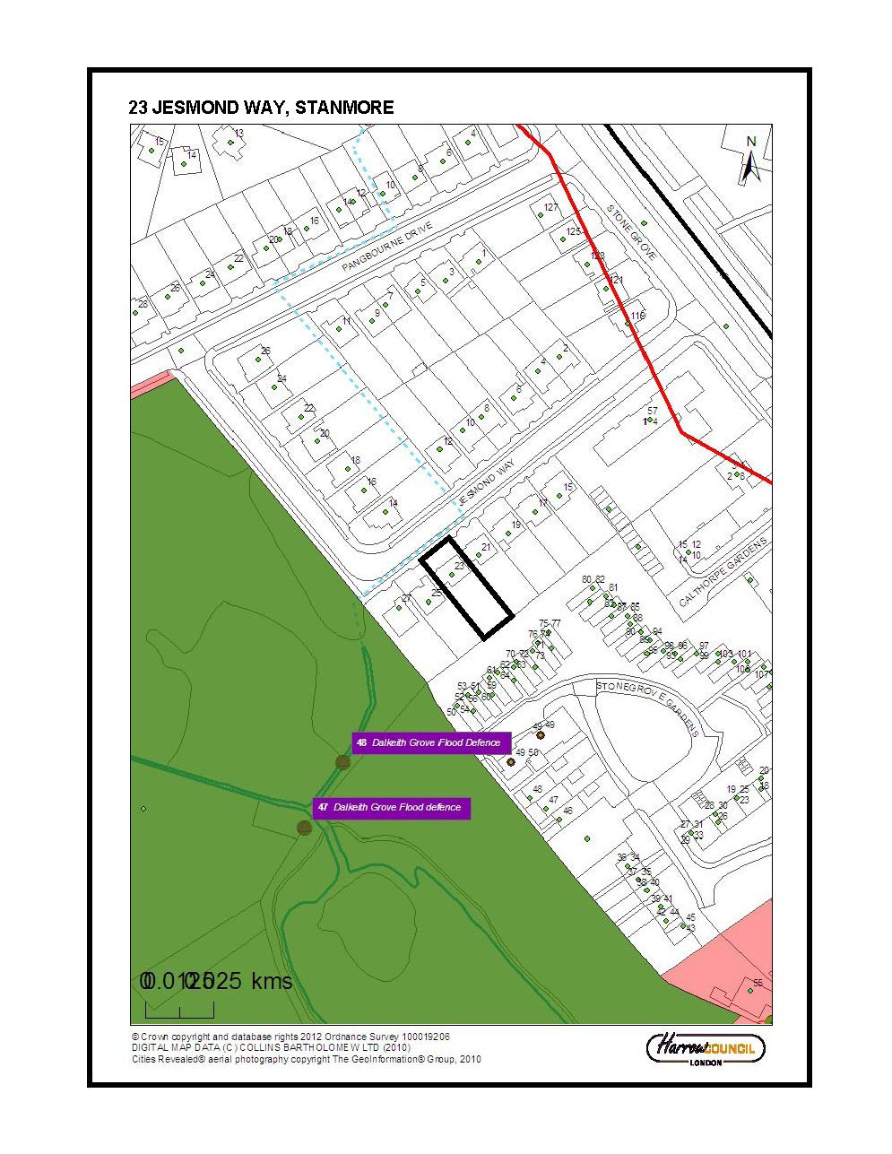
SECTION 4 - CONSULTATIONS FROM NEIGHBOURING AUTHORITIES

None.

SECTION 5 - PRIOR APPROVAL APPLICATIONS

None.

The applicant has not shown details of solar panels nor referred to them in the description of development and so theses elements do not fall to be considered here. The applicant is made aware of this by way of informative on this report. However, solar panels may constitute permitted development by virtue of Part 40 of The Town and Country (General Permitted Development) Order 1995 (as amended).

